Coupon Code Documentation

The coupon code generation system allows admins to create discount coupons for flight bookings. This feature enables you to offer promotional discounts to customers through unique coupon codes.

Coupon Code Setup :

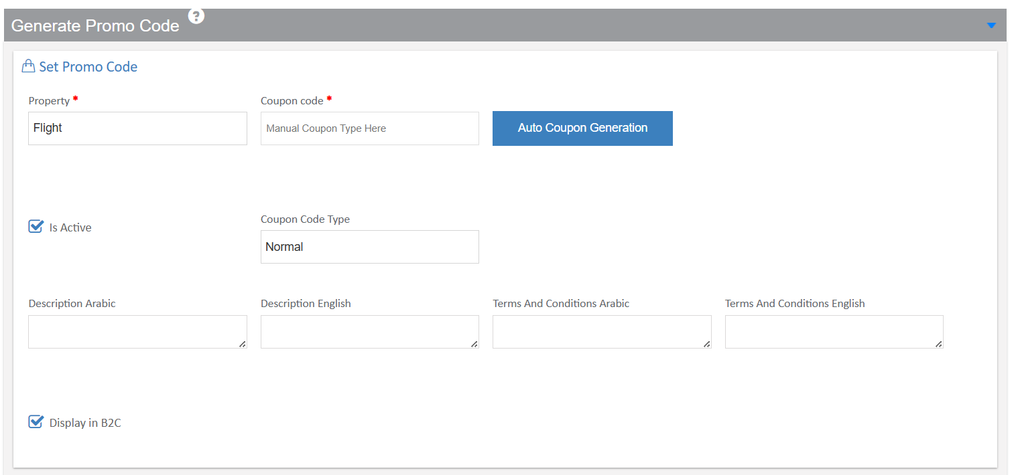

Property Field: This dropdown allows you to select which property or service the coupon applies to.If we choose Flight, it's set to "Flight," meaning this coupon will only work for flight bookings.

Coupon Code Field: You can enter a custom coupon code manually in this field (for example, "SUMMER2024" or "FLIGHT50"). Alternatively, you can click the "Auto Coupon Generation" button, which will automatically create a unique random code for you.

Is Active Checkbox: When checked, this option makes the coupon live and available for customers to use. If unchecked, the coupon will be disabled and cannot be applied to any bookings.

Coupon Code Type: This dropdown lets you select the type of coupon. The "Normal" option means it's a standard discount coupon available to all eligible customers.

Description Arabic: Enter a description of the coupon offer in Arabic language. This helps Arabic-speaking customers understand what the promotion offers.

Description English: Enter a description of the coupon offer in English language. This ensures English-speaking customers can understand the promotion details.

Terms And Conditions Arabic: Specify any rules, restrictions, or conditions that apply to this coupon in Arabic. For example, minimum booking amounts, blackout dates, or specific routes.

Terms And Conditions English: Specify the same terms and conditions in English to ensure all customers understand the limitations and requirements.

Display in B2C Checkbox: When checked, this coupon will be visible and usable on your customer-facing website (Business to Customer portal).

Flight-Specific Settings :

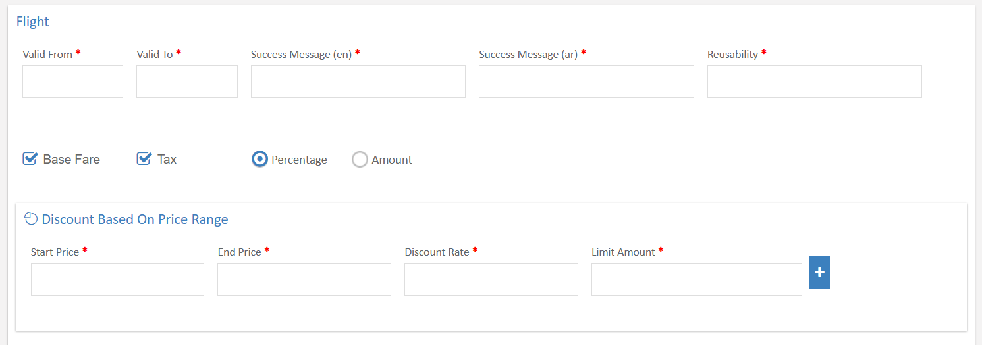

Valid From: Select the start date from which the coupon becomes active and can be used by customers.

Valid To: Select the end date after which the coupon will expire and can no longer be applied to bookings.

Success Message (en): Enter the message that will be displayed to customers in English when they successfully apply the coupon code.

Success Message (ar): Enter the message that will be displayed to customers in Arabic when they successfully apply the coupon code.

Reusability: Maximum number of times this coupon can be used.

Base Fare Checkbox: When checked, the discount will be calculated based on the base fare amount of the flight ticket (excluding taxes and fees).

Tax Checkbox: When checked, the discount will also apply to the tax portion of the flight ticket.
If both checked coupon applies to sum of Base fare + Taxes.

Discount Type - Percentage or Amount: You can choose between two options:

Percentage: The discount will be calculated as a percentage of the ticket price (for example, 10% off)

Amount: The discount will be a fixed amount deducted from the price (for example, $50 off)

Discount Based On Price Range Section:

This feature allows you to create tiered discounts based on the flight ticket price. You can set different discount rates for different price .

Start Price: Enter the minimum ticket price for this discount tier to apply.

End Price: Enter the maximum ticket price for this discount tier.

Discount Rate: Specify the percentage or amount of discount that applies to bookings within this price range.

Limit Amount: Set a maximum cap on the discount amount for this tier. This prevents excessive discounts on very expensive tickets.

Plus Button (+): Click this button to add additional price range, allowing you to create multiple discount levels for different prices.
Payment Gateway:

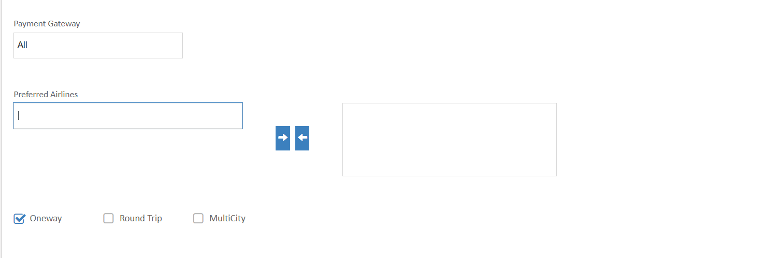

Select which payment methods this coupon can be used with. "All" means the coupon works with any payment option available on your platform.

Preferred Airlines: You can select specific airlines to which this coupon applies. Use the arrow buttons to move airlines between the available and selected lists. Leave empty if the coupon should work with all airlines.

Journey Type Options:

Oneway: Check this if you only need to apply the coupon to one-way flight bookings.

Round Trip: Check this if you only need to apply the coupon to round-trip flight bookings.

MultiCity: Check this if you only need to apply the coupon to multi-city flight bookings.

Sales Channels: Select which booking channels can use this coupon.

Direct website: Customers booking directly on your website

Inhouse: Valid for inhouse bookings

TravelAgent: Bookings made through travel agents

Backoffice subagent: Bookings made through back-office sub-agents.

Mobile Applications : Bookings made through your mobile app

Metasearch: Bookings from metasearch engines

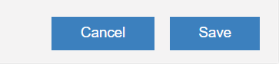

Cancel Button: Click this to discard all changes and exit without saving the coupon configuration.

Save Button: Click this to save all the coupon settings and make it available according to your configuration.

Flight

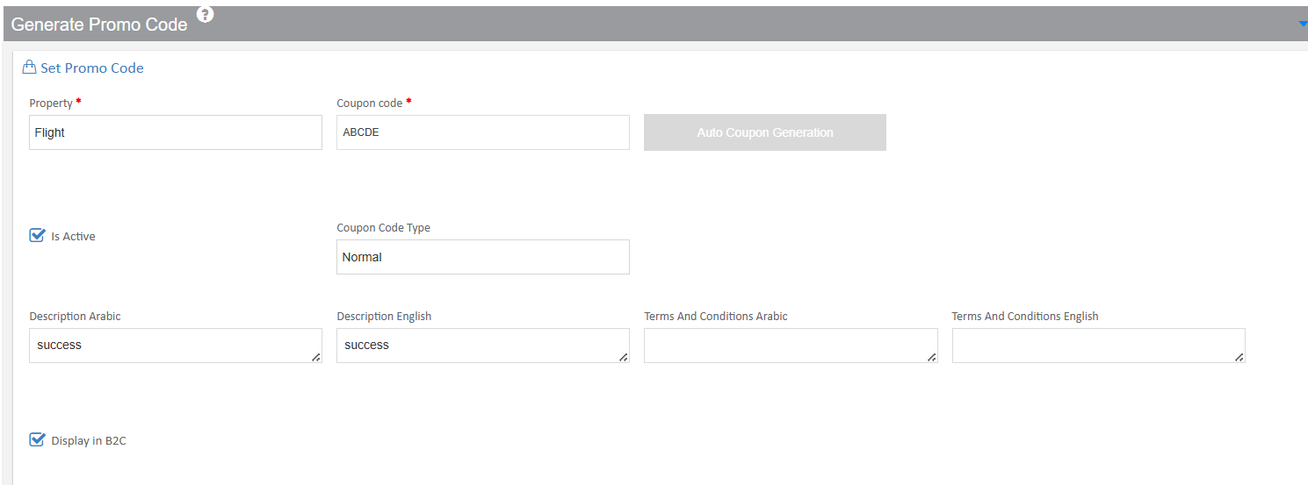

Property: Set to "Flight" - meaning this coupon only works for flight bookings.

Coupon Code: "ABCDE" - this is the exact code customers will enter or select

Is Active: Checked - confirming this coupon is live and available for customer use

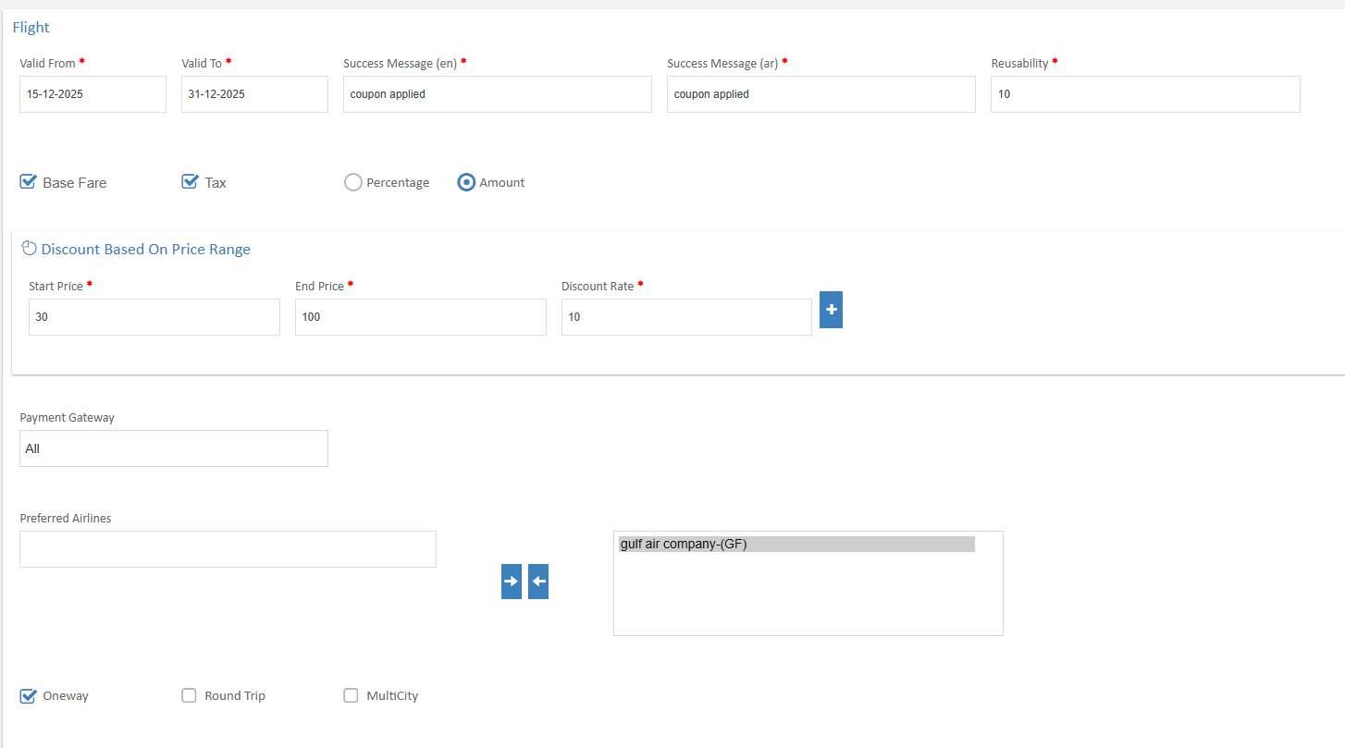

Start Price Field: Enter the minimum ticket price (in local currency) for this discount tier. In the example, it shows "30", meaning this tier applies to tickets priced from 30 KWD and above.

End Price Field: Enter the maximum ticket price for this discount tier. In the example, it shows "100", meaning this tier applies to tickets priced up to 100 KWD.

Discount Rate Field: Specify the discount percentage or amount that applies within this price range. In the example, it shows "10", and selected Amount which could mean 10 KWD

Add Button (+): Click this plus button to add additional price tiers. This allows you to create multiple discount brackets, such as:

30-100 KWD: 10% discount
101-300 KWD: 15% discount
301+ KWD: 20% discount

Payment Gateway Dropdown: Select which payment methods. The example shows "All", meaning customers can use any available payment method and still apply this discount code.

Preferred Airlines Section: This dual-list selector allows you to specify which airlines this coupon applies to.
Shows the selected airlines where this coupon is valid

Oneway Checkbox: When checked, customers can use this coupon for one-way flight bookings. In the example, this is selected.

Once saved by the admin, this coupon immediately becomes available on the customer-facing website, appearing in the list of available discount codes that customers can select and apply to their flight bookings.

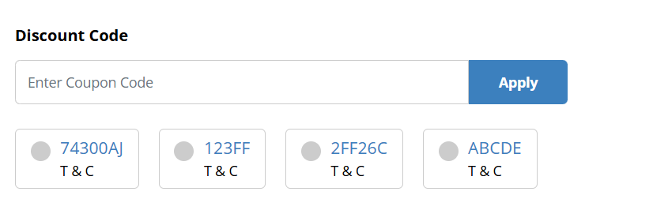

When customers are ready to complete their booking, they will see a "Discount Code" section on the booking page. This is where they can apply promotional offers to reduce their booking cost.

Enter Coupon Code Field: Customers can type their promo code directly into this input box.(like "74300AJ", "123FF", "ABCDE", etc.).

Apply Button: After entering the code, customers click this "Apply" button to activate the discount. The system will then verify if the code is valid and applicable to their booking.

Coupon Code Cards: Below the entry field, customers can see a list of available coupon codes displayed as clickable cards. Each card shows:

The Coupon Code: The unique code identifier (for example, "74300AJ", "123FF", "2FF26C", "ABCDE")
T & C Link: A "Terms & Conditions" link that customers can click to view the specific rules and restrictions for each coupon

Radio Button Selection: Each coupon card has a radio button on the left side. Customers can click on any card to automatically select that coupon code, which fills it into the entry field above.

When a customer applies a valid coupon code:

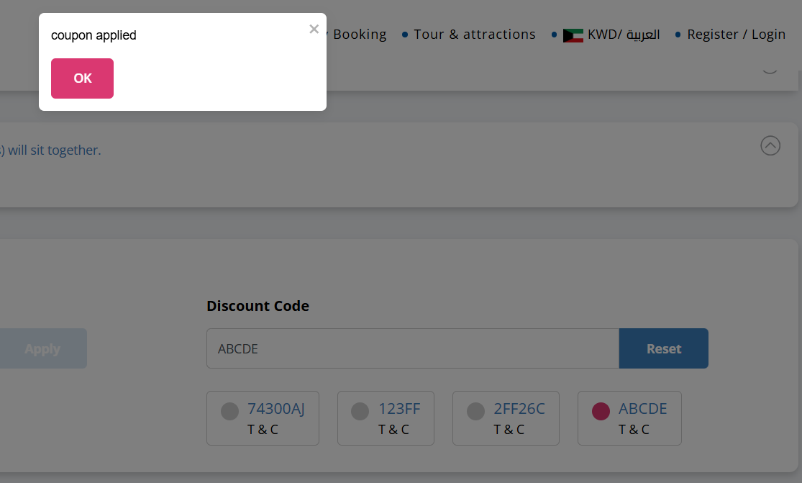

Success Popup: A confirmation popup appears on the screen with the message "coupon applied" to inform the customer that their discount code has been successfully activated.

OK Button: Customers click the "OK" button to close the popup and continue with their booking. The discount will now be reflected in their total booking amount.

Reset Button: If customers want to remove the applied coupon or try a different code, they can click the "Reset" button. This will clear the current coupon and allow them to enter a new one.

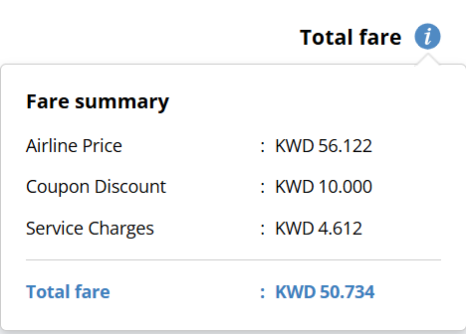

Once you've successfully applied a coupon code, the fare summary clearly shows how your discount affects the final price.

Airline Price: Shows the original base fare for your flight
Amount: KWD 56.122
This is the standard ticket price before any discounts or additional charges

Coupon Discount: Displays the savings you're receiving from the applied promotional code
Amount: KWD 10.000
This is the discount amount deducted from your airline price
In this example, the "ABCDE" coupon has saved you 10 KWD on your booking

Service Charges: Shows additional service charges that apply to your booking
Amount: KWD 4.612

Total Fare (Final Price):
Amount: KWD 50.734
This is your final payable amount after applying the coupon discount and adding service charges

Payment Details - TQR :

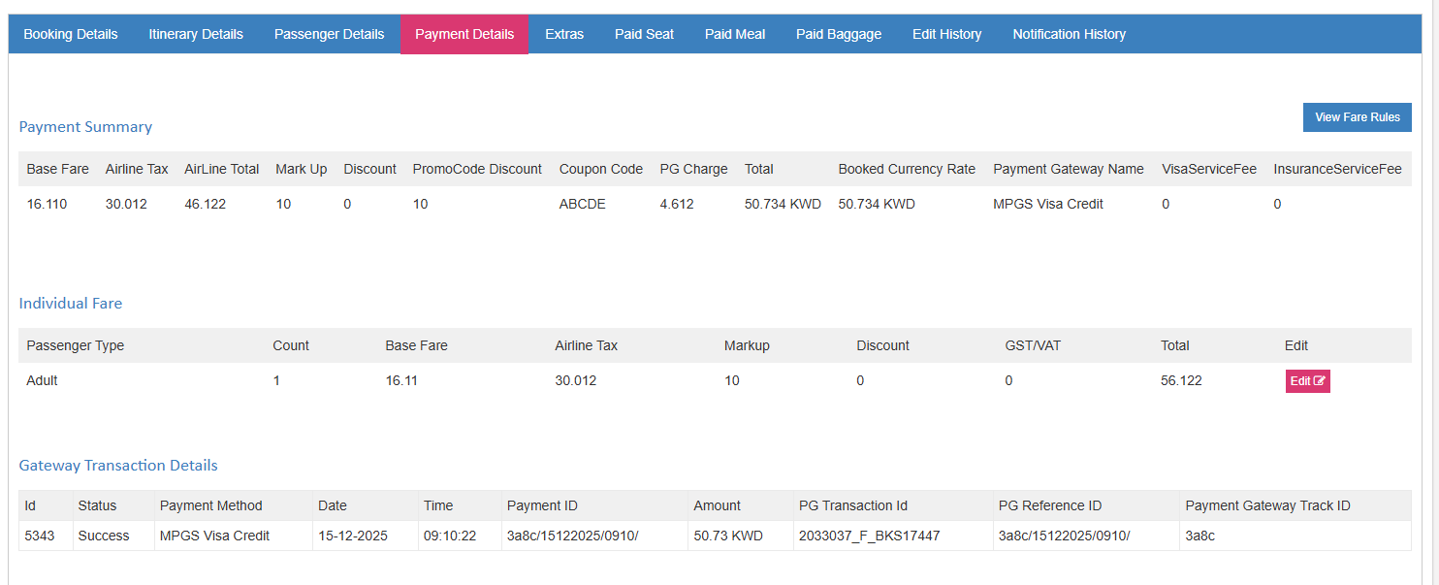

The Payment Details section in the admin panel provides comprehensive visibility into all booking transactions, including promotional code usage and discounts applied by customers. This allows administrators to track, monitor, and manage coupon code redemptions effectively.

The Payment Summary provides a complete breakdown of all charges and discounts applied to the booking.

PromoCode Discount: The specific discount amount from the applied coupon code
Amount shown: 10 KWD
This shows the actual savings the customer received by using their promotional code

Coupon Code: Displays which promotional code was used for this booking
Code shown: ABCDE
This allows administrators to track which specific coupon was redeemed

Sales Report :

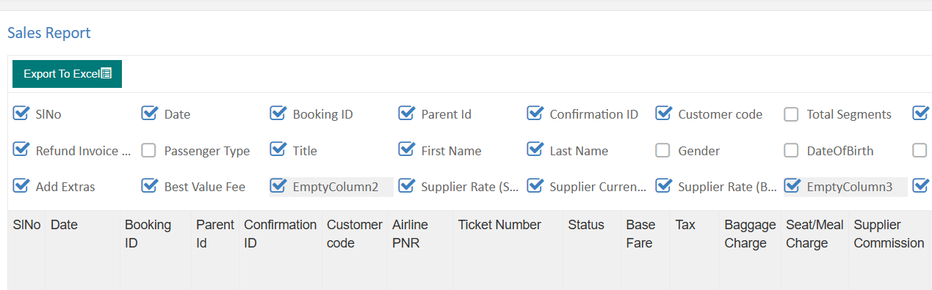

The Sales Report section provides administrators with a comprehensive view of all bookings and their financial details, including promotional code usage.
This reporting feature allows you to analyze the impact of discount campaigns on your overall sales performance.

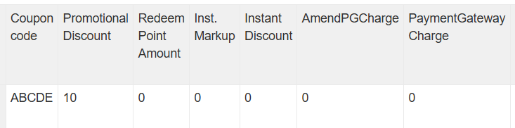

The sales report includes dedicated columns to track promotional code activity

Coupon code: Displays the specific promotional code that was applied to the booking

Example shown: ABCDE
This column shows the exact coupon code the customer used
Helps administrators track which promotional codes are being redeemed

Promotional Discount: Shows the total discount amount given through the promotional code
Amount shown: 10
This represents the value deducted from the booking (in your base currency, e.g., 10 KWD)

Hotel
Just like flight bookings, hotel can also benefit from promotional discount codes. Admins create hotel-specific coupons using the same intuitive interface.

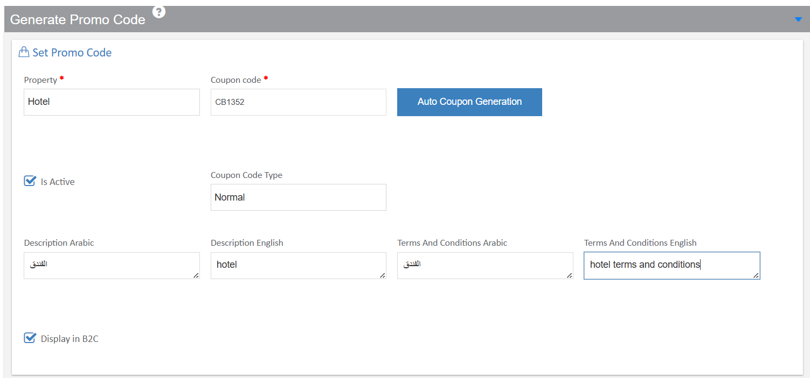
Property Field: Select "Hotel" from the dropdown menu to indicate this coupon applies exclusively to hotel bookings

Coupon Code Field: Enter your code or Click Auto coupon genertaion button to automatically create a random, unique coupon code if you prefer not to enter one manually .
Example shown: CB1352
This is the unique code customers will enter to receive their discount

Hotel-Discount Settings :

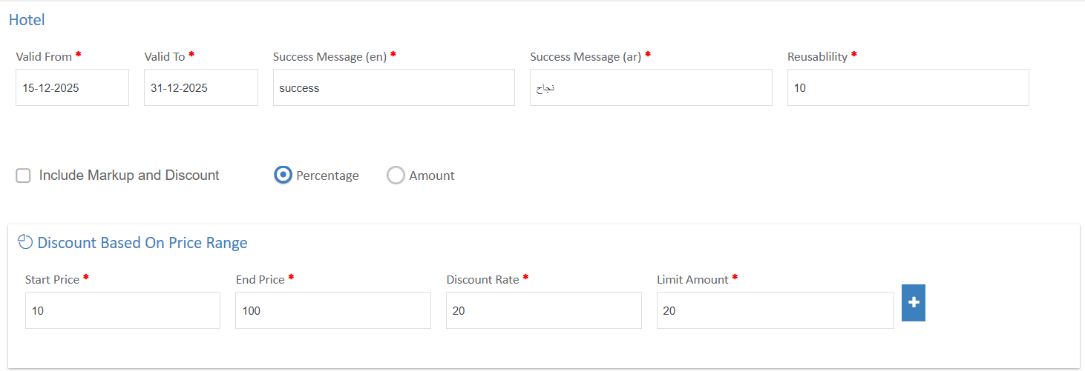

Valid From Field: Set the start date for hotel coupon activation
Customers can start using this coupon from December 15, 2025
Useful for planning seasonal promotions or special events

Valid To Field: Set the expiration date for the hotel coupon
This coupon will expire on December 31, 2025
Perfect for creating limited-time offers like holiday promotions

Include Markup and Discount Checkbox: When checked, the discount applies to both the base hotel price and any markup fees

Start Price Field: Enter the minimum hotel booking price for this discount

End Price Field: Enter the maximum hotel booking price

Discount Rate Field: Specify the discount percentage or amount for this price range

Limit Amount Field: Set a maximum discount cap for this tier

Even if the percentage calculation results in a higher amount, the discount will not exceed from the given limit amount.
(20 KWD)

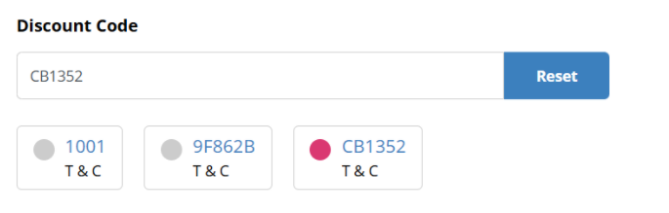

When customers are ready to complete their booking, they will see a "Discount Code" section on the booking page. This is where they can apply promotional offers to reduce their booking cost.

Coupon Entry Field: Text box where customers enter their code
Customers can type this code manually
Auto-fills when clicking on available coupon cards below

Coupon Card Display: Shows all valid hotel coupons the customer can use

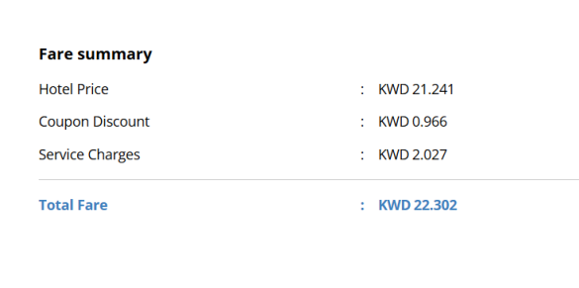
Fare Summary Section: Displays all charges and discounts clearly

Hotel Price: Original accommodation cost
This is the base rate for the hotel room before any discounts

Coupon Discount: Savings from the applied promotional code
This is how much the customer saves by using coupon "CB1352"
Based on the price range settings (10-100 KWD range gets 20% discount with 20 KWD max)

Payment Details - TQR :

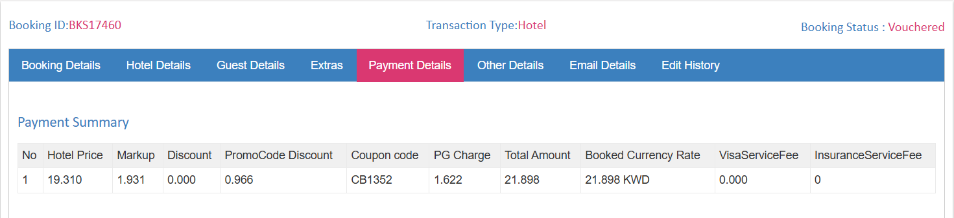

Payment Summary :
When administrators review hotel bookings, they can see complete payment details including coupon usage.

Hotel Price: Base accommodation cost
The original hotel room rate before markup and discounts

PromoCode Discount: Discount from the applied coupon code
As shown in the image the promoCode discount is calculated as:
5% of Hotel price , 5% of 19.310 which is .966

Coupon code: The specific promotional code used
Allows administrators to track which coupon was redeemed

Sales Report:

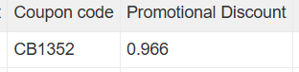

The sales report includes dedicated columns to track promotional code activity

Coupon code: Displays the specific promotional code that was applied to the booking

Example shown: CB1352
This column shows the exact coupon code the customer used
Helps administrators track which promotional codes are being redeemed

Promotional Discount: Shows the total discount amount given through the promotional code
Amount shown: 0.966
This represents the value deducted from the booking

Transfer

In addition to flights and hotels, your booking platform also supports promotional discount codes for transfer services (such as airport pickups, city transfers). Admins can create transfer-specific coupons to encourage customers to book transportation services.

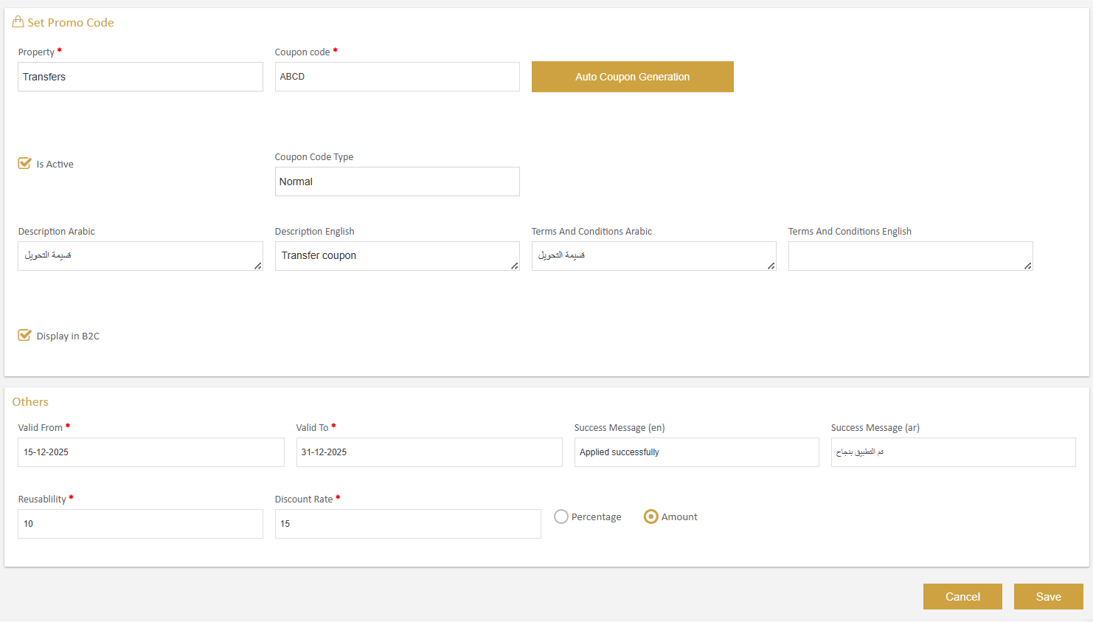

Property Field: Select "Transfers" from the dropdown menu
This ensures the coupon applies exclusively to ground transportation bookings.

Valid From Field: Set the start date when customers can begin using this transfer coupon

Valid To Field: Set the expiration date for the transfer coupon

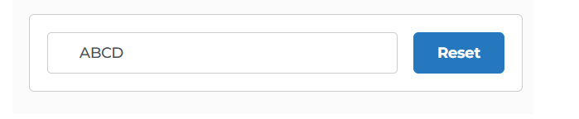
Coupon Entry Field: Text box for entering the promotional code
Customers type their transfer coupon code here

Reset Button: Blue button to clear the applied coupon

Price Summary Section :

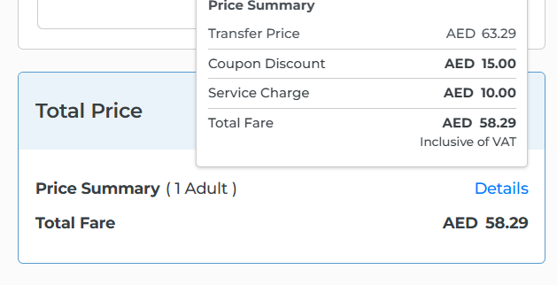

When customers book a transfer service, they see a clear pricing breakdown and coupon application section.

Price Summary Section: Displays detailed cost breakdown for the transfer booking

Transfer Price: The base cost of the transportation service
This is the standard rate for the selected transfer service

Coupon Discount: The savings from applying the promotional code
This matches the fixed amount discount (Eg: 15 AED) set by the admins Shows customers exactly how much they're saving

Total Fare: Final amount customer pays

Transfer Voucher :

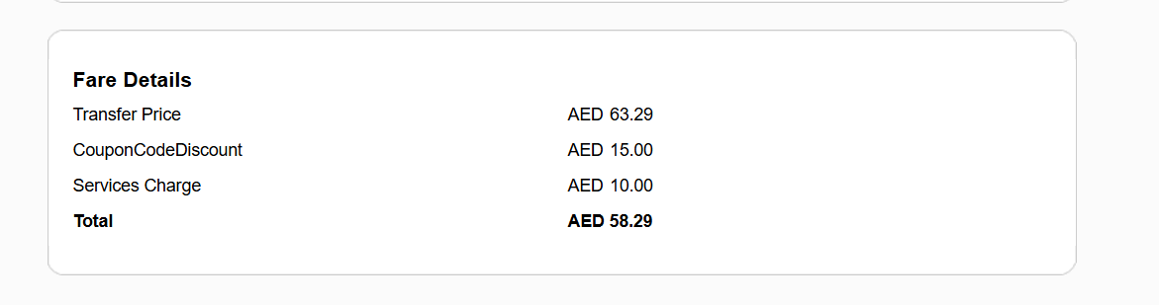
Hotel voucher also display the CouponCodeDiscount in the Fare Details

Payemnt Details - TQR :

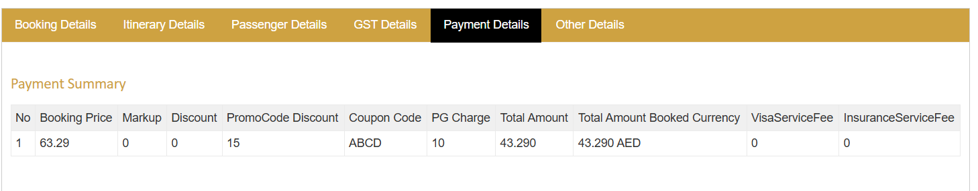

The Payment Summary provides complete visibility into transfer booking finances including coupon usage.

Booking Price: Base transfer service cost
Original price before any discounts or additional charges

PromoCode Discount: Discount from the applied coupon code
Savings from coupon "ABCD"

Coupon Code: The specific promotional code redeemed

Code shown: ABCD
Allows administrators to track which transfer coupon was used

Sales Report :

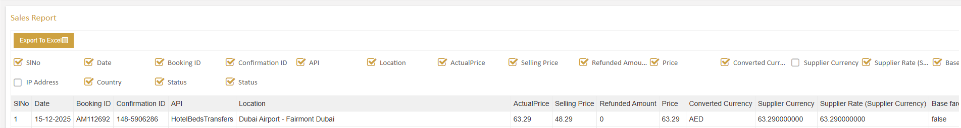

The sales report includes dedicated columns to track promotional code activity

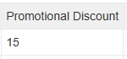
Promotional Discount: Shows the total discount amount given through the promotional code.

Cart Booking

Cart Booking is a special feature that allows customers to book multiple flight segments in a single transaction, creating customized travel itineraries. These combined bookings can include different types of flights such as GDS flights and LCC flights in various combinations. The coupon code system fully supports these complex multi-flight bookings, allowing customers to apply discounts to their entire cart.

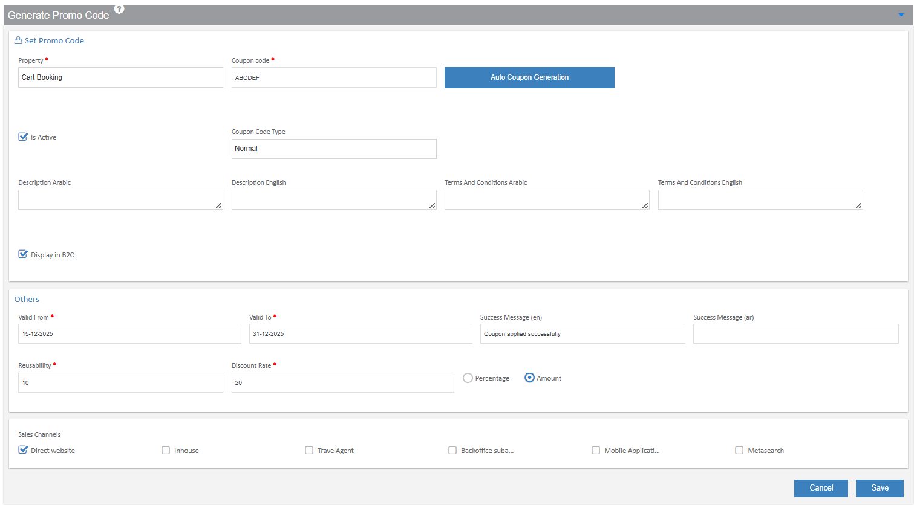

Property Field: Select the type of booking this coupon applies to

Example shown: Cart Booking
This special property type is specifically for multi-flight combination bookings

Coupon Code Field: Enter your promotional code for cart bookings

Example shown: ABCDEF
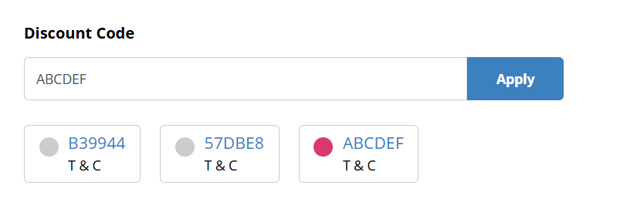

Discount Code Section: applying promotional codes to the entire cart
Coupon Entry Field: Text box for entering the cart booking code

Code shown: ABCDEF

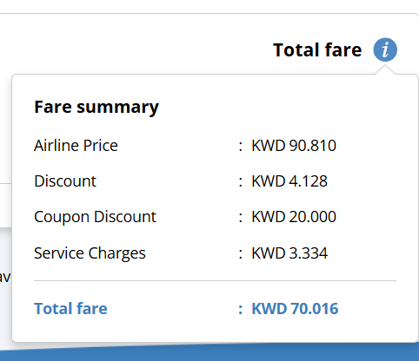

Total Fare Section: Shows complete pricing for the multi-flight cart booking with applied coupon
Fare Summary Breakdown:
Airline Price: Combined base fare for all flights in the cart

Amount shown: KWD 90.810
This is the total of all flight segments before any discounts
Represents the standard pricing for the complete itinerary

Coupon Discount: Savings from the applied cart booking promotional code

Amount shown: KWD 20.000
This is the discount from coupon "ABCDEF"
Based on the 20% percentage discount configured by admins

Payment Details -TQR :

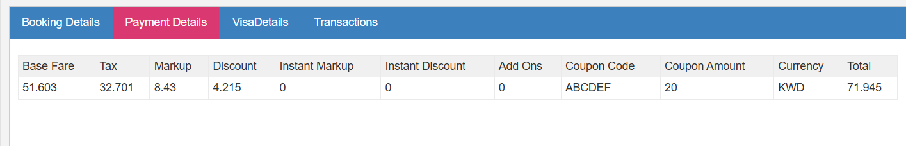

The Payment Summary provides complete visibility into Cart booking including coupon usage.

Coupon Code: Discount from the applied coupon code
Savings from coupon "ABCDEF"

