TRAVEL INSURANCE

Overview

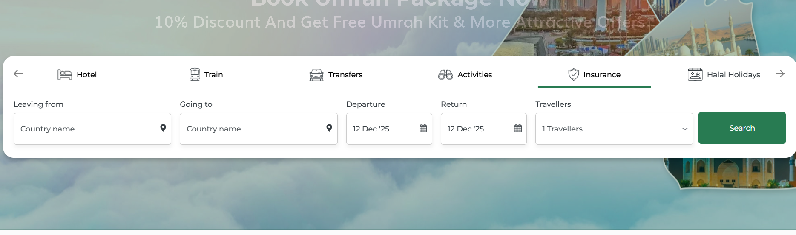
This document outlines the travel insurance booking system. The goal is to help travelers protect their trips with the right coverage whether it's medical emergencies, trip cancellations, lost baggage, or other unexpected events during their journey.

Search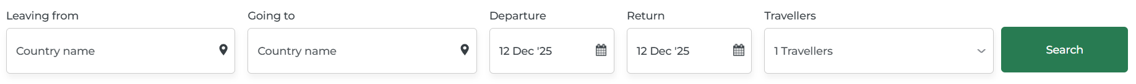
When someone clicks on the "Insurance" tab, they see a simple search form with these fields:

Leaving from
This is a dropdown menu showing all countries. Travelers select their home country from this list, the place where their journey begins.
Going to
Another dropdown menu with all destination countries. Travelers select where they're planning to travel to.
Departure Date
A calendar picker that lets travelers choose when they're leaving. They can select any future date starting from today . This helps the system understand when the coverage needs to start.

Return Date
Another calendar picker for selecting the return date. The system makes sure this date comes after the departure date. Once both dates are entered, the system automatically calculates the total trip duration in days.
Number of Travelers
A dropdown where travelers can select how many people need insurance, ranging from 1 to 20 travelers. They can specify the number of adults (12 years and older) and children (0-11 years). For children, they'll need to enter each child's exact age since insurance pricing varies based on age.
Search Button
A prominent green button labeled "Search" sits at the bottom of the form. When travelers click this button, the system processes all the information and displays available insurance plans that match their trip details.

3. Search Results Page
After clicking "Search", the page shows:
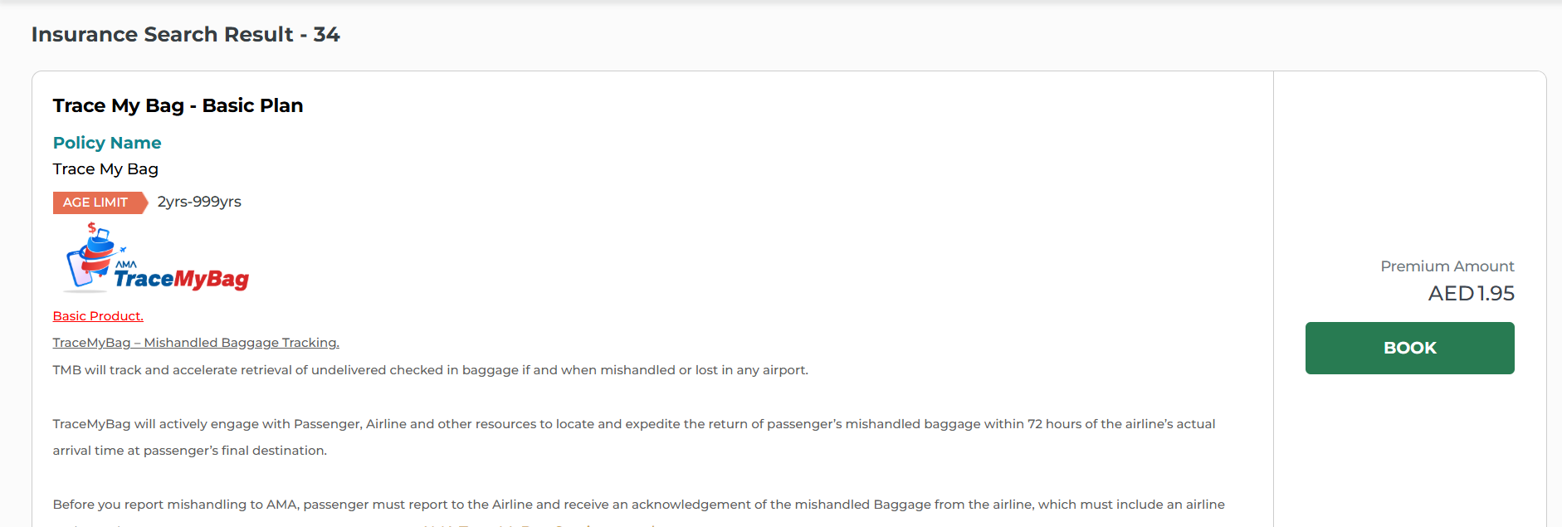

Each insurance plan appears as a card that shows all the important information travelers need. At the top, there's the plan name like "Trace My Bag - Basic Plan" and the policy name right below it. A colored badge shows the age limit, so travelers can quickly check if they're eligible.
The card displays the insurance company's logo and a label showing if it's a Basic, Silver, Gold, or Premium product. There's a short title explaining what the insurance covers, followed by a few paragraphs that describe how it works, what it protects, and any important conditions. For example, it might say the insurance tracks lost baggage and helps get it back within 72 hours.
On the right side, the price is shown clearly (like "AED 1.95"), and there's a big green "BOOK" button. When travelers click this button, they can start the purchase process for that plan.

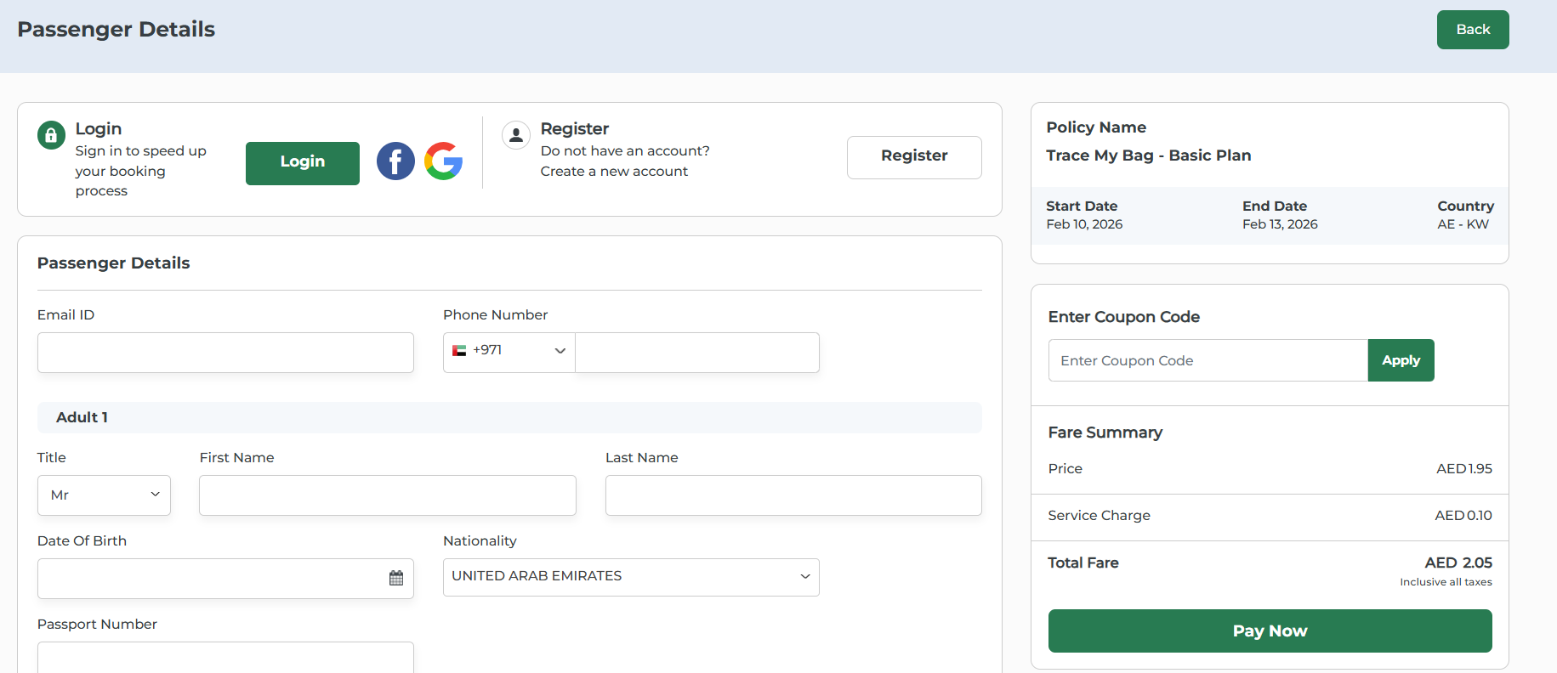

Passenger Details & Booking Page
After clicking "BOOK", travelers go to the passenger details page to complete their purchase. The page has three sections: Login/Register on the left, Passenger Details form in the center, and Booking Summary on the right.

Login/Register Section
Travelers can either log in to their existing account (with email or social login like Facebook/Google) or register as a new user. This speeds up the booking process and saves their information for future bookings.

Passenger Details Form
Contact Information: Travelers enter their Email ID and Phone Number with country code (for SMS notifications).
Traveler Information: For each traveler, the form collects Title (Mr/Mrs/Ms), First Name, Last Name, Date of Birth (using calendar picker), Nationality, and Passport Number. All information must match the passport exactly. If multiple travelers were selected during search, the form shows fields for each person (Adult 2, Child 1, etc.).

Booking Summary
Policy Details: Shows the Policy Name, Start Date, End Date, and Country route (like AE - KW).
Coupon Code: Travelers can enter promotional codes and click "Apply" for discounts.
Fare Breakdown: Displays the Price , Service Charge, and Total Fare with "Inclusive all taxes" note.
Pay Now Button: Large green button at the bottom to proceed to payment.
Back Button: Top right corner button to return to search results if needed.

Choose Payment Method:
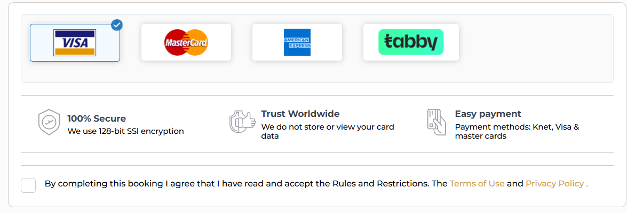

• Users can select one of the available payment options such as Visa, MasterCard,
American Express, or Tabby.
• The selected payment method is highlighted for clear identification.
Terms & Conditions:
• A mandatory checkbox is provided for users to confirm that they have read and accepted the Terms & Conditions and Privacy Policy.
• The booking process cannot proceed unless this checkbox is checked.

Insurance Voucher
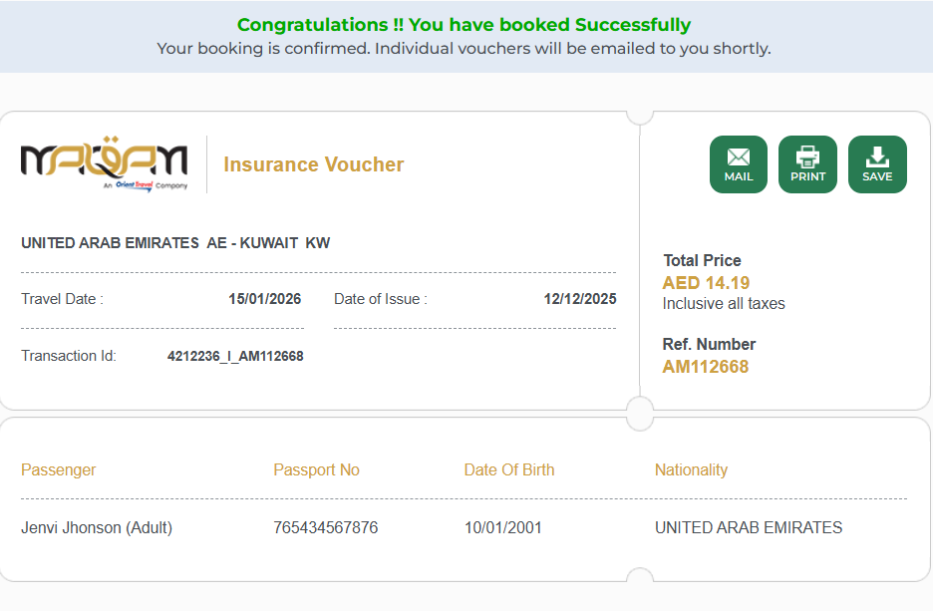
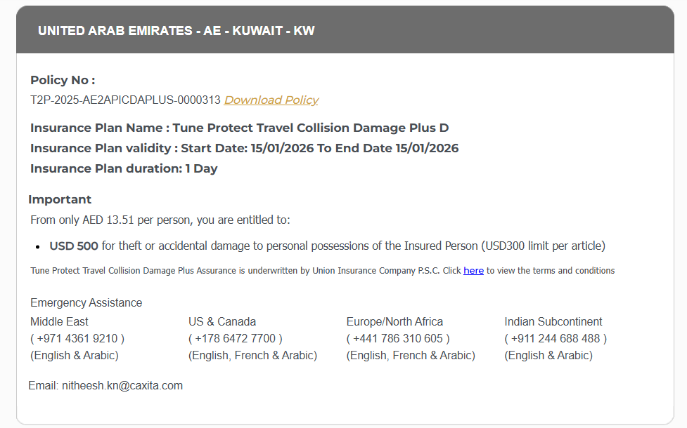
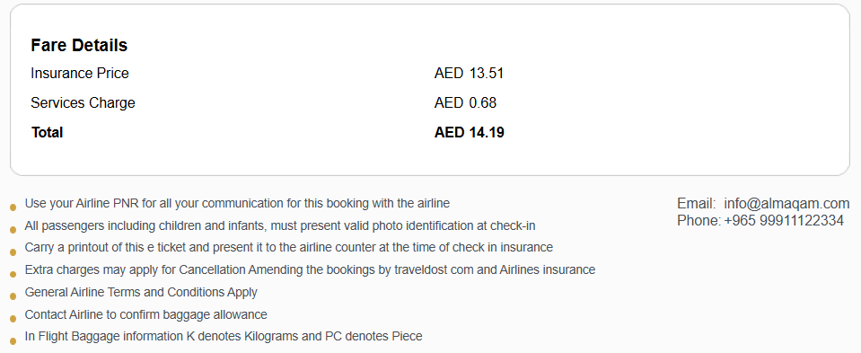

After successful payment, travelers see a confirmation page with a green success message at the top.Three green buttons appear at the top:
Action Buttons
Three green buttons appear at the top of the page. The MAIL button sends the voucher directly to the traveler's email address. The PRINT button opens a print dialog so travelers can print a paper copy. The SAVE button downloads the voucher as a PDF file to their device.

Insurance Voucher
The voucher contains all essential policy information that travelers need for their trip.
Travel Information
This section displays the travel route showing departure and destination countries. The Travel Date indicates when the trip begins. The Date of Issue shows when the insurance was purchased. A unique Transaction ID serves as the booking number for reference.
Price Summary
The right side of the voucher displays the Total Price paid for the insurance. A note confirms "Inclusive all taxes" so travelers know there are no hidden charges. A Reference Number is provided for use when contacting customer service.
Passenger Information
A table lists each traveler covered by the insurance. For every passenger, it shows their Name with type indicating Adult or Child, their Passport Number, Date of Birth, and Nationality. When multiple travelers are included in the booking, each person appears as a separate row in the table.

Policy Details
Policy Information
This section includes the official Policy Number which uniquely identifies the insurance policy. A Download Policy link allows travelers to download the complete policy document as a PDF. The Insurance Plan Name shows the specific coverage plan purchased. Insurance Plan validity displays the start and end dates of coverage. The Insurance Plan duration indicates the total number of days covered.
Coverage Details
The coverage section shows the cost per person for the insurance. It lists the coverage items with their limits, describing what is protected and up to what amount. The insurance company name is displayed along with a link to view the full terms and conditions of the policy.

Emergency Contacts
Emergency contact numbers are provided for different regions around the world. Each region has dedicated phone support with language assistance based on the area. An email address is also available for non-urgent support queries.

Fare Breakdown
The fare section shows a complete breakdown of charges. It displays the base insurance price, an additional service charge for the booking, and the final total amount that includes all taxes.

Important Notes
Several important reminders appear at the bottom of the voucher. Travelers are advised to use their airline booking reference for communications, bring valid identification to the airport, and present a printed copy of the voucher during check-in. The section also mentions that modification fees may apply, standard airline terms are applicable, and travelers should verify baggage rules directly with their airline.
Customer Support
Customer support contact details are provided, including an email address and phone number for assistance with bookings or questions.
Email Confirmation
After booking, travelers automatically receive a confirmation email. This email contains the booking reference, a downloadable voucher file, a summary of coverage benefits, emergency contact information, guidance on filing claims, and support contact details.

Manage Bookings
A Manage Bookings section is available where travelers can access their booking history. They can retrieve their vouchers, verify policy validity periods, view policy documentation, and reach out to support for booking-related assistance.

Cross-Selling Insurance During Flight Booking
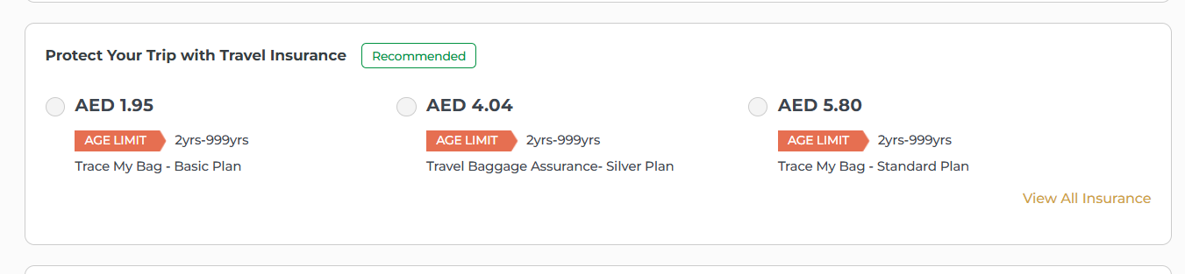
When travelers are booking their flight, a cross selling section appears offering travel insurance options. The heading says "Protect Your Trip with Travel Insurance" with a green badge marked "Recommended" to highlight its importance. This cross selling feature allows travelers to add insurance protection directly during their flight booking process.
Insurance Plan Display
Multiple insurance plans are shown side by side for easy comparison. Each plan displays its price at the top, an orange age limit badge showing the eligible age range, and the plan name below. The plans offer different coverage levels at different price points, allowing travelers to choose the protection that fits their needs and budget.
Selection and Options
Each insurance plan has a radio button that travelers can click to select their preferred option. Only one plan can be chosen at a time. A "View All Insurance" link appears on the right side, allowing travelers to see the complete list of available insurance plans with different coverage options if they want to explore more choices beyond the initially displayed plans.
Integration with Booking
When travelers select a cross-sell insurance plan, it gets added directly to their flight booking. The insurance cost combines with the flight ticket price for a single checkout process, making it convenient to purchase both protection and tickets together in one transaction.

Insurance in Fare Details
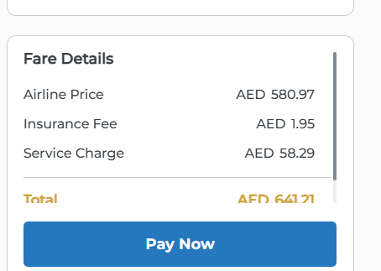
When travelers select an insurance plan during flight booking, the Insurance Fee line appears in the Fare Details section showing the insurance cost, which is then included in the Total amount for payment.
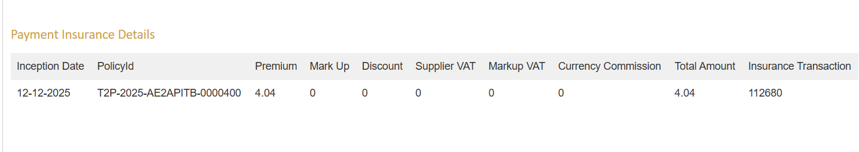The Payment Insurance Details section in the admin panel shows a transaction summary table. It displays the Inception Date, Policy ID, Premium amount, Mark Up, Discount, Supplier VAT, Markup VAT, Currency Commission, Total Amount, and Insurance Transaction reference number. This allows admin staff to quickly review the complete financial breakdown of each insurance booking.

ADMIN - TQR

Booking Details Tab

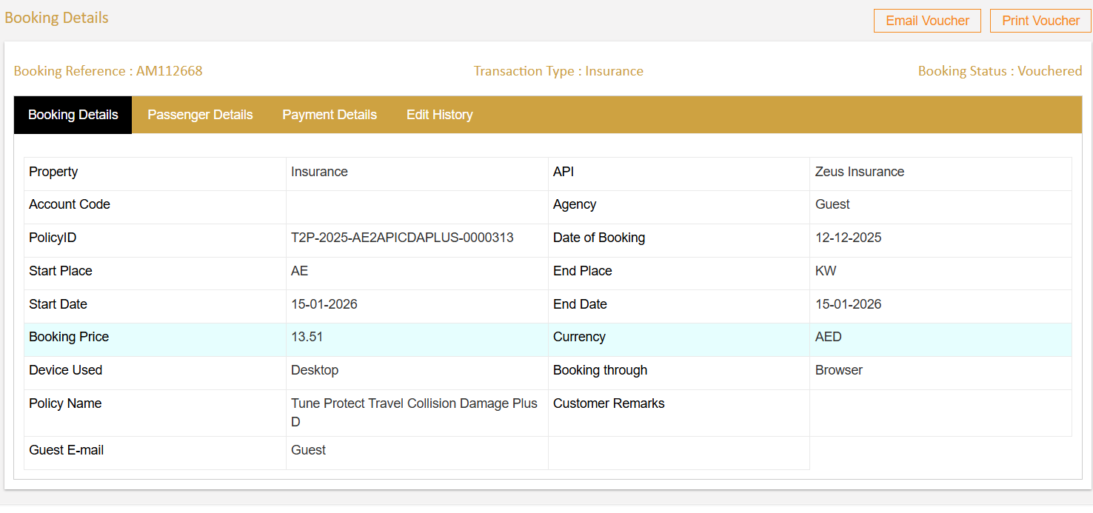

The Booking Details tab displays the insurance policy information in a table format. It shows the insurance provider, Policy ID, travel route with Start and End Place, coverage dates, Booking Price with currency, and Date of Booking. Additional information includes the device and channel used for booking, Policy Name, and Guest Email. This tab provides a complete overview of the insurance policy.

Payment Details Tab
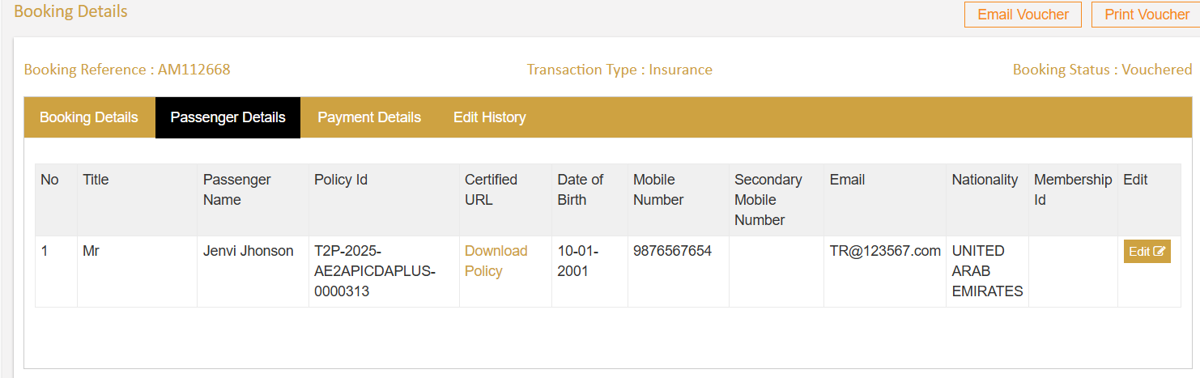
The Payment Details tab has two sections. The Payment Summary shows the Booking Price, Markup, Discount, VAT charges, and Total Amount paid. The Gateway Transaction Details displays the payment record including Transaction Status, Payment Method, Date, Time, Payment ID, Amount, and Gateway reference numbers. This tab provides complete payment transparency.
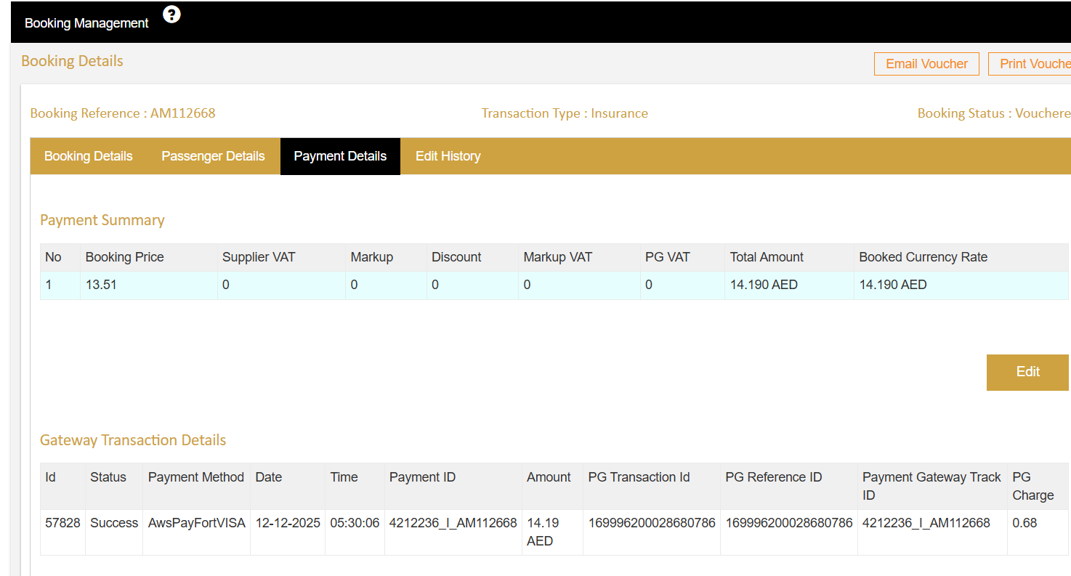

Payment Details Tab

The Payment Details tab has two sections. The Payment Summary shows the Booking Price, Markup, Discount, VAT charges, and Total Amount paid. The Gateway Transaction Details displays the payment record including Transaction Status, Payment Method, Date, Time, Payment ID, Amount, and Gateway reference numbers. This tab provides complete payment transparency.

