TRANSFER MODULE DOCUMENTATION

- Search Page:

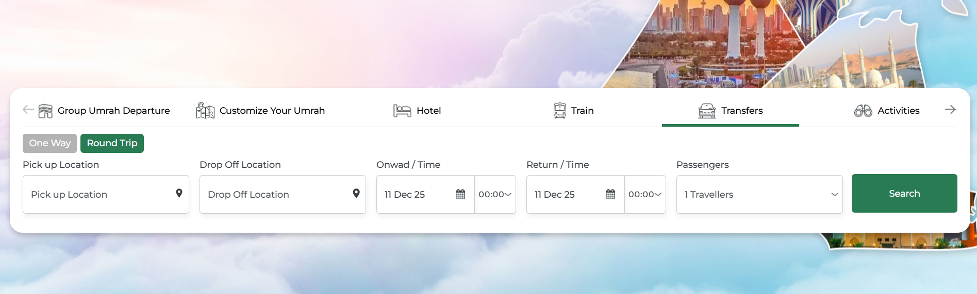

The Transfers allows users to book transportation services between locations.

The transfer search page serves as the primary interface for users to book airport transfers, city-to-city transportation, or point-to-point vehicle services.

It allows users to enter pickup and drop-off locations, travel dates and times, and the number of passengers. The purpose of this page is to simplify the ground transportation booking process by providing location suggestions, flexible scheduling options, and smooth navigation to available vehicle results.

- Journey Types

One Way :

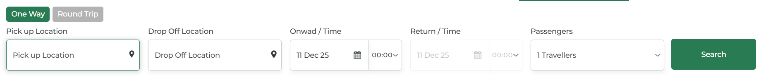

The One Way Transfers Search allows the user to book a single trip from a pick-up point to a drop-off point, and when this option is selected, the return time field is automatically hidden.

Round Trip :

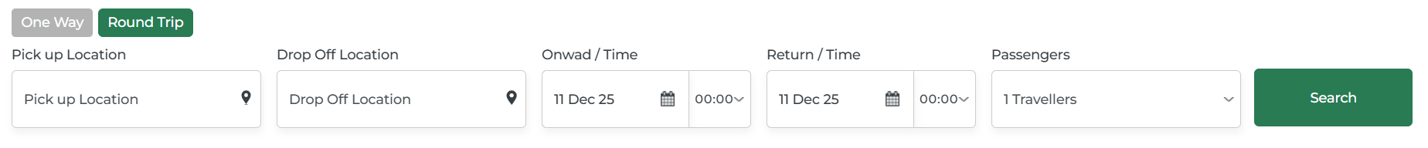

The Round Trip option is used when a customer wants to book both onward and return transfers within a single booking.

When this option is selected, the Round Trip button becomes highlighted and the One Way button is disabled.
The system then automatically displays both the “Onward / Time” and “Return / Time” fields.

- Pick Up Location & Drop Off Location

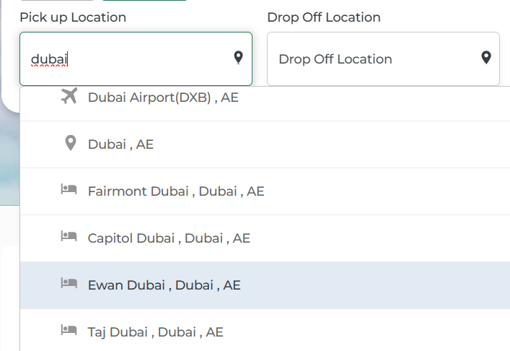

Pick up Location:

The text input field allows users to type their starting point, such as “Dubai,” and dropdown appears with auto-suggestions.

The suggestions include airports with an airplane icon, city names with a location pin, and hotels with a building icon—examples include “Dubai Airport (DXB), AE,” “Dubai, AE,” and “Fairmont Dubai, Dubai, AE.”

Users can select from the list to ensure an accurate pickup point for their transfer.

Drop Off Location:

The Drop-Off Location field allows users to enter their destination, showing a placeholder labeled "Drop Off Location."

It works the same way as the pickup field, providing auto-complete suggestions for airports, hotels, landmarks, and addresses as the user types, with a location pin icon indicating it is the destination input.

Selecting a suggested option ensures the driver receives the exact drop-off point.

- Onward/Time & Return /Time

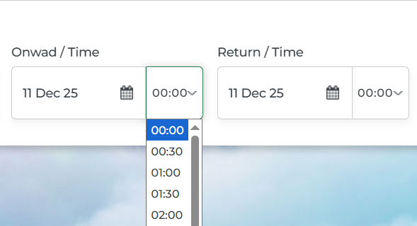

Date and time selectors work together to give you complete control over your transfer schedule, ensuring your driver arrives exactly when you need them.

Onward / Time :

The date field opens a dual-month calendar where past dates are disabled, and you can navigate between months using arrows.

The time field opens a scrollable 24-hour dropdown showing 30-minute intervals, with the selected time highlighted in blue at the top.
Together, these allow you to choose precise timings for airport pickups, hotel transfers, or scheduled departures.

Return/Time :

The date field opens a two-month calendar view where past dates are disabled, and you can navigate between months using arrow buttons. The time field opens a scrollable dropdown showing 24-hour format times at 30-minute intervals, with the selected time.

Together, these allow you to choose precise dates and pickup times for airport pickups, hotel transfers, or scheduled departures.

- Passangers

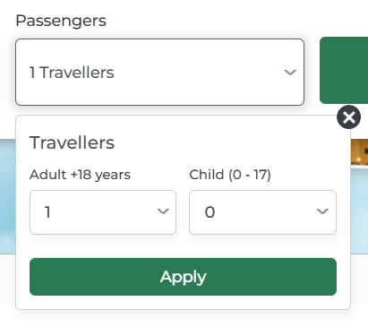

This dropdown field allows you to specify the number of passengers traveling in your transfer.

The vehicle options in your search results will be filtered based on passenger capacity to ensure everyone fits comfortably.

Default Display :

The main field displays “1 Traveller” by default, and clicking it opens the traveller selection panel. Inside the panel, users can adjust their traveller details. A close (X) button in the top-right corner allows them to exit the panel easily.

Traveller Categories:

Adult +18 years

The dropdown menu displays selectable numbers from 1 to 22, allowing users to choose the number of adult passengers aged 18 and above.

The currently selected value is highlighted in blue for easy visibility. Users can scroll through the list to select any number up to a maximum of 22 adults.

Child (0 - 17)

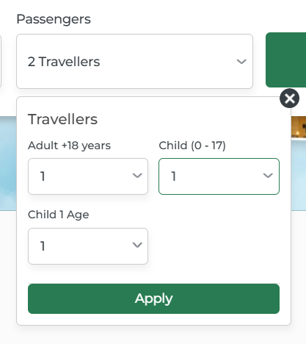

A separate dropdown is available for selecting the number of children under 18 years old, ranging from 0 to 21, with the currently selected value displayed.

When one or more children are added, corresponding age fields automatically appear, labeled as Child 1 Age, Child 2 Age, etc., each showing "Select Age" as a placeholder.

These age dropdowns ensure accurate child details for proper vehicle selection.

Apply Button :

The Apply button at the bottom of the panel is used after selecting the passenger counts.

Once clicked, it updates the main Travellers field with the total number of passengers selected.

- Search


Once you've entered all the required information including your pickup location, drop-off destination, travel dates and times, and the number of passengers clicking this button initiates your transfer search and redirects you to the results page.

- Transfers Result Page

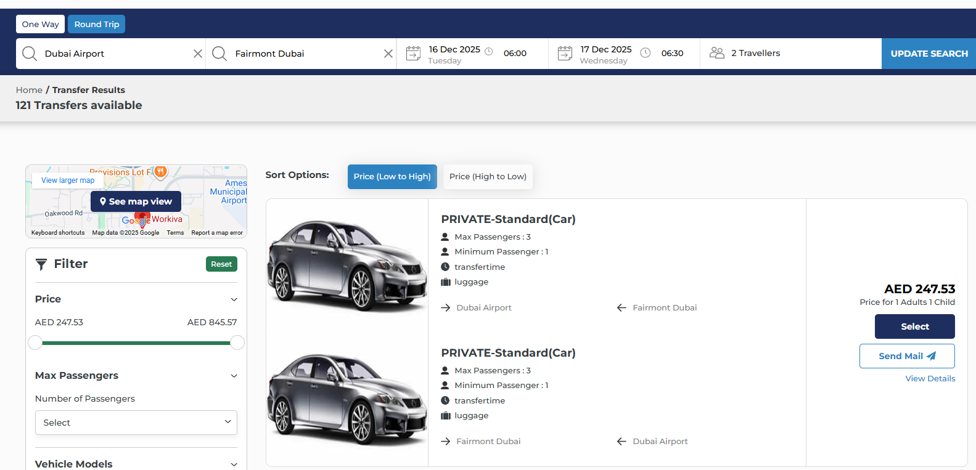

After clicking the search button, you're redirected to the transfer results page where all available vehicles matching your criteria are displayed.

The page shows " Transfers available" at the top, indicating the total number of options found for your route and dates.

A compact search summary bar remains at the top of the page, displaying your selected pickup location , drop-off location , travel dates , pickup times , and passenger count , with an "UPDATE SEARCH" button in blue on the right allowing you to modify your search criteria without going back to the search page.

- UPDATE SEARCH

The update search panel at the top of the results page, providing quick access to modify your transfer search without navigating back to the home page.

Trip Type Selection: The panel begins with "One Way" and "Round Trip" toggle buttons on the left, with "Round Trip" currently highlighted in blue to indicate the active selection, allowing you to quickly switch between trip types if needed.

Pick Up Location: The first search field displays "pick up location" with a search icon on the left and an "X" clear button on the right, enabling you to click and modify your pickup point by typing a new location or selecting from the dropdown suggestions.

Drop Off Location: Next to the pickup field, "drop off location" is shown with the same search and clear functionality, allowing you to change your destination with a single click.

Onward Date and Time: The outbound journey details displayed below in lighter text, accompanied by a calendar icon, and the time with a clock icon, both fields clickable to open their respective date and time pickers for easy modification.

Return Date and Time: Since Round Trip is selected, the return journey information with a calendar icon, and pickup time with a clock icon, mirroring the format of the onward fields.

Passengers: The field shows " Travellers counts " with a person icon, and clicking it opens the traveller selection panel where you can adjust the number of adults and children traveling.
UPDATE SEARCH Button: A button on the far right allows you to apply any changes you've made to your search criteria, refreshing the results page to show transfers matching your updated requirements without losing your place or having to start the search process from scratch.

- View Map

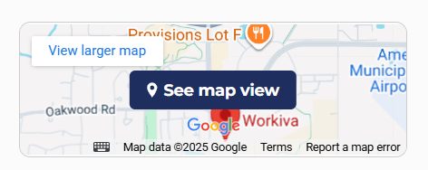

The Map View feature provides a visual representation of your transfer route, helping you understand the geographical location of your pickup and drop-off points.

See map view Button:

"See map view" appears on the map thumbnail, which opens the full interactive map overlay when clicked.

Interactive Map Overlay:

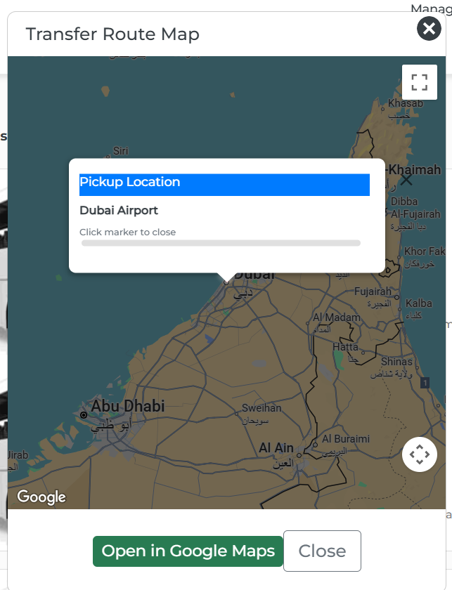
When you click "See map view", a large overlay window opens displaying the complete transfer route map with your pickup location clearly marked with a location pin.

The map shows the geographical area between your selected locations, including nearby landmarks, roads, and place names for better orientation.

A white popup box appears on the map showing "Pickup Location" as the header , followed by the specific location name (e.g., "Dubai Airport") and a "Click marker to close" instruction below.

Map Controls: You can interact with the map by zooming in or out using your mouse scroll wheel or pinch gestures on mobile devices, and drag to pan around and explore the surrounding area.

Open in Google Maps: "Open in Google Maps" button at the bottom of the overlay allows you to launch the route in the full Google Maps application for turn-by-turn navigation or additional features, while a "Close" button next to it dismisses the map overlay and returns you to the transfer results page.

- Sort Options



The Sort Options feature, on the results page, allows you to organize the available transfer vehicles according to your pricing preference.

This section displays two sorting buttons:

"Price (Low to High)" and "Price (High to Low)", with the currently active sorting option highlighted in blue.

By default, the results are sorted by "Price (Low to High)" to show the most economical options first, but you can click "Price (High to Low)" to view premium or higher-priced vehicles at the top of the list, making it easy to find transfers that match your budget or quality preferences.

- Filter

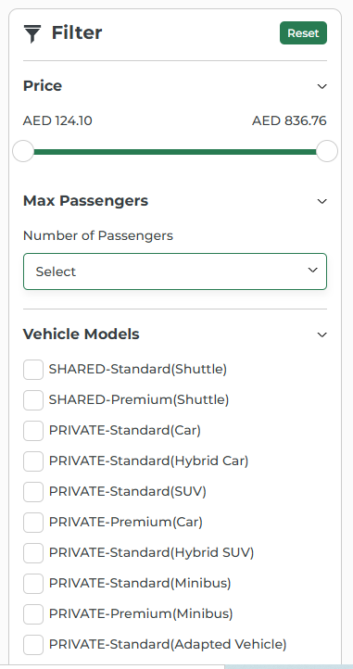
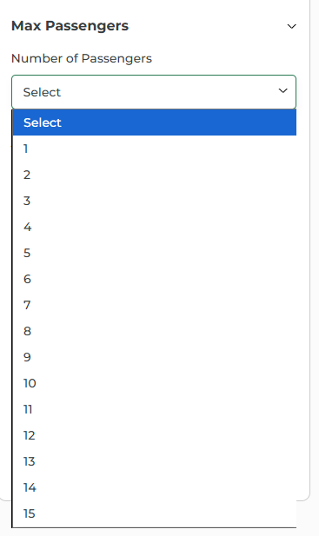
The Filter panel, located on the left side of the results page , helps you narrow down your transfer options to find the perfect vehicle that meets your specific requirements.

At the top of the panel, a "Filter" heading is displayed alongside a "Reset" button on the right, which clears all applied filters and returns the results to their default state.

Price Filter:

The Price section at the top of the filter panel features a dual-handle slider that allows you to set your preferred price range for transfers.

The minimum price (e.g., "AED 124.10") is displayed on the left and the maximum price (e.g., "AED 836.76") on the right, and you can drag either handle to adjust your budget range, with the results automatically updating to show only vehicles within your selected price bracket.

Max Passengers:

Below the price filter, the Max Passengers dropdown allows you to filter vehicles based on their seating capacity. When you click the "Select" field with the dropdown arrow, a scrollable list appears showing passenger count options from 1 to 15 , with the currently selected value , ensuring you only see vehicles that can accommodate your entire group comfortably.

Vehicle Models:

The Vehicle Models section displays a comprehensive list of vehicle categories with checkboxes, allowing you to filter by specific vehicle types such as "SHARED-Standard(Shuttle)", "SHARED-Premium(Shuttle)", "PRIVATE-Standard(Car)" etc.

You can select multiple vehicle types by clicking their respective checkboxes, and the results page will immediately update to show only the vehicles matching your selected categories, whether you're looking for shared shuttles for budget-friendly travel or private premium options.

- Transfer Vehicle Results

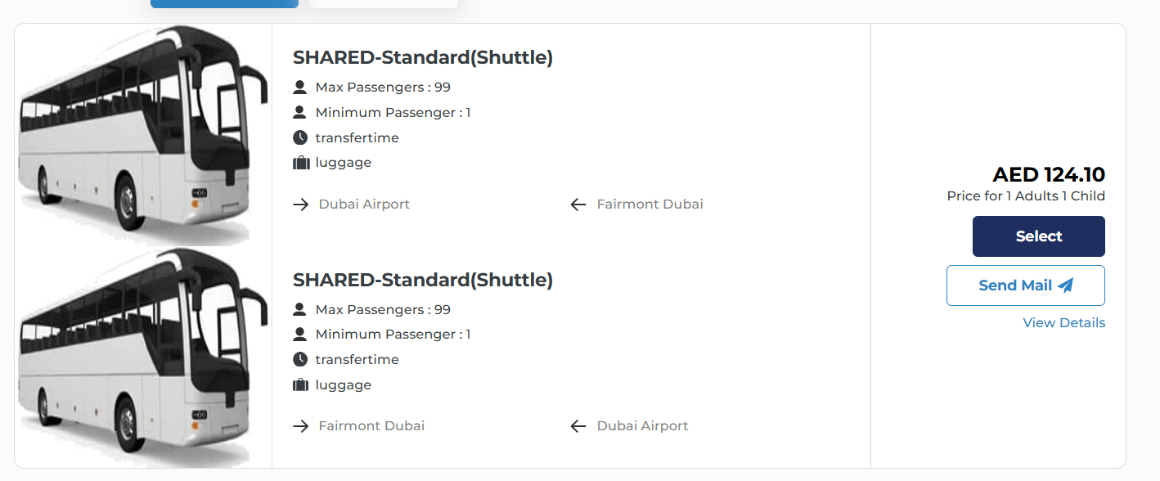

Each transfer option is presented as a comprehensive card displaying all essential information needed to make your booking decision.

On the left side of each card, a photo shows the actual vehicle you'll be traveling in
Above the image, the vehicle category is clearly labeled, for example "SHARED-Standard(Shuttle)" indicating this is a shared shuttle service where you'll travel with other passengers, or "PRIVATE-Standard(Car)" for exclusive private transportation.

Max Passengers: shows the maximum number of travelers the vehicle can accommodate
helping you confirm the vehicle fits your group size.

Minimum Passenger: This indicates the minimum number of passengers required to book the transfer, typically "1" meaning solo travelers can book, though some shared services might require minimum group sizes.

Transfer time: provides estimated journey duration information so you can plan your schedule accordingly and know how long you'll be traveling between your pickup and drop-off locations.

luggage: Indicates the baggage capacity or allowance for the vehicle

The card shows your complete journey route with directional arrows for easy visualization. For the outbound journey, a right-pointing arrow (→) precedes your pickup location (such as "Dubai Airport"), while a left-pointing arrow (←) shows your drop-off destination (like "Fairmont Dubai"). For round-trip bookings, a second vehicle card appears below showing the return journey with the locations reversed—the arrow points right (→) from your hotel (Fairmont Dubai) and left (←) back to the airport (Dubai Airport).

Price Display: The total cost is shown on the right side, such as "AED 124.10", making it easy to compare prices across different vehicles at a glance.

Price Breakdown: Below the price,"Price for 1 Adults 1 Child" (or your specific passenger configuration), confirming this is the total cost for your entire group, not a per-person rate, eliminating any confusion about the final amount.

Select Button: "Select" allows you to choose this vehicle and proceed directly to the booking and passenger details page where you'll enter traveler information and complete payment.

Send Mail Button: "Send Mail" lets you email this transfer option to yourself or others, useful for sharing options with travel companions or saving for later review.

View Details Link: opens a detailed popup window containing comprehensive information about the transfer service, including pickup instructions, cancellation policies, terms and conditions, and any special notes about the service.

- Passenger Details page:

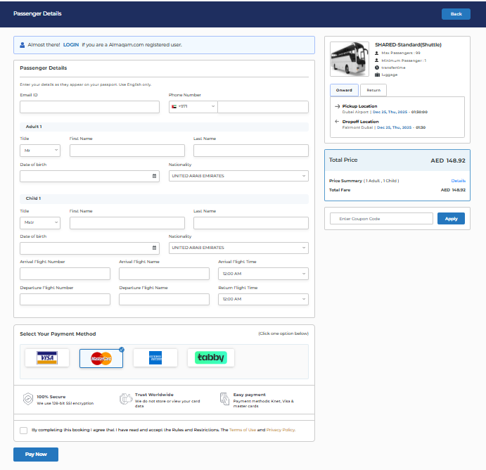

After selecting your preferred vehicle from the results page and clicking the "Select" button, you're directed to the passenger details page where you'll provide traveler information and complete your booking payment.

This page is divided into several sections including passenger information forms, booking summary, and secure payment options to finalize your transfer reservation.

At the very top of the page, "Passenger Details" on the left side, indicating the current step in your booking process, with a "Back" button on the right allowing you to return to the results page if you need to choose a different vehicle or modify your search.
LOGIN if you are a registered user," encouraging existing customers to sign in to their accounts.
Logging in can speed up the booking process by auto-filling your saved passenger details,though you can also proceed as a guest without creating an account.

Passenger Details Section :

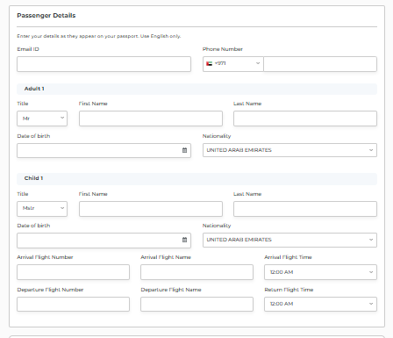

This form collects all necessary information about the travelers for your transfer booking, with clear labels and organized fields making it easy to complete.

The section begins with "Passenger Details" as the title, followed by a helpful note "Enter your details as they appear on your passport. Use English only," ensuring accuracy for travel documentation and international bookings.

Email ID: A text field where you enter your email address to receive booking confirmations, e-tickets, and any updates about your transfer.

Phone Number: Split into two fields with a country code dropdown (showing "+971" for UAE in the example) and a number field, allowing the transfer provider to contact you on travel day for pickup coordination or any schedule changes.

Adult 1 (Primary Passenger) :

The form requires detailed information for the first adult traveler who serves as the booking contact and primary passenger.

Title: A dropdown menu with options like "Mr," "Mrs," "Ms," or other titles to select the appropriate prefix for the passenger's name.

First Name: Text field for entering the passenger's given name exactly as it appears on their passport or identification document.

Last Name: Text field for the passenger's surname or family name, again matching official documents.

Date of Birth: A date picker field with a calendar icon allowing you to select the passenger's birth date, which may be required for age verification.

Nationality: A dropdown menu displaying "UNITED ARAB EMIRATES" in the example, where you select the passenger's country of citizenship, important for visa requirements and international transfer regulations.

Child 1 (Additional Passenger) :

Since the booking includes 1 child , a second passenger form appears with the same field structure as Adult 1.

Title: Dropdown for the child's title, typically "Mas" (Master) or "Miss" depending on gender.

First Name and Last Name: Text fields for the child's full name as it appears on their travel documents or birth certificate.

Date of Birth: Calendar picker to enter the child's exact birth date, crucial for determining age-appropriate services like car seats, booster seats.

Nationality: Dropdown to select the child's citizenship, matching the nationality shown on their passport or travel documents.

Flight Information Fields :

For airport transfers, additional fields collect your flight details to ensure timely pickup coordination and driver scheduling.

Arrival Flight Number: Text field where you enter your inbound flight number (e.g., "EK203"), allowing the transfer provider to track your flight's real-time status and adjust pickup timing if your arrival is delayed or early.

Arrival Flight Name: Field for the airline name operating your arrival flight, providing additional confirmation of your travel details.

Arrival Flight Time: Dropdown menu showing times like "12:00 AM" where you select your scheduled flight arrival time, helping the driver coordinate the best pickup time accounting for customs, baggage claim, and immigration processing.

Departure Flight Number: For return transfers, enter your outbound flight number so the driver can ensure you arrive at the airport with adequate time before departure.

Departure Flight Name: The airline operating your departure flight, completing the round-trip flight information.

Return Flight Time: Dropdown to select your departure flight time (e.g., "12:00 AM"), allowing the provider to calculate the optimal pickup time from your hotel considering airport distance, traffic patterns, and recommended check-in times.

Booking Summary Panel :

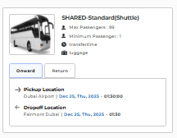
A summary box on the right side keeps all your transfer details visible while you complete the form.

Vehicle Information: The panel displays your selected vehicle type "SHARED-Standard(Shuttle)" with the vehicle image, confirming which transfer you're booking.

Capacity Details: Shows "Max Passengers: 99" , "Minimum Passenger: 1" confirming booking requirements, "transfertime" for journey duration, and "luggage" for baggage information.

Journey Type Tabs: Two tabs labeled "Onward" and "Return" allow you to switch between viewing your outbound and inbound journey details in the summary.

Route Information:

Pickup Location: Shows "pickup location" with an arrow, displaying exactly where and when your outbound transfer begins

Dropoff Location: Displays "drop off location" with an arrow, showing your destination and estimated arrival time

Total Price Display :

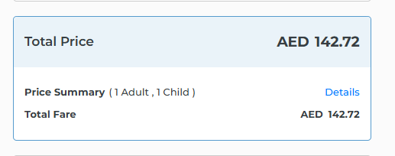

Total Price:The final amount you'll pay for your complete round-trip transfer.

Price Summary: section showing "| 1 Adult, 1 Child |" confirming your passenger breakdown, with a "Details" link to expand and view the itemized cost breakdown for each journey leg
Total Fare: Repeats "AED 148.92" below for confirmation and easy reference while entering payment information.

Coupon Code Section:

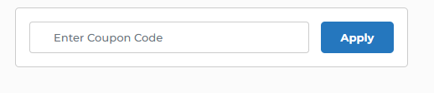

“Enter Coupon Code" field with a "Apply" button allows you to input promotional codes or discount vouchers to reduce your total price before payment.

Payment Method Selection :

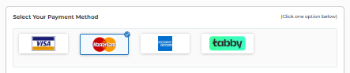

The payment section offers multiple secure options for completing your booking, clearly labeled "Select Your Payment Method" with a note "[click one option below]" guiding you to choose.

Terms and Conditions :

A checkbox with accompanying text states "By completing this booking I agree that I have read and accept the Rules and Restrictions, the Terms of Use and Privacy Policy," with the terms linked for review. This mandatory agreement ensures you understand and consent to the booking conditions, cancellation policies, and data handling practices before finalizing payment.

Pay Now Button :



At the bottom of the page, "Pay Now" button becoming active only after all required fields are filled and the terms checkbox is selected.

Clicking this button processes your payment through the selected payment gateway and confirms your transfer booking, after which you'll receive email confirmation with your e-ticket.

- Transfer Voucher

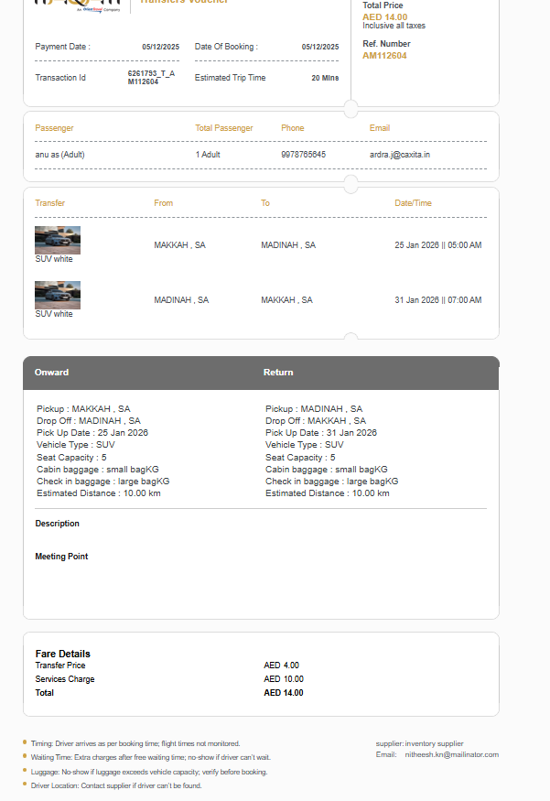

After successful payment, a transfer voucher is automatically generated and sent to your registered email address, serving as your official booking confirmation and travel document.

Booking Information:

The top section contains essential booking details including Payment Date showing when payment was processed, Date of Booking, confirming reservation date, and Estimated Trip Time indicating journey duration between locations.

On the right side, Total Price displayed with a note "Inclusive all taxes" confirming the final amount paid, while Ref. Number shows the unique booking reference "AMI112587" used for tracking and customer service inquiries.

Passenger Information: The passenger section lists all travelers with columns for Name, Total Passenger count , Phone number, and Email , ensuring the driver can identify and contact passengers on travel day.

Transfer Details: The main transfer card displays the service provider with their logo icon ,showing From location and To location with the journey Date/Time listed indicating exact pickup timing.

onward journey section confirms the pickup and drop-off points, along with the pickup date, vehicle type, seat capacity, cabin baggage allowance, check-in baggage limit, and the estimated travel distance for the trip.

The description highlights that CheapFlights is a trusted travel partner offering a comprehensive search engine for flights, hotels, and car rentals, encouraging users to rely on the platform for travel planning.

Meeting point section reminds passengers to be on time at the designated pickup location.

Fare details indicate a clear and transparent transfer price with no hidden charges.

Important notes mention that timings follow booking limits with non-motorized flights, waiting time charges may apply, daily driver cancellation limits are in place, luggage exceeding the vehicle capacity must be confirmed before booking, and driver location can be obtained by contacting the supplier. The supplier name and email are provided for direct communication.

Booking Actions

- Reconfirmed

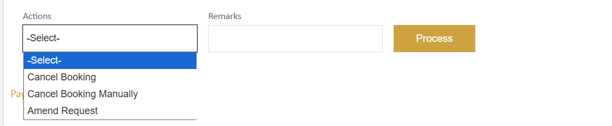

After a transfer booking is confirmed,in the admin portal's TQR (Travel Query Request) section,They have access to various booking management actions through a dropdown menu to handle post-booking modifications and cancellations.

Cancel Booking:
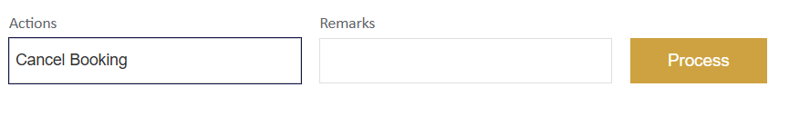
This action is for cancel the GDS PNR ONLINE.

Cancel Booking Manually:
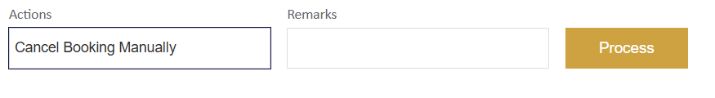
This action is to change the status of the transaction to Cancelled.
Its an OFFLINE process.
we can use this action to manually change the status of that transaction to cancelled. You have to CANCEL the PNR from the terminal screen.

Amend Request:
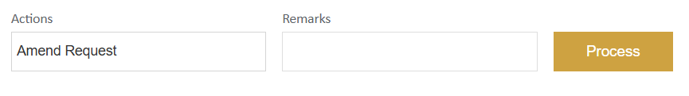
for making modifications to existing booking details such as passenger information, pickup times, or vehicle changes without creating a new reservation.

- Booking failed

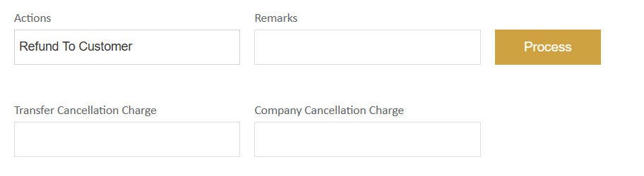
When a payment transaction is successfully processed but the transfer booking fails, administrators can initiate a customer refund through a dedicated action panel in the admin portal.

Refunded To Customer : customer payment was debited but no valid booking was created, requiring immediate refund processing to return funds to the customer.

- Payment initiated

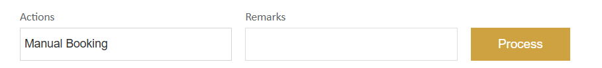

When a customer initiates payment but the booking process is interrupted or incomplete, resulting in a "Payment Initiated" status without final confirmation, administrators can manually complete the booking through the manual booking action to ensure the customer receives their reserved transfer service.

Manual Booking: specifically used for bookings that are stuck in intermediate stages where payment has been initiated but the reservation was not automatically confirmed due to payment gateway timeouts, browser closures, or network interruptions during the checkout process.

