Static Package Module
Search-to-Ticketing Workflow Documentation

Summary
The Static Package Module provides ready made travel packages with fixed itineraries. Users can quickly search, view details, and book complete packages that already include flights, hotels, transfers, and activities at a fixed price

- SearchFlow
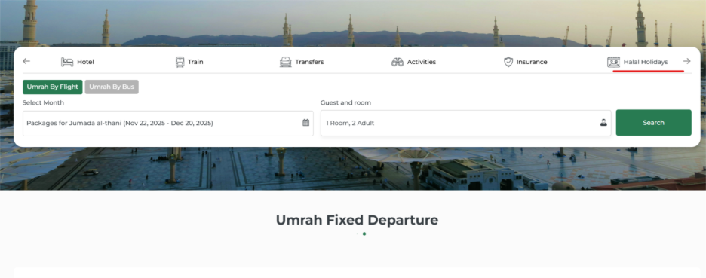
When the user navigates to the Static Package section from the homepage, a search bar is displayed at the top of the page. The search bar contains three main input fields, which allow the user to filter and search for available holiday packages.

Field 1: Where to? (Destination)

The “Where to?” field allows the user to enter or select the travel destination. As the user types, the system should show destination suggestions based on available static packages. The user can type manually or choose a suggested option. Examples include Makkah, Madinah, or any configured package destination.

2: Select Month (Travel Date)

The “Select Month” field allows the user to choose the intended travel month. The field opens a month-picker dropdown showing only the months for which packages are available. The user selects the preferred departure month, and the chosen month is displayed in the field.

3: All adventure (Package Category)
The “Package Category” field allows the user to filter packages based on category type. A people/group icon is displayed to represent category selection. The field functions as a dropdown selector listing all available package categories.

Search Button
The “Search” button is displayed as a green action button positioned on the right side of the search bar. When the user clicks this button, it triggers the search query based on the values entered in the destination, travel month, and package category fields. The system should then display the list of matching static packages.

2.Package Selection → Package Details Page
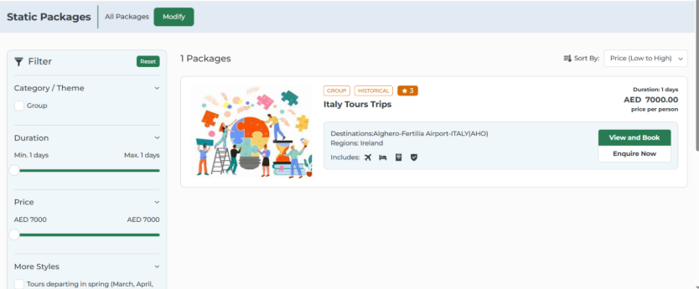
The “All Packages” tab displays the results based on the user’s search inputs. It shows all available packages that match the selected destination, travel month, and category criteria.

Modify Button
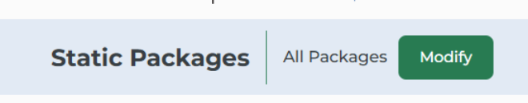
The “Modify” button is displayed as a green action button that allows the user to change or adjust the previously selected search criteria. When clicked, it reopens the search fields for editing without resetting the user’s current selections

Filters Section
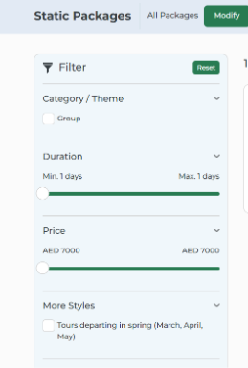

The Filters section enables the user to refine the displayed package results. At the top of the panel, a filter icon is shown along with a “Reset” control that clears any applied filters. The Category or Theme filter provides a set of checkbox options, allowing the user to select categories such as Group, Historical, or any other available package themes. A duration slider is provided to allow the user to specify the minimum and maximum number of travel days, thereby narrowing the results based on trip length. Additionally, a price range slider is displayed, showing values in the user’s selected currency, and allows the user to set the minimum and maximum price limits for the package search.

Results Section

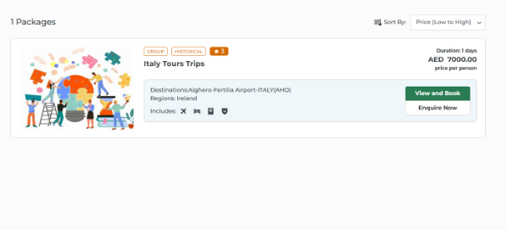

The Results section presents the list of packages matching the user’s search parameters. The system displays the total number of available packages at the top of the results area. A sorting control is provided, allowing the user to reorder the results by price, duration, or rating. Each result is rendered as a package card containing all relevant package information. The card includes the package image, associated category labels, star rating, package title, trip duration, per-person price, destination, and region. The card also displays icons representing the services included within the package, such as flight, hotel, transfers, and insurance. Each card provides two action options: one to view the package details and proceed with booking, and another to submit an enquiry for the selected package.

Package Selection

The Package Selection module allows the user to refine and interact with search results. Users can filter packages by category, duration, price range, and style preferences, with a reset option to clear all filters. Packages can also be sorted by price, duration, or rating. Applied filters and sorting preferences dynamically update the displayed results to help users find relevant packages efficiently.

View and Book
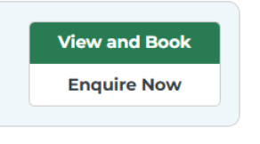

The “View and Book” action allows the user to navigate from the search results to the selected package details page. This page provides comprehensive package information and enables the user to proceed with booking.

Enquire Now
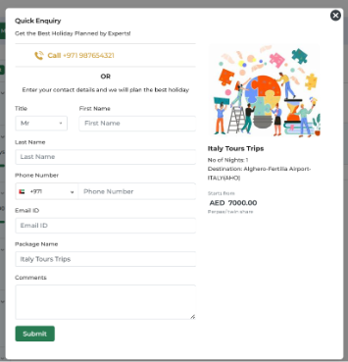

The “Enquire Now” action opens a modal window containing an enquiry form when clicked on a package card. The form captures user information including Title (Mr./Mrs./Ms.), First Name, Last Name, Phone Number with country code, Email ID, Package Name (auto-filled, read-only), Nationality, Country of Residence (optional), Date of Travel (optional), Number of Passengers, and Comments (optional). The Submit button validates required fields, submits the form, displays a success message, and sends a confirmation email. The Close (X) button allows the user to exit the modal without submitting the form.

Package Details Page
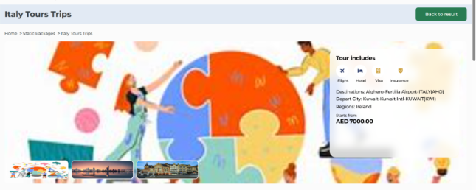

When the user clicks “View and Book”, they are directed to the package details page, which provides comprehensive information about the selected package. The page header displays the package title, a breadcrumb navigation (Home > Static Packages > [Package Name]), and a Back to Results button at the top right to return to the search results.
The page opens with a large hero banner image of the destination, accompanied by clickable thumbnail images for additional views. Key package highlights are displayed prominently.
The page opens with a large hero banner image of the destination, accompanied by clickable thumbnail images for additional views. Key package highlights are displayed prominently. The Tour Includes section uses visual icons to indicate included services such as flights, accommodation, visa assistance, and travel insurance.

Package Overview and Highlights
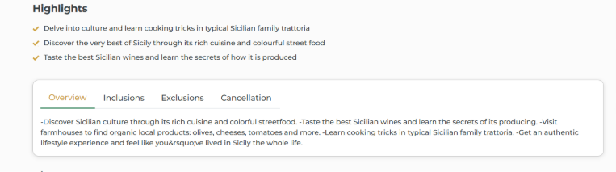
The Package Overview section provides a detailed introduction to the selected package. A prominent hero banner image displays the destination, supported by smaller clickable thumbnails for additional photos. Key package highlights are shown below the images, summarizing the unique experiences and features of the trip. This section allows the user to quickly understand the main attractions and activities included in the package.

Overview Tabs
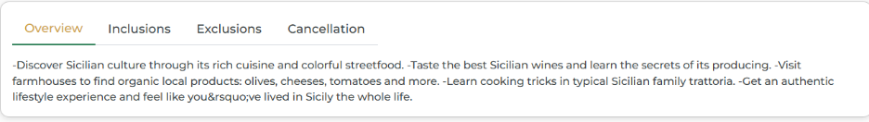
The package details page includes an Overview tab with additional sections such as Inclusions, Exclusions, and Cancellation. The Overview tab displays detailed descriptive content about the package, including cultural experiences, culinary activities, and other notable highlights. Inclusions and exclusions clearly indicate what services or experiences are covered or not covered in the package. The Cancellation tab provides the policy details for easy reference.

Itinerary Section

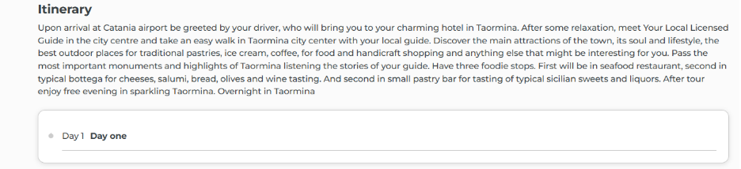
The Itinerary section outlines the day-wise schedule of the package. Each day provides a detailed description of planned activities, attractions, and meals. This includes arrival procedures, local sightseeing, cultural or culinary experiences, and any special highlights. Users can expand or collapse each day to view details efficiently. The itinerary is intended to give users a clear understanding of the trip flow and daily experiences.
Booking
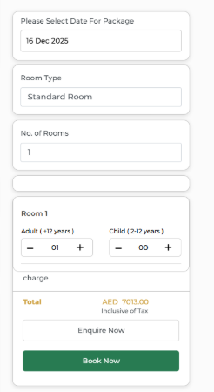

The booking sidebar allows the user to plan their package and initiate booking. Users can select the travel date, room type, number of rooms, and passenger details (adults and children). The sidebar dynamically calculates the total package cost in the selected currency. Action buttons include Enquire Now to submit an enquiry form, and Book Now to proceed with the booking. The sidebar ensures all critical booking parameters are captured before finalizing the reservation.

3.Passenger Details Page
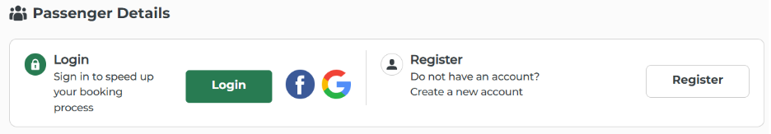
The Passenger Details page collects traveler information needed to complete the booking. After selecting package dates and room preferences, users land on this page to enter personal and travel document details.

User Authentication Section
The authentication section offers two options for users before they fill out the passenger form.
The left side contains a Login option. The heading reads "Login" with supporting text "Sign in to speed up your booking process" below it. A green "Login" button is provided, along with Facebook and Google icons for social login alternatives. This option benefits returning customers who have previously saved their information in the system.
The right side presents a Register option. The heading states "Register" with text underneath saying "Do not have an account? Create a new account". A white "Register" button with a border completes this section. New users can create an account here to store their details for future bookings.
Users have three choices: login with existing credentials, register a new account, or skip this section entirely and proceed as a guest to fill the form manually.

Fare Details
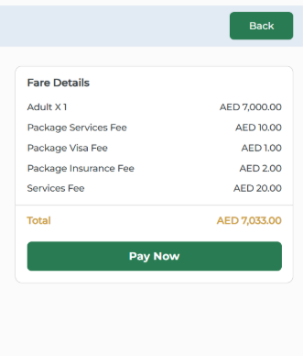
The Fare Details section displays a clear breakdown of all charges included in the selected static package, such as adult fare, visa fee, insurance fee, service fees, and any additional applicable costs. All values are dynamically fetched based on the user’s selected package and traveler details. The total payable amount is calculated and highlighted for user clarity. Below the fare summary, the Pay Now button allows the user to proceed to the payment gateway after validating all mandatory fields, while the Back button lets users return to the previous page without losing their entered information.

Standard Room Section
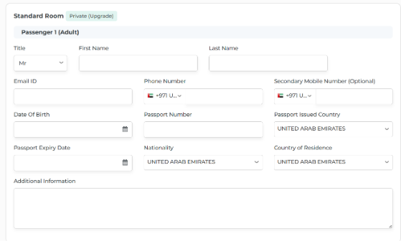

The Standard Room section displays the default room type selected for the package, along with any available upgrade options. It helps the user clearly understand the room category included in their booking before entering passenger information. This section ensures clarity on accommodation details before proceeding with traveler data entry.
Payment Method
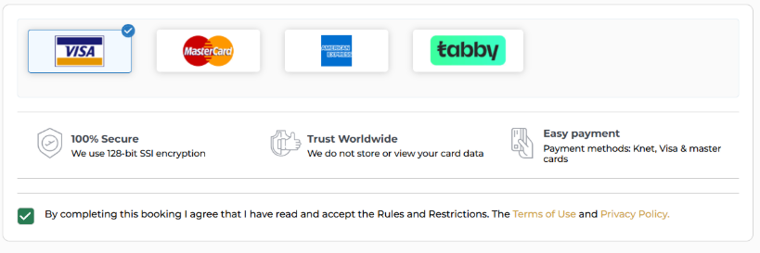
Choose Payment Method:
• Users can select one of the available payment options such as Visa, MasterCard, American Express, or Tabby.
• The selected payment method is highlighted for clear identification.
Terms & Conditions:
• A mandatory checkbox is provided for users to confirm that they have read and accepted the Terms & Conditions and Privacy Policy.
• The booking process cannot proceed unless this checkbox is checked.
Pay Now Button:
• Once all required details are completed, clicking the Pay Now button redirects the user to the secure payment processing page.
• This serves as the final step to complete the package booking.

4.Hotel Booking Voucher
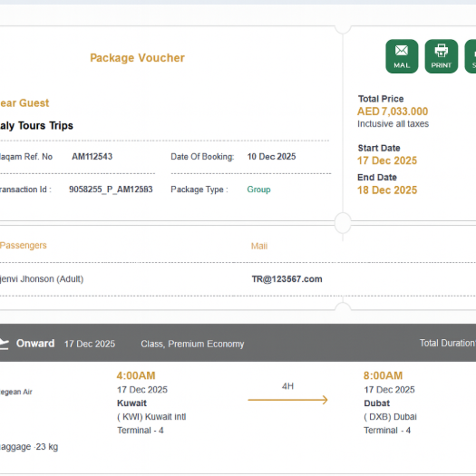
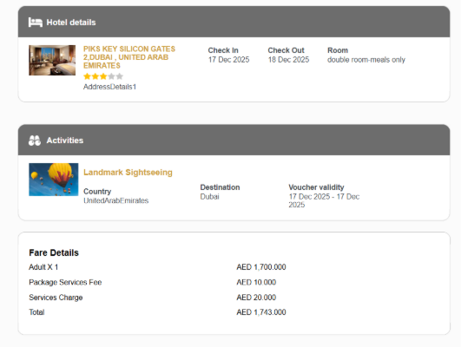

After the customer completes the payment, the system generates a Static Package Voucher. This voucher acts as the official confirmation of the entire package booking, including flights, hotel stay, activities, and fare information. The voucher is downloadable, printable, and shareable, ensuring customers can easily access it at any time

Voucher Header
• Displays the voucher title, and quick-action buttons such as Mail, Print, and Save.
• Shows key booking information including Total Price, Booking Date, Start Date, and End Date of the trip.
• Provides essential references Ref. Number, Transaction ID, and Package Type for easy tracking and verification.

Guest & Package Details
• Includes a greeting and the Package Name
Displays details such as package type (e.g., Group), booking date, and internal booking identifiers.
• Helps users verify they are viewing the correct package information.
Passenger Information
• Lists the names of all passengers included in the booking.
• Displays each passenger’s registered email ID or contact information.
• Ensures correct traveler details are recorded for the trip.
Hotel Details Section

Displays the booked hotel’s:

Image

Name

Star rating

Shows the Check-in and Check-out dates.

Displays room category and occupancy type (e.g., Double Room, Room Only).

Indicates the total number of nights included.

Transfer Details
Transfer details show how the traveler will be transported between important points during the trip. These transfers are already included in the package and cannot be changed. It normally covers:

Airport → Hotel transfer on arrival

Hotel → Airport transfer on departure

Inter-city or inter-hotel transfers if the itinerary includes multiple cities

Activity pick-up and drop-off transfers, if provided by the package

Activities

Lists all included activities :

Activity title

Destination

Activity country

Voucher validity dates

Price Summary
• Displays the total amount paid, inclusive of all taxes.
• Ensures the user has a clear confirmation of the final price charged.

Important Notes
• May include instructions or guidelines for using the voucher during travel.
• Helps travelers and service providers verify booking details smoothly.

5.ADMIN TQR ( Transaction Queue Report )
This admin page allows backend users to view, verify, and manage complete hotel booking information. The TQR ensures that all booking, guest, hotel, and room details are correctly displayed and editable where required
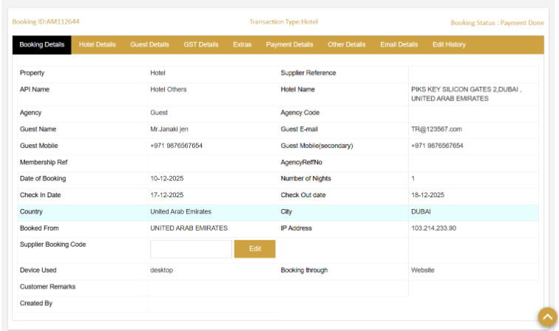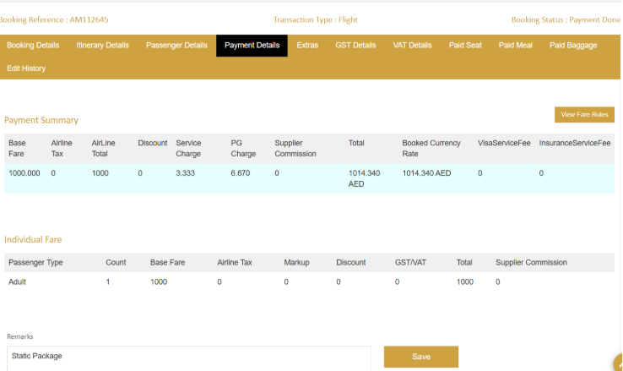

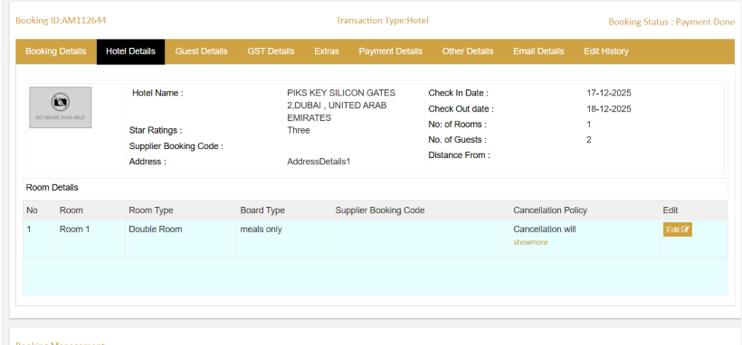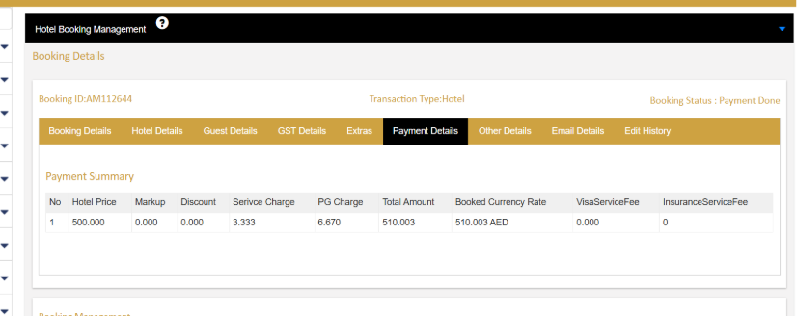

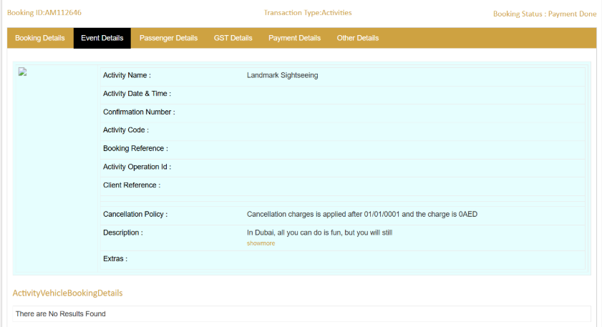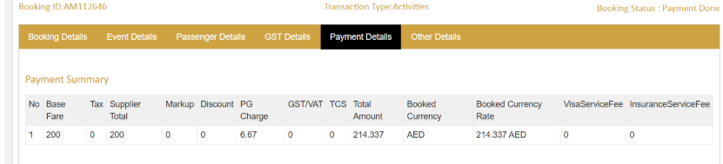

Booking Actions
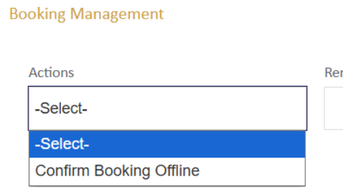

Confirm Booking Offline – Used to manually confirm a booking when payment has been ini ated but not completed online

