FLIGHT MODULE DOCUMENTATION

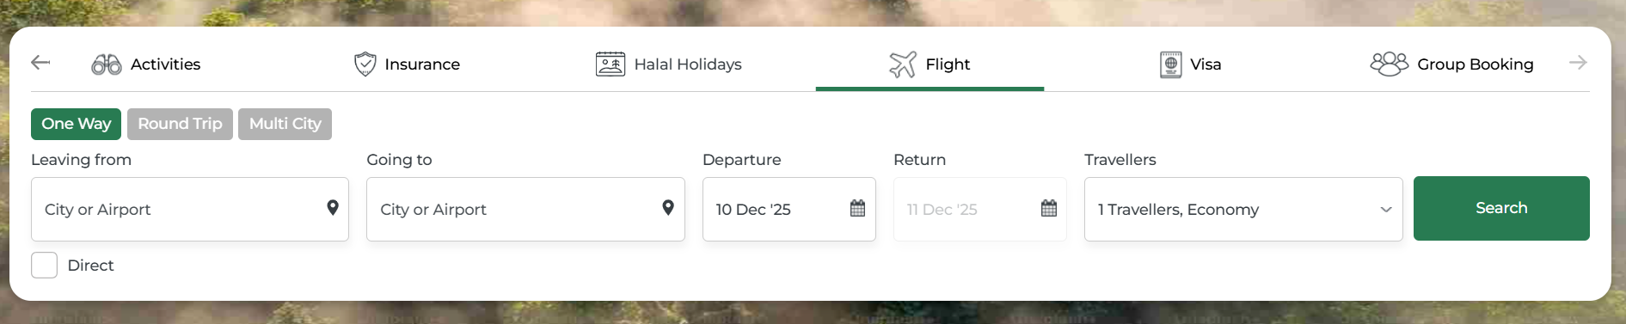

Search Page:

The flight search page serves as the primary interface for users to find and book suitable flights based on their travel requirements. It offers an intuitive and user-friendly design that allows users to quickly enter essential details such as departure location, destination, travel dates, number of travelers, cabin class, and trip type (One Way, Round Trip, or Multi City).

The purpose of this page is to simplify the flight booking process by providing location suggestions, real-time search filters, and smooth navigation to the results page. By entering the required information and selecting their preferred options, users can view available flight options matching their preferences and proceed further with booking.

- Journey Types:



One Way :

- This option is perfect for travelers who need a flight in only one direction.
- When you select "One Way," you'll book a single flight from your departure city to your destination without a return journey.
- With One Way selected, you only need to enter your departure location, destination, and travel date. The system will show available flights for that specific route without requiring return information.

Round Trip :



- This is the most commonly used option for travelers who know both their departure and return dates.
- When you select "Round Trip," you'll book both your outgoing and return flights together in a single reservation.

Multi City:



- This option is designed for travelers who want to visit multiple destinations in a single trip.
- Instead of flying back to your starting point after each leg, Multi City allows you to create a custom itinerary connecting several cities in one booking.
- Perfect for:

Visiting several cities across different countries on one vacation (like flying from Dubai to Paris, then Paris to London, and finally London back to Dubai)

When you select "Multi City," the interface allows you to add multiple flight segments with different departure and arrival cities for each leg. This option often provides better value than booking separate tickets for each journey, while keeping your entire itinerary organized in one place.

- Leaving From:

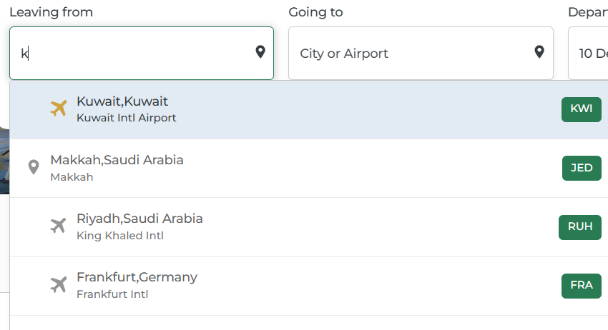

- This is a text-based search field where users can enter either:

- The name of a city (e.g., "Kuwait", "Dubai", "London")
- The name of an airport (e.g., "Kuwait Intl Airport")
- An airport code (e.g., "KWI", "DXB", "LHR")

- As the user types, the system displays auto-suggestions based on the entered text. These suggestions include:

- City names with their corresponding countries
- Airport names with full details
- Airport codes displayed as badges (e.g., "KWI", "DXB")

Each suggestion shows a plane icon, the location name, and additional details such as the full airport name. This auto complete functionality helps users quickly select their departure location without typing the complete name, ensuring accuracy and saving time.

- Going To :

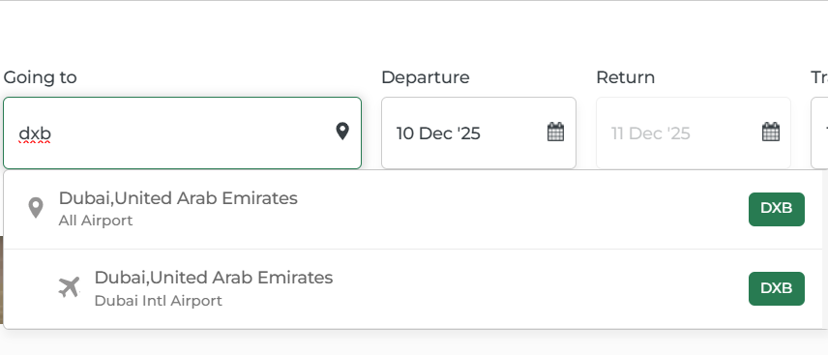

- This is a text-based search field where users can enter either:

- The name of a destination city
- The name of an airport
- An airport code

Similar to the "Leaving from" field, as the user types, the system provides intelligent auto-suggestions that match the entered text. The suggestions display:
Destination city and country information
Complete airport names

- Departure & Return :

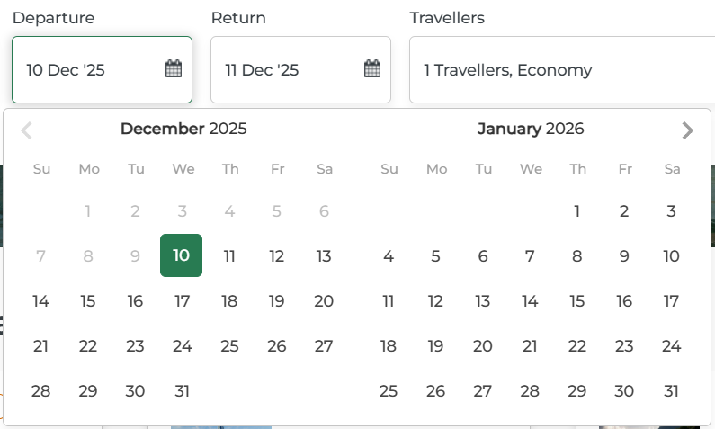

Departure :

- This is a date selection field where users choose when they want to begin their journey. When you click on this field, an interactive calendar opens up showing two months side by side for easy browsing.
- The calendar displays:

- The current month and the following month together, making it simple to plan trips that span across month boundaries
- The current date (today) is typically marked or highlighted so you always know where you are in the calendar

- You can navigate through different months using the arrow buttons on either side of the month names.
- The calendar is designed to prevent you from selecting dates in the past, ensuring you only book flights for future travel.

Return :

- This field appears when you've selected "Round Trip" as your trip type. It allows you to choose the date when you want to fly back to your starting location.
- The return date picker works seamlessly with your departure selection:

- Once you select a departure date, the system automatically ensures you can only choose return dates that come after your departure
- When the calendar opens, your departure date remains highlighted so you can easily see it while selecting your return date

- Travellers :

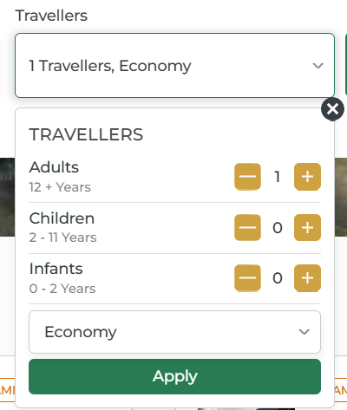

- This is a dropdown field that displays your current passenger selection, showing the total number of travelers and the selected cabin class (e.g., "1 Travellers, Economy").
- Maximum passenger limit is 9.

Passenger Count Selection:

- The travellers panel is divided into three age categories, each with simple plus (+) and minus (-) buttons to adjust the count

Adults :

Age: 12+ Years

This category is for passengers aged 12 years and above. Every flight booking must include at least one adult traveler.
Use the plus and minus buttons to increase or decrease the number of adult passengers traveling with you.
- Minimum 1 passenger needed.

Children :

Age: 2 - 11 Years

This category is for young travelers between 2 and 11 years old. Children in this age group typically require their own seat on the aircraft and may qualify for discounted fares.
Adjust the count using the buttons to match the number of children traveling with you.

Infants :

Age: 0 - 2 Years

This category is for the youngest travelers, babies under 2 years old. Infants usually don't require a separate seat and often travel on an adult's lap .
- “Infant count should be equal or less than Adult count”

Cabin Class Selection :

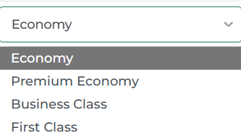

- Below the passenger counts, you'll find a dropdown menu to select your preferred cabin class:

- Economy - Standard seating with essential services
- Premium Economy - Extra legroom and enhanced comfort
- Business Class- Premium service with lie-flat seats on long-haul flights
- First Class - Luxury travel with the highest level of service

Apply Button :

Once you've selected the number of travelers in each category and chosen your cabin class, click the green "Apply" button to confirm your selections.
The main field will then update to show your total passenger count and chosen class (e.g., "3 Travellers, Business").

- Search Button:


This is the primary action button that initiates your flight search.
Once you've entered all the required information ,departure location, destination, travel dates, and passenger details
click save button to proceed.

- What happens when you click:

The system processes your search criteria and queries available flights
You're redirected to the flight results page showing all available options matching your requirements.

Result page :

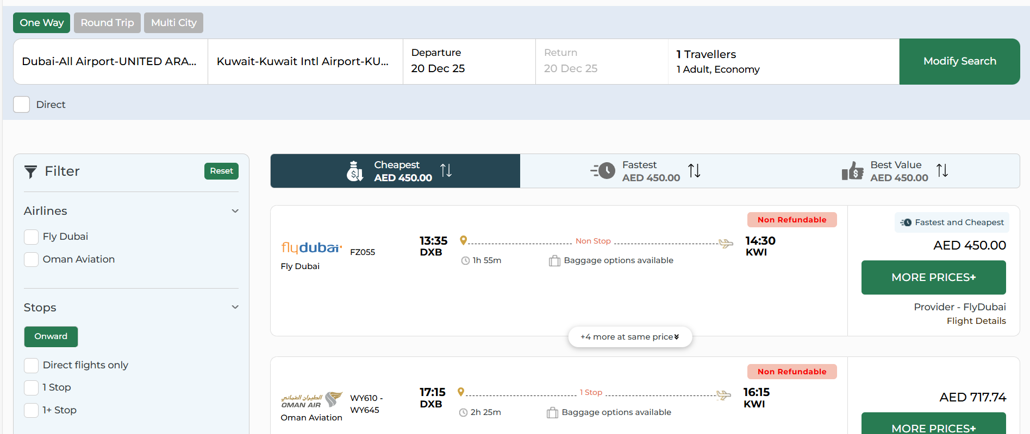

- After clicking the search button, you're taken to the flight results page where all available flights matching your criteria are displayed.

- This page helps to find the perfect flight through filtering, sorting, and detailed flight information.

- Modify Search :

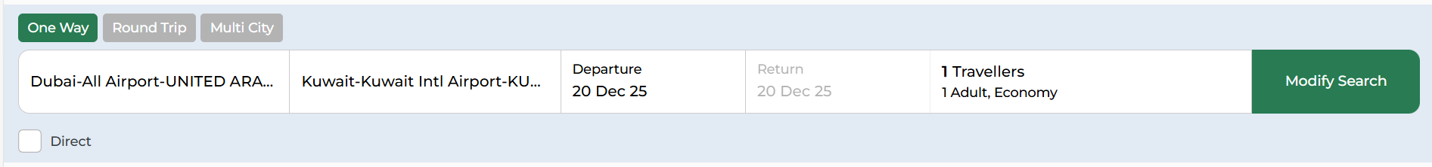

- The modify search bar remains visible at the top of the results page, allowing you to adjust your search criteria without starting over.

- After clicking modify search button any changes you make will instantly update the flight results below.

1. Journey Type Selection :

Choose between One Way, Round Trip, or Multi City options
The selected trip type is highlighted in green
Switching trip types will adjust the form fields accordingly (e.g., Round Trip shows return date, One Way hides it)

2. Departure Location

- Click the field to enter or change your departure city or airport
- Auto-suggestions appear as you type (city names, airport names, or codes)
- Shows the currently selected departure point (e.g., "Dubai-All Airport-UNITED ARAB EMIRATES")

3. Destination Location

- Click to modify your arrival city or airport
- System provides auto suggestions
- Displays the current destination (e.g., "Kuwait-Kuwait Intl Airport-KUWAIT")

4. Departure Date

- Click to open the calendar popup
- Select a new departure date if your travel plans change
- Currently selected date is displayed (e.g., "20 Dec 25")

5. Return Date

- Only visible when "Round Trip" is selected
- Opens calendar popup for date modification

6. Travellers

- Displays current passenger count and cabin class (e.g., "1 Travellers, 1 Adult, Economy")
- Click to open dropdown panel for adjusting:

- Number of adults, children, and infants
- Cabin class selection (Economy, Premium Economy, Business, First Class)
- Changes are applied when you click "Apply" in the dropdown

7. Direct Flights Checkbox

Toggle to filter results showing only non-stop flights
When checked, removes all flights with layovers from the results

8. Modify Search Button

Modify serach button that processes your updated search criteria
Refreshes the flight results instantly based on new parameters
Keeps you on the same results page and no need to navigate away
Allows quick refinement of your search for better options

- Sort Options :

Three quick-access sorting tabs help you find flights based on your priorities:
- Cheapest - Displays flights starting from the lowest price (e.g., AED 450.00), perfect for budget-conscious travelers.
- Fastest - Shows flights with the shortest total travel time, ideal when you want to reach your destination quickly
- Best Value - Balances price and convenience, offering the optimal combination of cost and travel time

- Filter Options

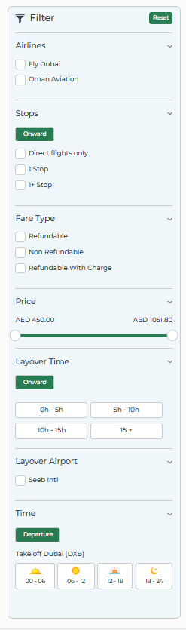

- The filter panel on the left side of the results page helps you narrow down flight options based on your specific preferences.
- Each filter can be applied independently or combined with others to find your ideal flight.

Reset Button: Green button that clears all applied filters at once, returning you to the full list of available flights

1. Airlines :
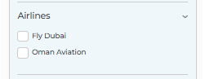
- Select specific airlines you prefer to fly with (e.g., Fly Dubai, Oman Aviation)
- Check multiple airlines to see flights from only those carriers

- Stops :
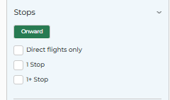
- Onward Button: Green toggle showing filters for your outbound journey
- Return (visible only for round-trip).

Direct flights only: Shows only non-stop flights with no layovers
1 Stop: Displays flights with exactly one layover during the journey
1+ Stop: Shows flights with one or more stops (multiple layovers)

- Fare Type :
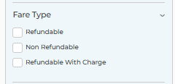
Choose based on your ticket flexibility needs:

- Refundable: Tickets that can be cancelled with a full refund
- Non Refundable: Cheaper tickets that cannot be refunded if cancelled
- Refundable With Charge: Tickets that can be refunded but with a cancellation fee

4. Price :
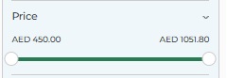
Interactive price range slider with minimum and maximum values (e.g., AED 450.00 to AED 1051.80)
Drag the slider handles to set your budget range
Results automatically update to show only flights within your selected price range

- Layover Time :
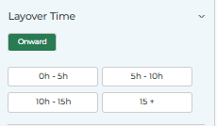
Onward Button: Indicates filters for outbound journey layover duration
Choose your preferred connection time:

0h - 5h: Short layovers for quick connections
5h - 10h: Medium-length layovers, useful for brief airport exploration
10h - 15h: Long layovers, might allow leaving the airport
15+: Extended layovers, potentially overnight connections

6. Layover Airport :
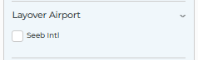
Filter flights based on which airports you'll connect through
Select specific airports you prefer or want to avoid (e.g., "Seeb Intl")
Useful for choosing convenient connection points or avoiding unfamiliar airports

- Time :
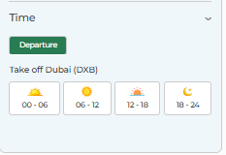
Departure Button: Green toggle showing departure time filters for the outbound flight
Take off Dubai (DXB): Shows the departure airport with time slots
Select your preferred departure time of day:

00 - 06: Early morning/red-eye flights (moon icon)
06 - 12: Morning flights (sunrise icon)
12 - 18: Afternoon flights (sun icon)
18 - 24: Evening/night flights (sunset icon)

Each time slot is represented with an icon showing the time of day, making it easy to visualize when your flight departs. This helps you choose flights that fit your schedule and preferences.

4.Flight Cards :

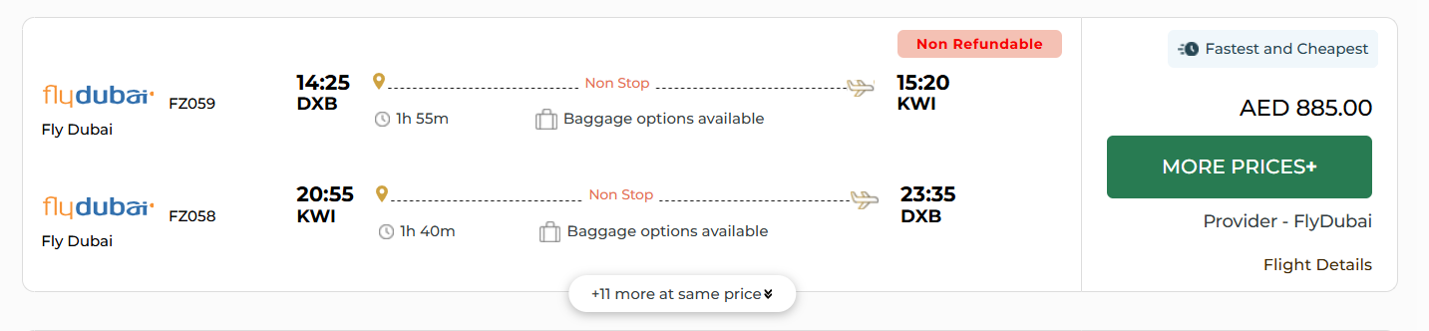

Each flight result is displayed as a detailed card providing all essential information needed to make your booking decision.
The cards are organized to show multiple options from the same or different airlines at a glance.

Airline Information

- Airline Logo and Name: Displays the carrier's branding (e.g., "flydubai") for quick recognition
- Flight Number: Shows the specific flight code (e.g., "FZ059", "FZ058") for reference during booking
- Provider Name: Listed at the bottom as "Provider - FlyDubai" indicating which provider is offering the ticket

Flight Timing

- Departure Time and Airport: Shows when the flight leaves and from which airport (e.g., "14:25 DXB", "20:55 KWI")
- Arrival Time and Airport: Displays when you'll reach your destination and at which airport (e.g., "15:20 KWI", "23:35 DXB")
- Flight Duration: Clock icon with total travel time clearly shown (e.g., "1h 55m", "1h 40m")

Flight Route Information

- Route Visualization: Dotted line with airplane icon showing the flight path between departure and arrival
- Stop Information: Clearly labeled as "Non Stop" for direct flights, or shows the number of stops for connecting flights (e.g., "1 Stop")
- Stop Location Icon: Yellow pin marker indicating if there's a layover point along the route

Additional Services

- Baggage Options: Suitcase icon with "Baggage options available" text indicating you can add checked luggage
- Fare Type Badge: "Non Refundable" label in red/pink highlighting the ticket's cancellation policy
- Value Indicator: Badge showing "Fastest and Cheapest" when a flight offers the best combination of speed and price

Pricing and Actions

- Price Display: Large, prominent price in your selected currency (e.g., "AED 885.00") on the right side
- MORE PRICES+ Button: Button to view alternative branded fare option
- Flight Details Link: Clickable text to expand and see complete itinerary, baggage allowance, and fare rules

Multiple Options Indicator

- Same Price Flights: Shows (eg: "+11 more at same price" ) when multiple flight times are available at the identical rate
Clicking this expands to show all available departure times without price differences
Helps you choose the most convenient timing without worrying about price variations

5.Branded Fares:

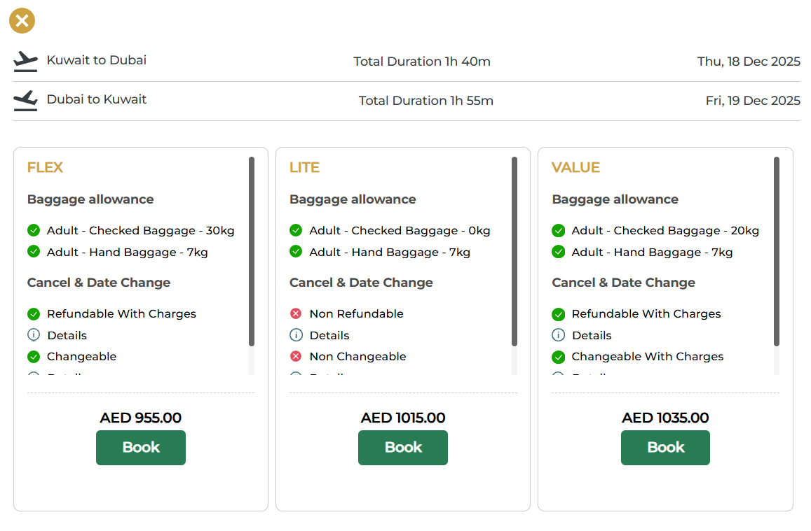

After Clicking the MORE PRICES+ Button in the Flight card Branded Fares modal displayed.

Branded Fares :

When you click "MORE PRICES+", a popup window appears showing different fare categories, each with varying prices and benefits. This allows you to choose the fare type that best matches your needs and budget.

Flight Summary Header :

- Route Information: Shows both outbound and return journeys with airplane icons (e.g., "Dubai to Kuwait" and "Kuwait to Dubai")
- Duration Display: Total flight time for each leg (e.g., "Total Duration 1h 55m", "Total Duration 1h 40m")
- Travel Dates: Clear display of departure dates for each journey (e.g., "Wed, 18 Dec 2025", "Thu, 19 Dec 2025")
- Close Button: X icon in the top-left corner to exit the popup and return to the results page

Fare Categories
The system typically displays fare types side by side for easy comparison:
- LITE Fare (Budget Option)
- VALUE Fare (Standard Option)
- FLEX Fare (Premium Option)

Book Button :

"Book" button at the bottom of each fare column
Clicking proceeds to the passenger details and payment page for your selected fare type
Each fare category has its own booking button, allowing you to choose and proceed independently

Passenger Details Page:

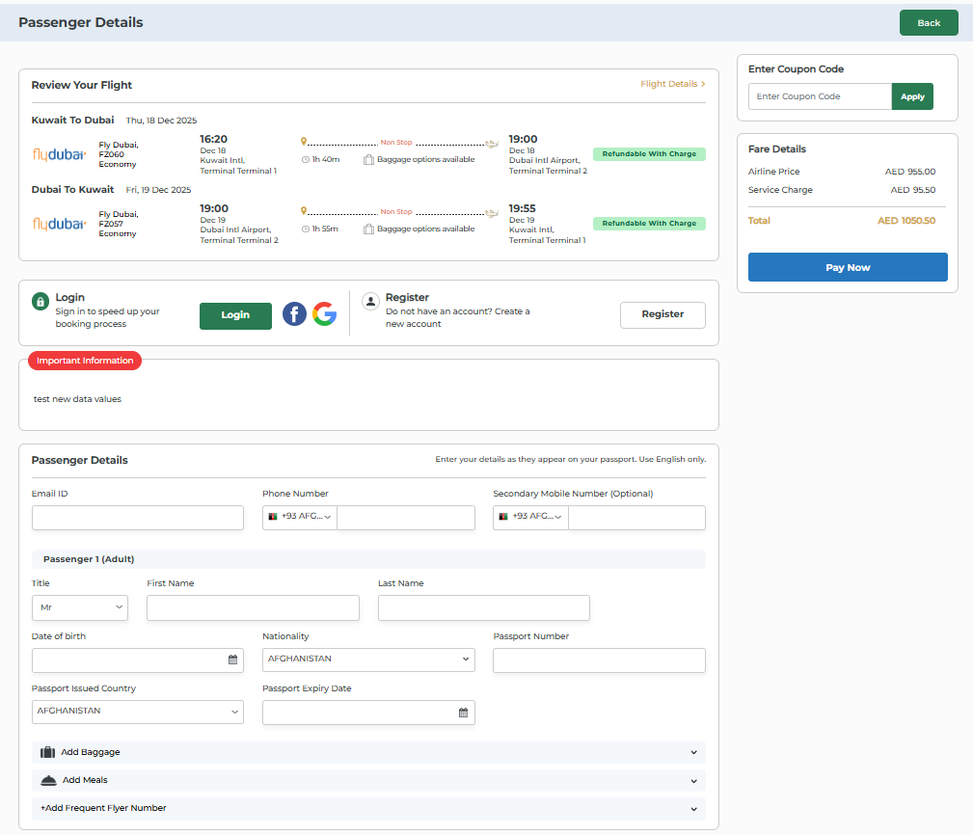

- After selecting your preferred Branded fare and clicking "Book," you're directed to the passenger details page where you'll provide traveler information and complete your booking.

- This page summarizes your flight selection and collects all necessary passenger data.

- Page Header:

- Title: "Passenger Details" at the top identifying the current booking stage
- Back Button: Button in the top-right corner to return to the flight results page if you need to change your selection

- Review Your Flight Section :

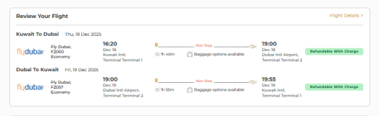

This panel displays a summary of your selected flights for final verification before payment.

- Outbound Flight details such as date, Airline &Flight details,Departure and Arrival details, Route type,baggage details,fare type details etc.

- Return Flight details such as date, Airline &Flight details,Departure and Arrival, Route type,baggage details,fare type details etc.

Flight Details Link: Click to expand and view complete itinerary & fare information such as :
- Onward & Return Itineray details
- Fare summary : In the Fare Summary Tab ,each passengers base fare ,Taxes and fees , Per passenger fare , and Total fare is displayed in a table
- Fare Rules: Fare break up and cancellation details are mentioned in this tab.

- Login/Register Section:

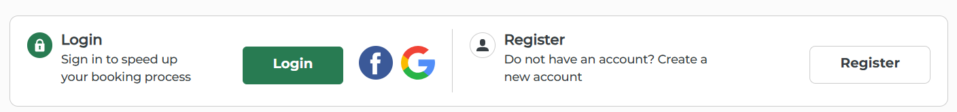

Before entering passenger details, you can choose to proceed as a guest or sign in to your account.

Login Option :

- Purpose: "Sign in to speed up your booking process" - auto-fills saved passenger information
- Login Button: Sign in modal is displayed on the right side when we click on Login Button
- Social Login: Facebook and Google icons for quick social media sign-in

Register Option :

- Purpose: "Do not have an account? Create a new account" for first-time users
- Register Button: Button to create a new account

- Important Information :

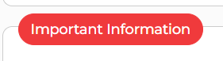

"Important Information" section highlighting urgency messages to the passenger.

- Passenger Details form :

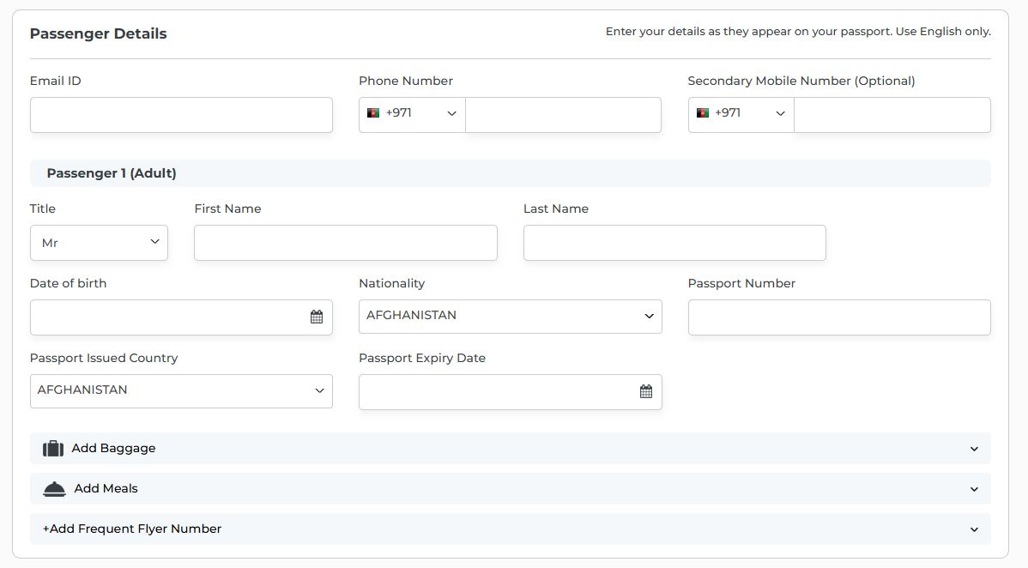

- This section collects all required information for each traveler.

- Email ID: Text field for entering your email address
Booking confirmation and e-ticket will be sent here

- Phone Number : Country code dropdown (e.g., "+93 AFG...")
Phone number field for contact during travel
- Secondary Mobile Number (Optional)

Passengers Details Form contains :

- Title: Dropdown menu with options (Mr, Mrs, Ms,Miss.)
Must match the title on your passport

- First Name : Text field for given name as it appears on passport

- Last Name : Text field for surname/family name .Must match passport exactly

- Date of Birth : Calendar picker for selecting birth date
Required for age verification

- Nationality: Dropdown menu to select your country of citizenship (e.g., "AFGHANISTAN")
Important for visa requirements and immigration

- Passport Number: Text field for entering passport number

- Passport Issued Country: Dropdown showing which country issued your passport (e.g., "AFGHANISTAN")

- Passport Expiry Date: Calendar picker for passport expiration date

Additional Options (Expandable Sections) :

Add Baggage
Collapsible section (click to expand with dropdown arrow)
Add extra checked baggage beyond your fare allowance

Add Meals
Expandable section for pre-ordering in-flight meals
Select meals for each passenger and flight segment

+Add Frequent Flyer Number
Add your frequent flyer number to earn miles/points

Note: "Enter your details as they appear on your passport. Use English only." reminder ensures accurate data entry.

View Saved Travellers :

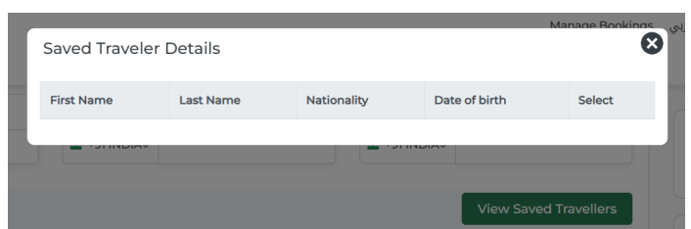

- For Login Users you can see a button “View Saved Travellers”. For quickly filling passenger details from saved traveller records.
- It shows saved travellers details with fields (first name, last name, nationality, date of birth.

- Travel Insurance :

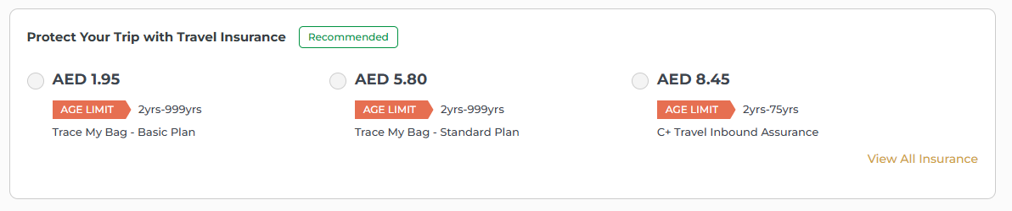

This optional section offers travel insurance plans to protect your journey against unexpected events.

Insurance Plan Options:

- You can choose from multiple insurance plans by selecting the radio button next to your preferred option

- Adding travel insurance provides financial protection against trip cancellations, medical emergencies, lost baggage, and other unforeseen circumstances during your journey.

- Payment Gateways :

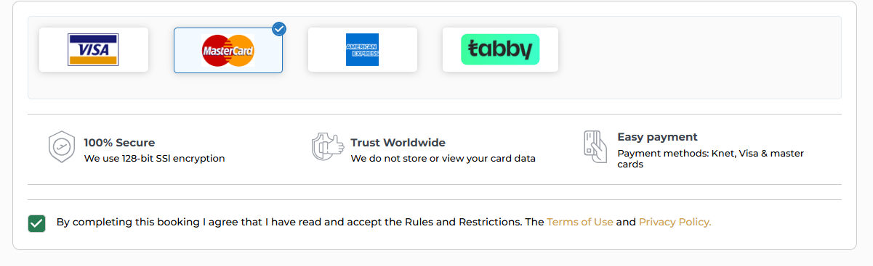

This section displays all available payment options for completing your booking. You can choose from multiple secure payment methods by clicking on your preferred option.

- Blue checkmark indicates this option is currently selected

Security and Trust Features

The page includes three trust badges to reassure customers about payment security:
- 100% Secure
- Trust Worldwide
- Easy payment

Terms and Conditions

Acceptance Checkbox: Green checkmark box that must be selected before proceeding
Agreement Text: "By completing this booking I agree that I have read and accept the Rules and Restrictions."
Clickable Links: "Terms of Use" (in orange) and "Privacy Policy" (in orange) can be clicked to view full legal documentation.

- Coupon code:

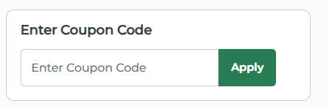

- This section allows you to apply promotional codes or discount coupons to reduce your total booking cost.
- If you have a valid coupon, enter it here before proceeding to payment.

Apply Button: Click Apply Button after entering your coupon code to validate and apply the discount

- Valid coupons instantly reduce the total price shown in the fare details
- Error message appears if the coupon is invalid.
- Discount amount is displayed in the price breakdown.

- Fare Details:

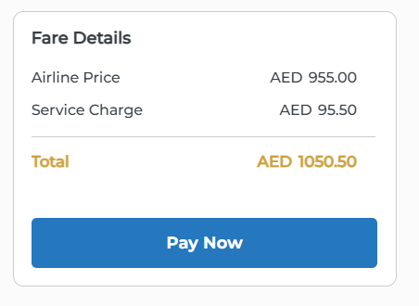
This panel provides a transparent breakdown of all costs associated with your flight booking. All prices are displayed in your selected currency for easy understanding.
- Airline Price
- Service Charge
- Total
If traveller have any coupon codes or any discounts then it will be also mentioned in the fare details panel.

Pay Now Button: button positioned at the bottom of the fare details panel
Click to proceed to the secure payment gateway
Only becomes active after completing all required passenger information and accepting terms.

- Flight Ticket

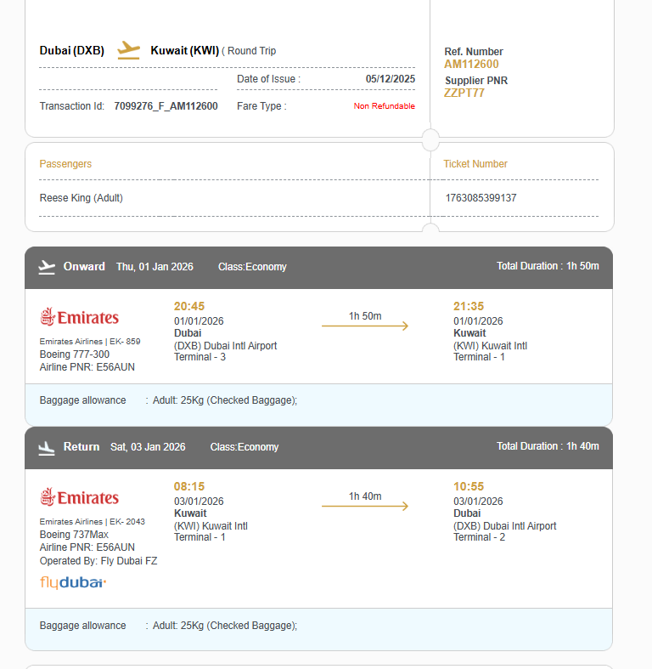

After successful payment, you receive your ticket confirmation page displaying all essential travel details.
This serves as your official flight booking confirmation and contains all information needed for your journey.

Route Information :

- Displays your travel route with airplane icon
- Shows trip type
- Date of Issue: when your ticket was issued

Transaction Details:

- Transaction ID: - unique booking identifier for customer service reference
- Fare Type: indicates ticket cancellation policy

Reference Numbers :

- Ref. Number: main booking reference
- Supplier PNR: airline's internal booking code These numbers are essential for check-in and customer service inquiries

Passenger Information :

- Lists all travelers on the booking
- Shows passenger names exactly as they appear on travel documents

Ticket Number:

- Unique airline ticket number
- Required for check-in and serves as proof of purchase
- Each passenger receives their own ticket number

Outbound Flight Details:

- Direction: "Onward"
- Date
- Cabin Class
- Total Duration:complete travel time
- Airline Information ,Departure Information, Flight Duration,Arrival Information, Baggage Allowance

Return Flight Details:

- Direction: "Return"
- Date
- Cabin Class
- Total Duration
- Airline Information ,Departure Information, Flight Duration,Arrival Information, Baggage Allowance

Departure And arrival Information: such as Time,
Date,Airport and Terminal.

Booking Actions

- Itineray saved:

At "Itinerary Saved" status, the passenger information has been stored in the internal database.

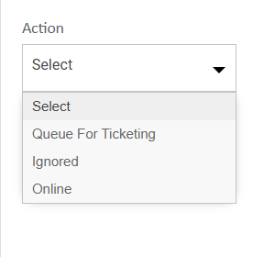

Queue For Ticketing:

- This is a manual/offline process
- Marks the booking to be manually ticketed by an admin/agent
Agent needs to:

- Process payment manually
- Issue ticket through GDS or airline system
Used when automated ticketing isn't possible or desired

Ignored:

Marks the itinerary as ignored or excluded from further processing.

- Booked/Reconfirmed

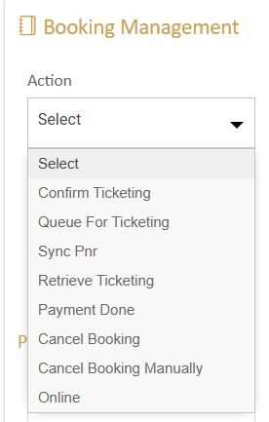

When a flight is booked/Reconfirmed, these are the actions that can be performed:

Confirm Ticketing

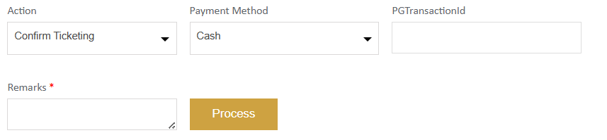

- Issues the actual ticket and completes the booking process by generating the official e-ticket.

- Updates the booking status from “Booked” to “Ticketed.”

- Ensures the seat is fully confirmed, secured, and paid for.

- This action is fully automated and processed through the online ticketing system.

Queue For Ticketing

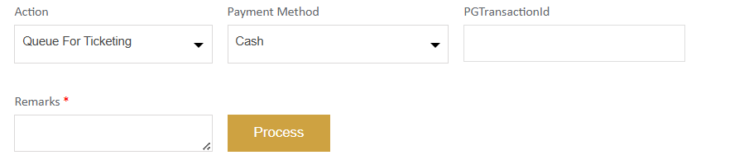

- This option is used to manually confirm and issue the ticket for a booking.

- Once selected, a popup appears allowing you to enter ticket numbers for each passenger.

- If needed, ticket numbers can also be added or edited later from the passenger details edit section.

- This is a completely offline process, meaning no automated ticket issuance occurs in the system.

Sync PNR

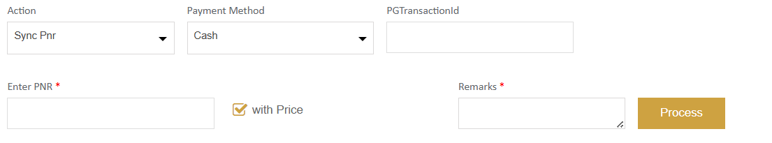

- The Sync PNR option allows users to enter a new or existing PNR for synchronization.

- During the Sync PNR process, the system updates the Itinerary, Passenger, and Ticket details in the transaction based on the PNR response received from the supplier.

Retrieve Ticketing

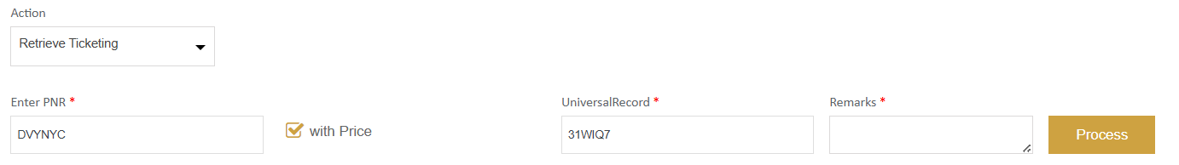

- This action is used when ticketing has failed in the system.

- Only the Ticket Numbers will be updated against the transaction after retrieval.

- No changes will be made to the itinerary or passenger information during this process.

Payment Done

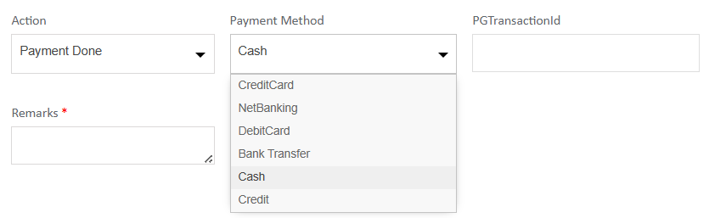

- This action is used to set the Payment Mode for the booking.

- Once the payment is successfully processed, the booking status will automatically update to “Payment Done.”

- A Payment Method selection option is available, allowing the user/admin to choose the desired payment mode before completing the action.

Cancel Booking

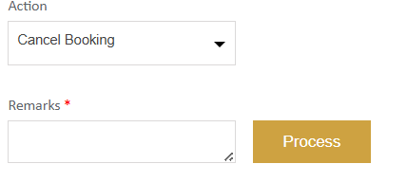

- This action is used to cancel the GDS PNR through online .

- When triggered, it sends a cancellation request to the Global Distribution System (GDS) for the selected PNR.

- The booking is marked as cancelled in both the internal database and the GDS.

Cancel Booking Manually

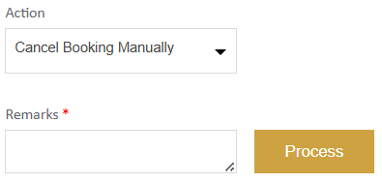

- This action is used to update the transaction status to Cancelled manually.

- It is performed when Online Cancellation fails or cannot be processed.

- Using this option only changes the internal transaction status, not the booking in the airline system.

- The PNR must be cancelled separately from the terminal screen to complete the process.

- Ticketed

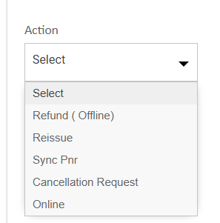

Refund (Offline)

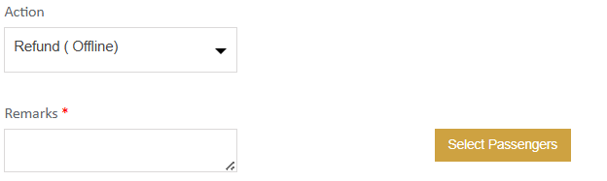

- Refunds are handled offline and cannot be processed automatically through the system.

- You can only perform a refund for ticketed transactions.

Reissue

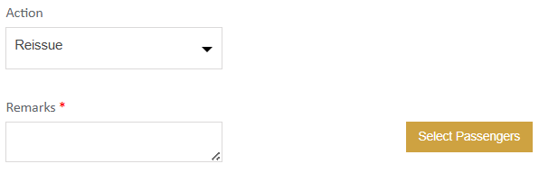

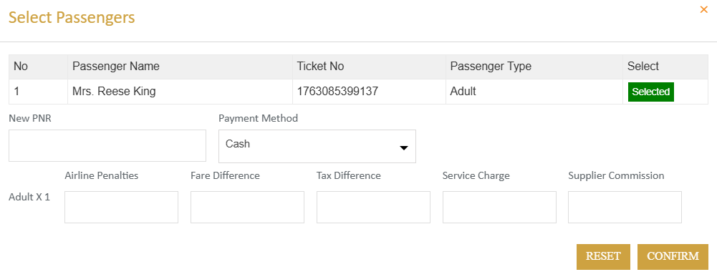
Reissue is an OFFLINE process
- Reissue, then click Select Passengers.
Passenger Selection Options

In the popup,

- Enter New PNR if available (auto-creates new transaction).

- Choose any payment method.

- Enter charges per passenger type (system auto-calculates totals).

- Click Confirm, add remarks, and Process.

- A new child transaction is created and shown in Transaction History.

Cancellation Request

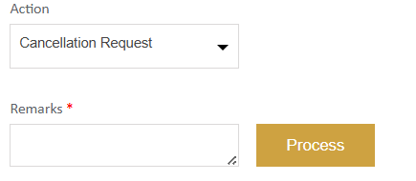

- Sub-agents can initiate a cancellation request for a booking.

- Once submitted, the transaction status updates to “Cancellation Requested”.

