HOTEL MODULE DOCUMENTATION
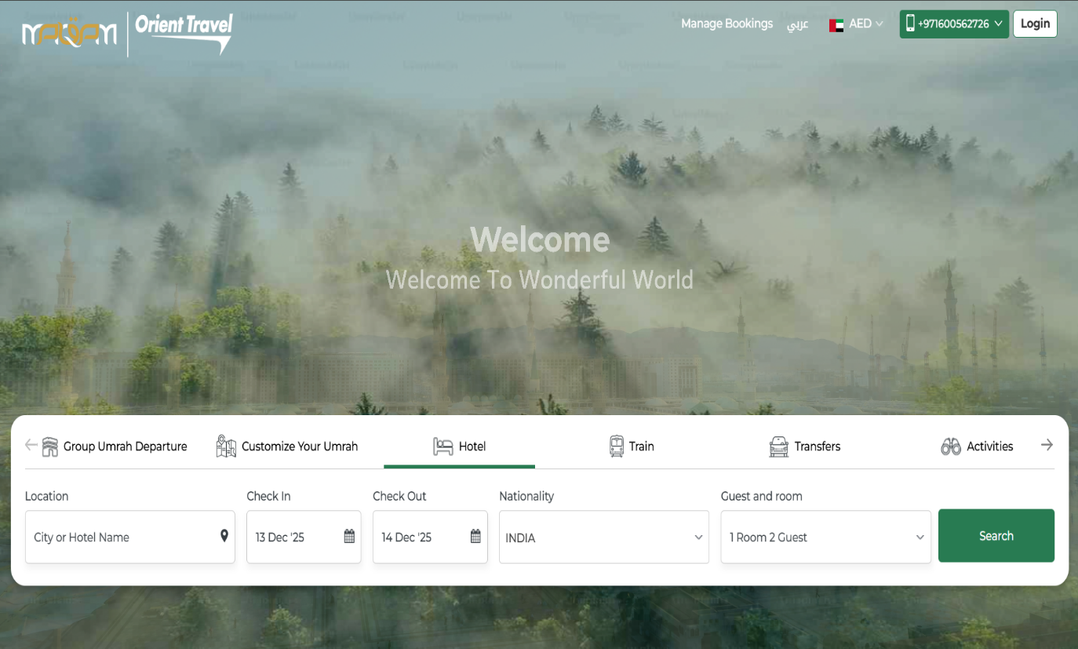
Search Page:
The hotel search page serves as the primary interface for users to find and book suitable accommodation based on their travel requirements. It offers an intuitive and user-friendly design that allows users to quickly enter essential details such as location, travel dates, nationality, number of guests, and number of rooms. The purpose of this page is to simplify the hotel booking process by providing relevant suggestions, real-time search filters, and smooth navigation to the results page. By entering the required information and clicking the search button, users can view available hotel options matching their preferences and proceed further with booking.
1. Location
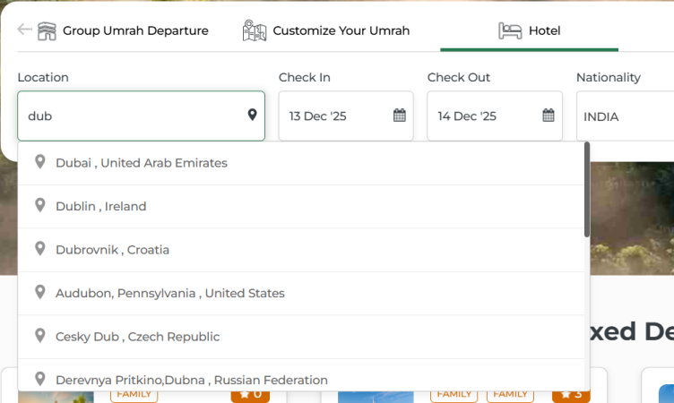

This is a text-based search field where users can enter either:

The name of a hotel, or

The name of a city where they want to find a hotel.

As the user types, the system displays auto-suggestions based on the entered text.
This helps in quickly selecting relevant locations without typing the full name.

2. Check-In and Check-Out Dates
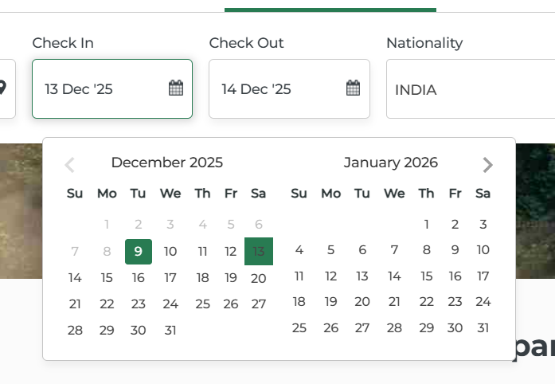

These fields allow the user to select the desired stay period.

When clicking on either field, a calendar popup appears to choose the dates.

Default selection:

Check-in: Today’s date

Check-out: Tomorrow’s date
This ensures there is always at least one night selected automatically.

Users can modify these dates as per their travel requirements.

3. Nationality
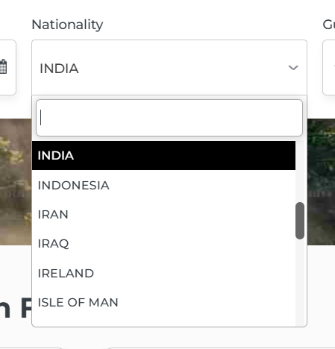

This is a dropdown field used to select the traveller’s nationality.

On click, it opens a dropdown list with a search bar, allowing users to quickly find their nationality.

4. Guest and Room Selection
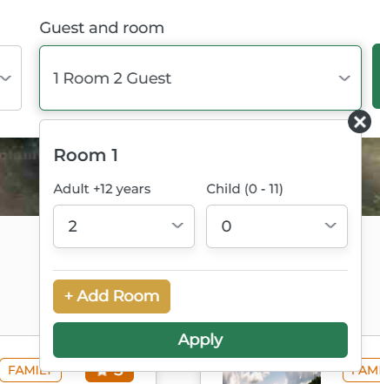

This section allows selection of the number of rooms and guests.

The default value is 1 Room, 2 Guests.

Users can customize:

Number of rooms (maximum 9 rooms)

Number of guests per room (maximum 9 guests per room)

Important rule: Every room must have at least 1 adult.

Guests are categorized into:

Adults

Children

5. Search Button


After entering all required information, users click the Search button.

The system then processes the inputs and displays hotel results according to the selected criteria.

On successful search, the user is redirected to the Hotel Results Page where available hotel options are listed.

