Flight Module - Documentation
- Executive Summary

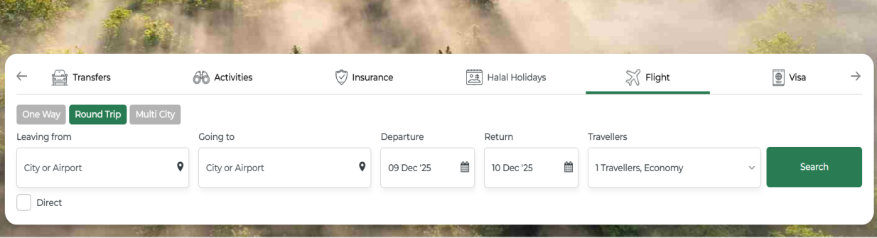

1.1 Purpose

This document defines the complete scope of the flight booking system , covering the end-to-end user journey from flight search through ticket issuance

1.2 Business Objectives

Provide seamless flight booking experience
Support multiple trip types (One-way, Round-trip, Multi-city)
Integrate with multiple payment gateways
Support multi-currency and multi-language operations

- System Overview

2.1 Trip Types

One Way: Single sector journey
Round Trip: Return journey with outbound and inbound flights
Multi City: Multiple destinations (up to 4 flight segments)

2.2 Travel Classes

- Economy
- Premium Economy
- Business Class
- First Class

2.3 Passenger Categories

Adults: 12+ years
Children: 2-11 years
Infants: 0-2 years

- Flight Search Module

  - Search Interface

3.1.1 One-Way Search Fields

Leaving From: Origin airport/city
Going To: Destination airport/city
Departure Date: Date picker

Travellers: Passenger count selector

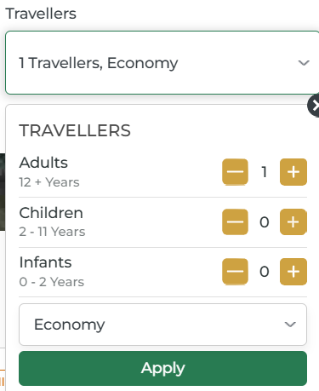

- Adults (12+ years)
- Children (2-11 years)
- Infants (0-2 years)

Class: Dropdown (Economy/Premium Economy/Business/First)

3.1.2 Round Trip Additional Fields

Return date picker is enabled for round trip.

3.1.3 Multi-City Additional Fields

Multiple Flight Segments: Up to 4 segments

3.2 Search Validation Rules

- Origin and destination cannot be the same

Mandatory field and validation should show if we don’t choose city
(“Enter a valid Airport code or City”)

- Return date must be after departure date
- Minimum 1 adult passenger required
- Infants count cannot exceed adults count
- Maximum passenger limit validation (9 total)
- Date must be current or future date

3.3 Search Functionality

Auto suggestions for airports and cities
Airport code and city name search support

Modify Search

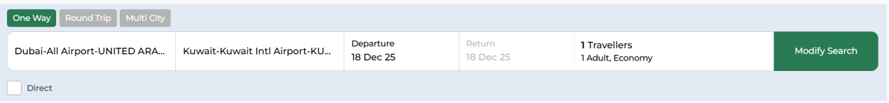

The Modify Search bar is a compact summary and edit panel for the original flight search criteria; its scope is to display key fields (trip type, route, dates, travellers, direct flag) and allow users to adjust them, then re run availability.

Purpose:

Allow the user to change any of these parameters without going back to the original search page

- Flight Result & Review

  - Search Results Display

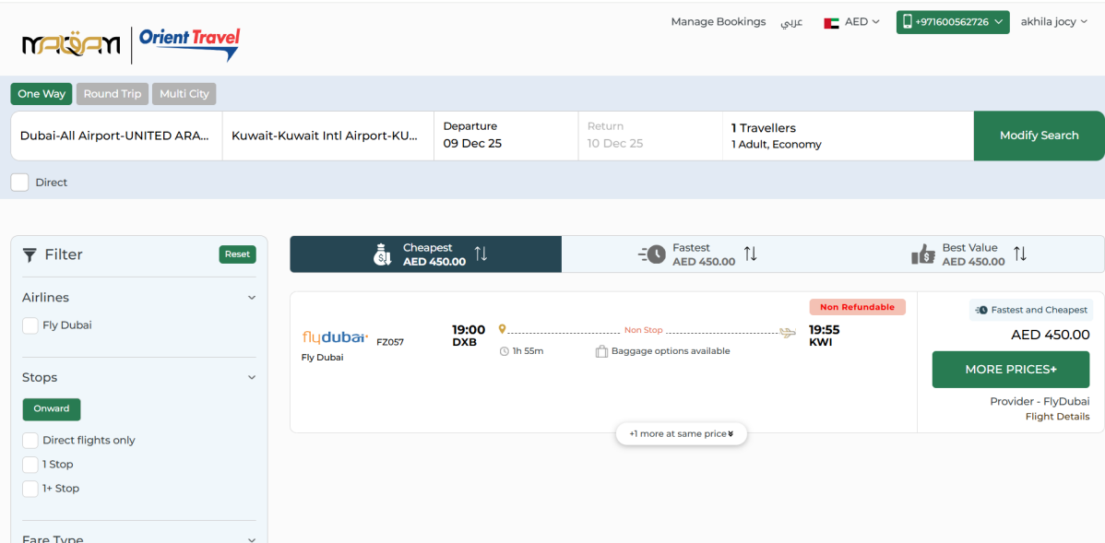

    - Flight Listing Features

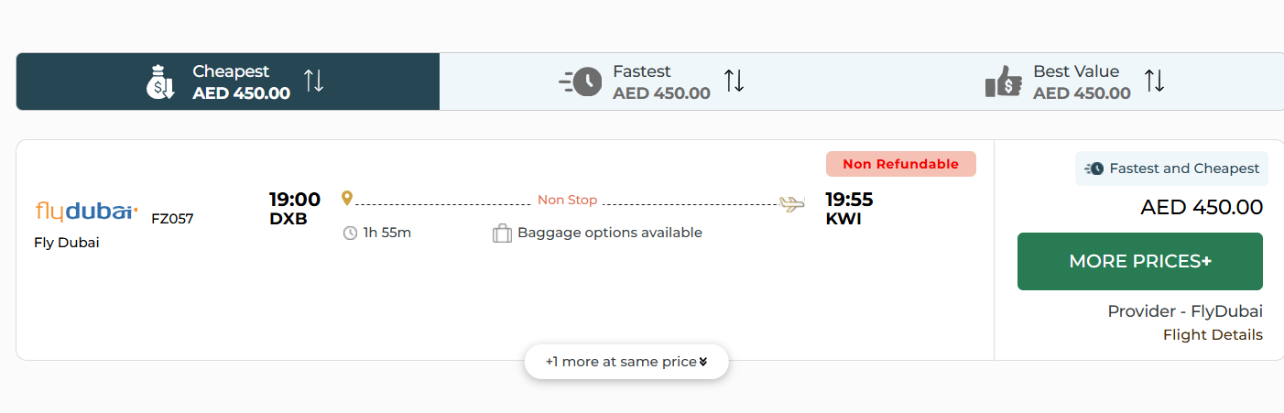

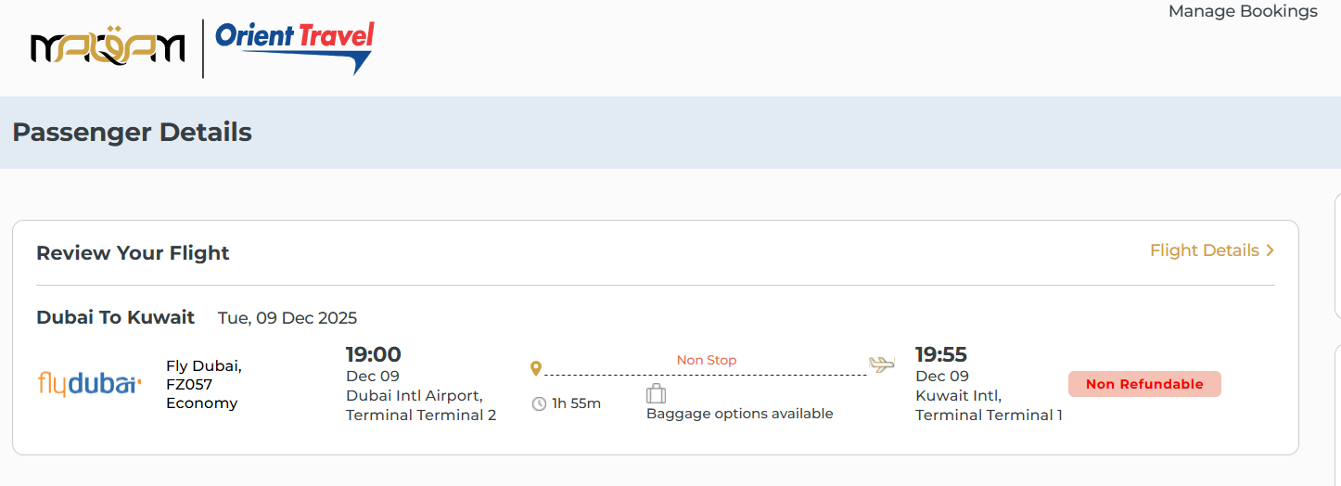
Airline Information

- Airline logo
- Airline name
- Flight number

Flight Details

- Departure time and airport
- Arrival time and airport
- Flight duration
- Number of stops (Direct/1 Stop/2+ Stops)
- Layover duration (for connecting flights)

Fare Information

- Base fare
- Taxes and fees breakdown
- Total price per passenger
- Total booking amount
- Currency conversion options

Baggage Information

- Cabin baggage allowance
- Check-in baggage allowance
- Additional baggage options

Fare Rules

- Refundable/Non-refundable
- Cancellation charges
- Date change fees

    - Sorting Options

Cheapest / Fastest / Best Value:

- Cheapest: lowest total price among all itineraries for this search.
- Fastest: shortest total journey time.
- Best Value: flight that balances price and duration.matching both cheapest and fastest

    - Filtering Options

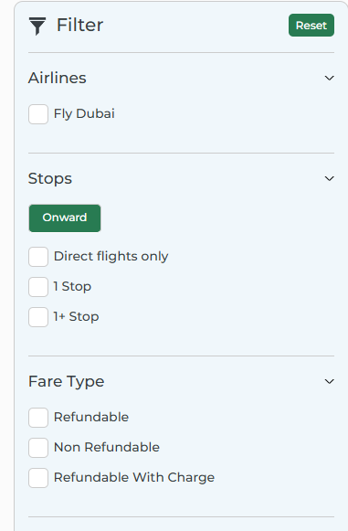

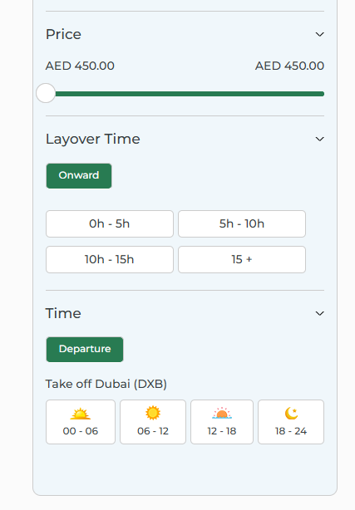

- Filter by : Airlines

- Stops: Filter flights based on number of stops.(Direct/1 Stop/2+ Stops) Return (visible only for round-trip).

- Price range slider: Slider dynamically filters flight results based on price range.

- Fare Type:
Multi-select checkboxes.
If none are selected, all fare types are included.
Refundable
Non Refundable
Refundable with Charges

- Layover Time:
Filter For Onward and Return
- Filter applies only to flights with layovers
Options:
0H – 5H
5H – 10H
10H – 15H
15H +
Departure time slots (Morning/Afternoon/Evening/Night)

4.2 Flight Details

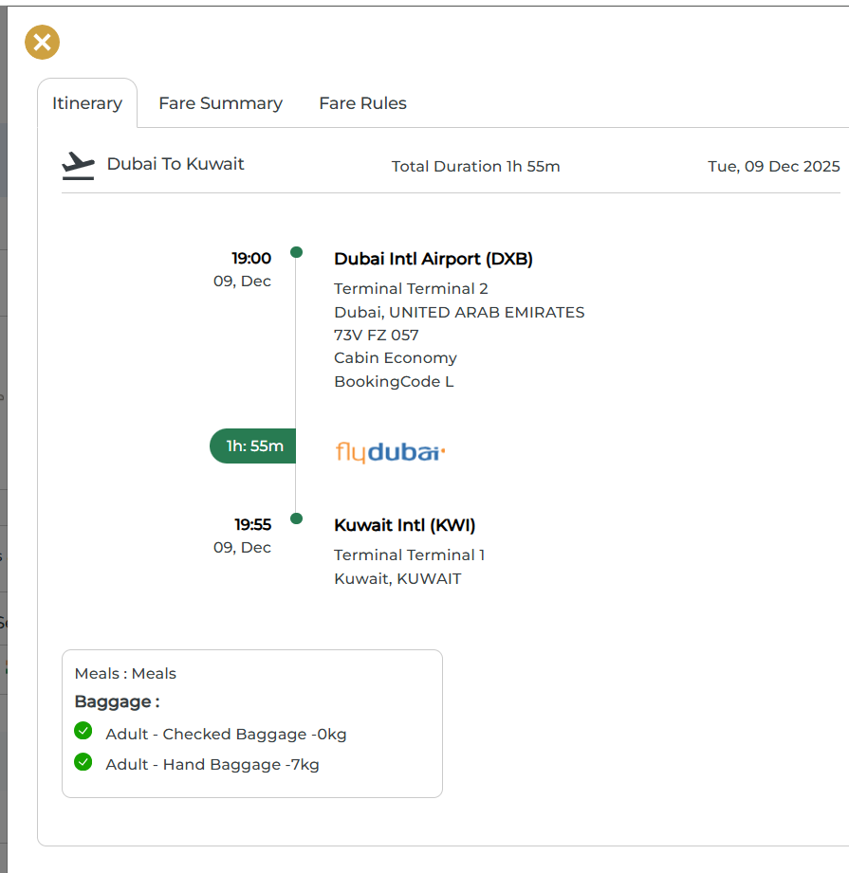
Flight Details section contains the :

- Complete itinerary breakdown
- Segment-wise flight information
- Terminal information like the arrival terminal and departure terminal.
- Layover details
- Baggage policy
- Fare breakup
- Fare rules and restrictions

- Passenger Information Module

5.1 Contact Information

This section contains the contact information's like the email address and mobile number of the traveller.

- Email Address: For booking confirmation
- Phone Number: Country code + number
- Seconadry Mobile Number: Optional

5.2 Traveller Details Form

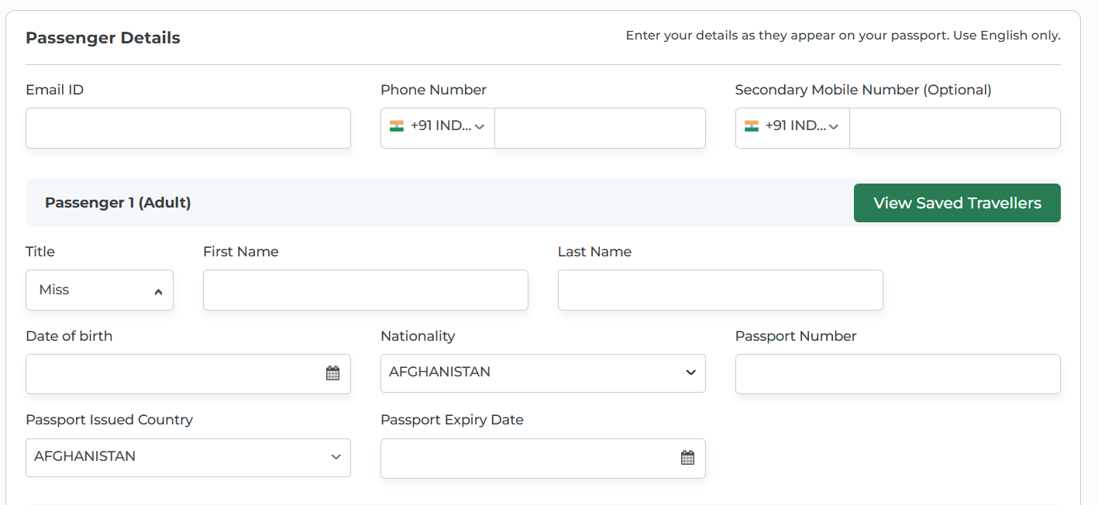

5.2.1 Adult Passenger Fields

Title: Mr./Miss/Mrs./Ms.
First Name: As per passport
Last Name: Date of Birth: Date picker
Nationality: Country selector
Passport Number: Alphanumeric
Passport Issued Country
Passport Expiry Date: Date picker
Frequent Flyer Number: Optional
Also contains paid Meal or paid baggage options for the Traveller (Optional)
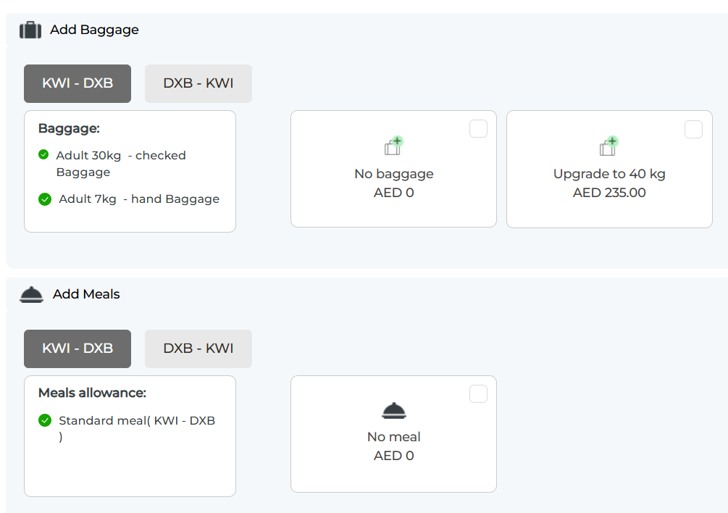
Paid baggage:
Traveller can choose for each flight segment (eg: KWI–DXB and DXB–KWI) and it displayed default with included allowance checked plus hand baggage for an adult.​
For the selected segment, the user can either keep the current baggage option at no extra cost or upgrade the checked baggage allowance with additional charge.
Traveller can choose paid meals also by paying additional charge for segment wise.

View Saved Travellers:

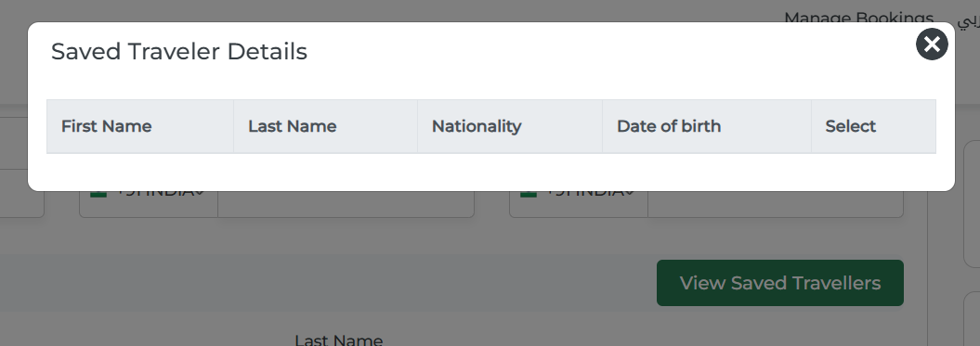

For quickly filling passenger details from saved traveller records.
It shows saved travellers details with fields (first name, last name, nationality, date of birth.

5.2.2 Child Passenger Fields
Same Fields as adult
The date of birth selected must ensure the traveler is between 2 and 11 years old on the date of travel.

5.2.3 Infant Passenger Fields
Same Fields as adult
The date of birth selected must ensure the traveler is between 0 and 2 years old on the date of travel.

Travel Insurance:

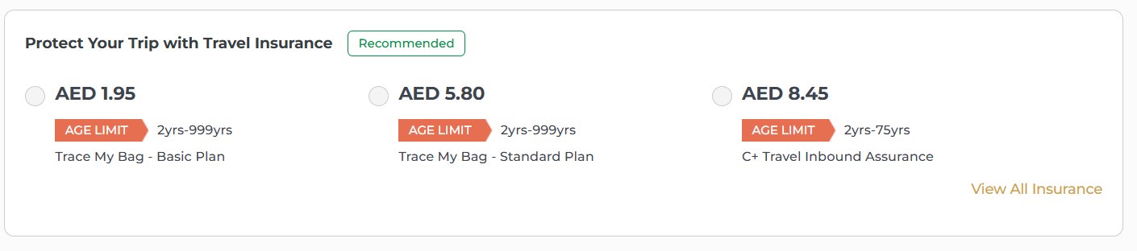
It presents multiple insurance plans with prices, age limits, and plan names, plus a “View All Insurance” , which aligns with offering different coverage options.

- Payment & Checkout

6.1 Payment Methods

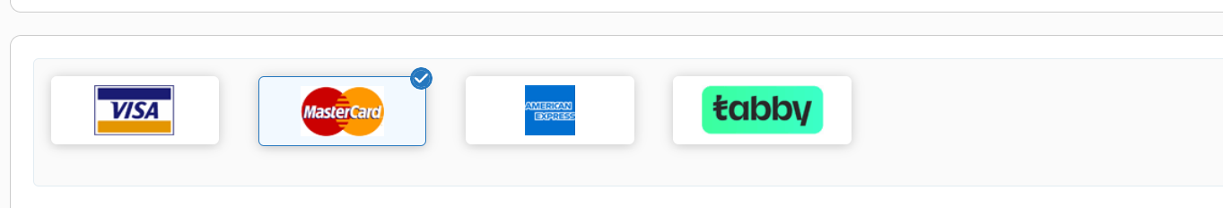
The payment section supports multiple methods as described in the scope: major credit/debit cards (Visa, Mastercard, American Express) and the Tabby
Users can select their preferred gateway by clicking the corresponding logo, which then becomes highlighted to indicate the active payment choice during checkout

6.2 Promo Code & Discounts
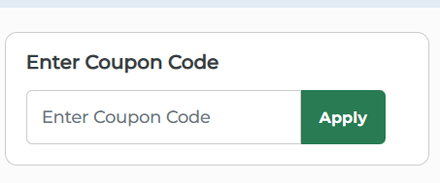
Promo Code & Discounts functionality described in the Payment section, allowing users to enter a coupon code before paynow

6.3 Fare Summary

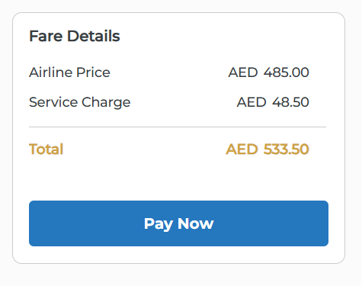
This Fare Details where the system breaks down costs before the user confirms payment.​​
It clearly separates the airline price and the service charge, calculates the total amount payable (AED 533.50), and provides a “Pay Now” button to proceed with the final payment step.

Flight Ticket

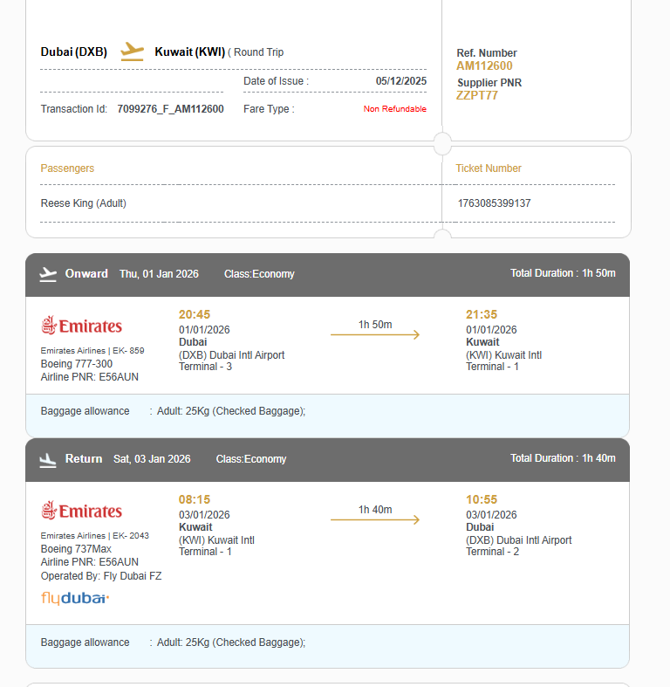

This is the passenger’s e-ticket generated after successful booking and payment.
​​
It includes booking and ticket information such as reference number, supplier PNR, transaction ID, date of issue, fare type (non‑refundable), and individual ticket number for the traveler.
​​
The itinerary section shows onward and return flight details including airline, flight numbers, aircraft type, departure/arrival airports and terminals, times, and total duration for each leg in economy class.​
​
Baggage allowance is clearly indicated for the adult passenger on both sectors, aligning with the scope requirement to display confirmed baggage details on the e-ticket
Booking Actions

Itineray saved:

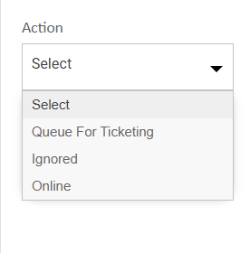
Queue For Ticketing:

Moves the saved itinerary into ticketing .
Its an offline action.

Ignored:

Marks the itinerary as ignored or excluded from further processing.

Booked / Reconfirmed

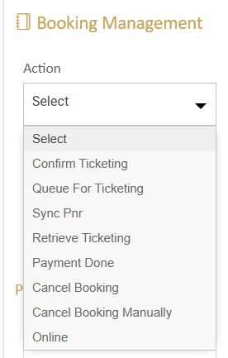

Ticketed:

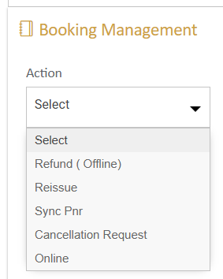

Booking failed:

