HOTEL MODULE DOCUMENTATION
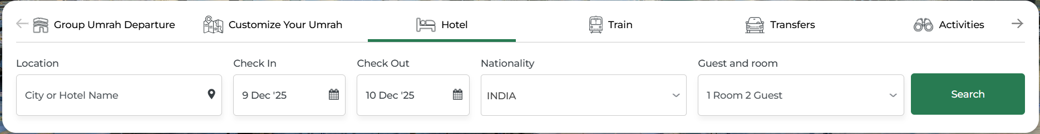
Search Page:
The hotel search page serves as the primary interface for users to find and book suitable accommodation based on their travel requirements. It offers an intuitive and user-friendly design that allows users to quickly enter essential details such as location, travel dates, nationality, number of guests, and number of rooms. The purpose of this page is to simplify the hotel booking process by providing relevant suggestions, real-time search filters, and smooth navigation to the results page. By entering the required information and clicking the search button, users can view available hotel options matching their preferences and proceed further with booking.
1. Location
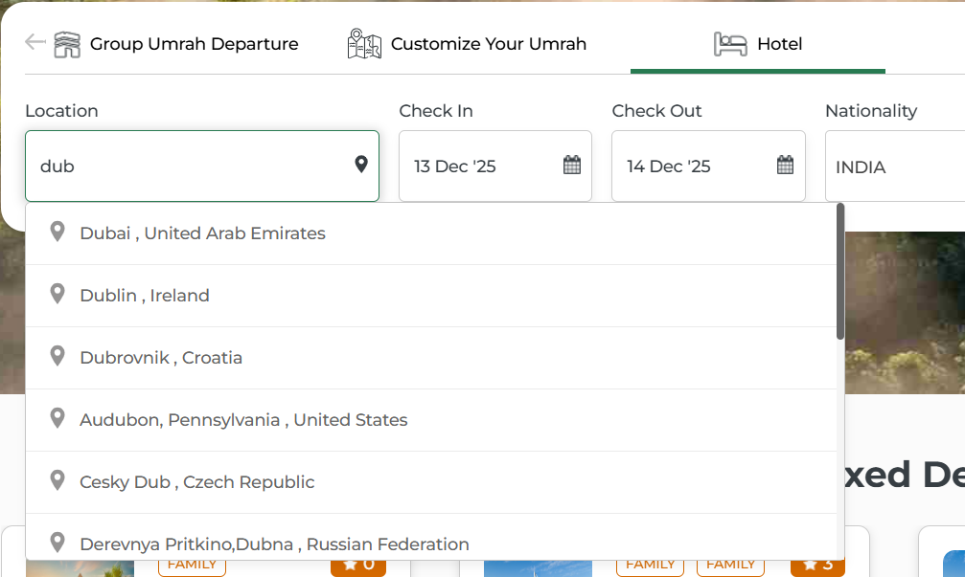

This is a text-based search field where users can enter either:

The name of a hotel, or

The name of a city where they want to find a hotel.

As the user types, the system displays auto-suggestions based on the entered text.
This helps in quickly selecting relevant locations without typing the full name.

2. Check-In and Check-Out Dates
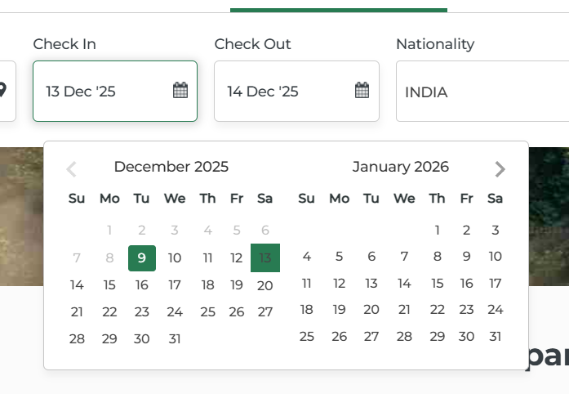

These fields allow the user to select the desired stay period.

When clicking on either field, a calendar popup appears to choose the dates.

Default selection:

Check-in: Today’s date

Check-out: Tomorrow’s date
This ensures there is always at least one night selected automatically.

Users can modify these dates as per their travel requirements.

3. Nationality
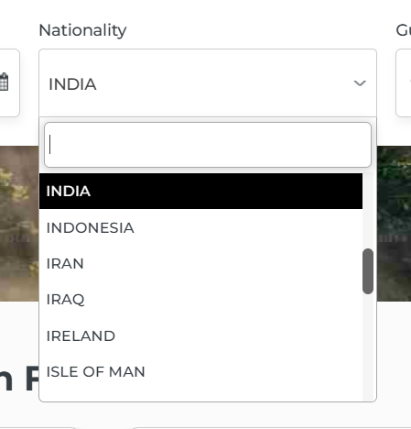

This is a dropdown field used to select the traveller’s nationality.

On click, it opens a dropdown list with a search bar, allowing users to quickly find their nationality.

4. Guest and Room Selection
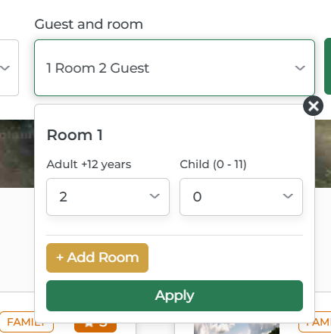

This section allows selection of the number of rooms and guests.

The default value is 1 Room, 2 Guests.

Users can customize:

Number of rooms (maximum 9 rooms)

Number of guests per room (maximum 9 guests per room)

Important rule: Every room must have at least 1 adult.

Guests are categorized into:

Adults

Children

5. Search Button
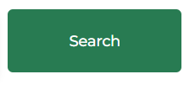

After entering all required information, users click the Search button.

The system then processes the inputs and displays hotel results according to the selected criteria.

On successful search, the user is redirected to the Hotel Results Page where available hotel options are listed.

Results Page :
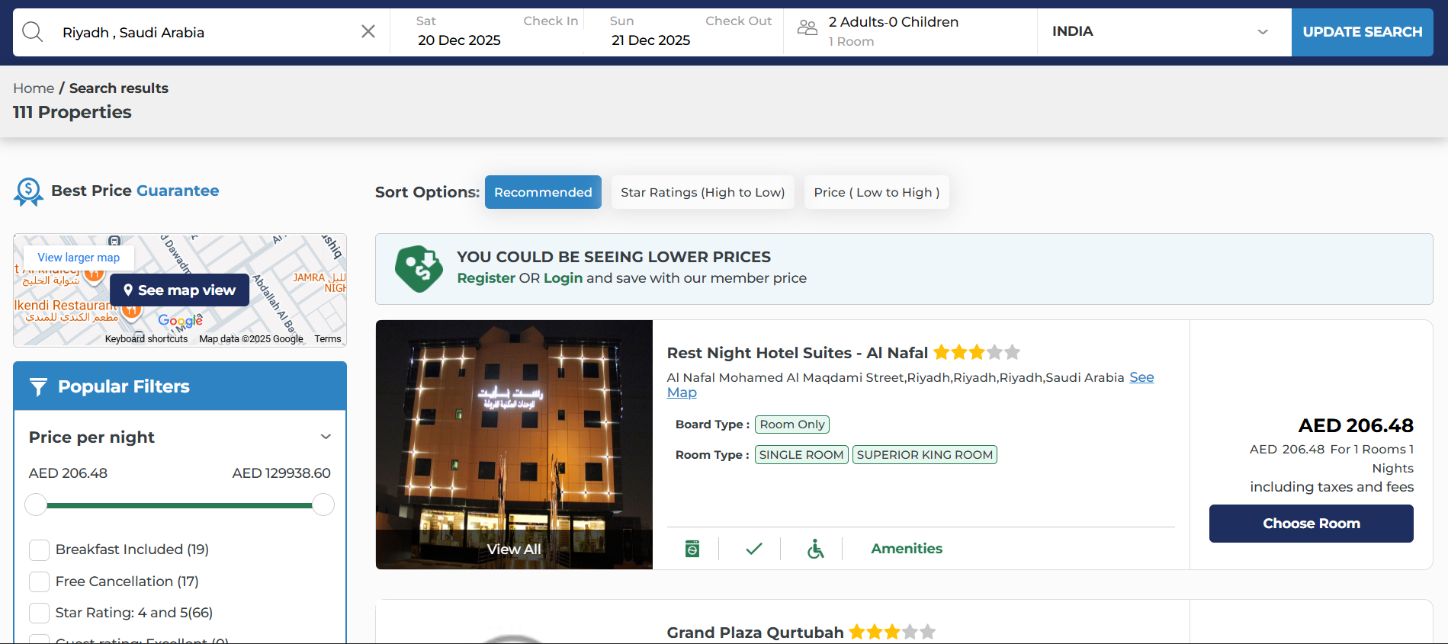
The search results page displays the hotel options based on the information entered in the initial search. At the top of the page, the same search details are shown in the Modify Search section, allowing users to update their location, dates, nationality, or guest details without returning to the main search page. The list of available hotels is generated according to the selected criteria, ensuring accurate and relevant results. Additionally, the page provides sorting options and multiple filters, helping users refine their search further and quickly find hotels that best match their preferences.
Modify Search
1. Location

Users can type a city name or hotel name into the text field.

The system displays auto-suggestions based on the entered text.

Helps users quickly choose the correct search destination.

2. Check-In Date

Opens a calendar popup when clicked.

Users select the date they want to start their stay.

Previously selected date is shown and can be modified anytime.

3. Check-Out Date

Also opens a calendar popup for date selection.

Must be later than the check-in date.

Users can easily update their stay duration.

4. Nationality

Clicking opens a dropdown list with a search option.

Users select their nationality from the available list

Nationality may influence pricing or hotel availability.

5. Guests & Rooms

Users can select the number of rooms (up to 9) and guests.

Each room must have at least one adult.

Maximum 9 guests per room, including adults and children.

6. Update Search Button

Refreshes the results based on updated search inputs.

Keeps the user on the same results page—no redirection.

Helps refine the search quickly and efficiently.
Sort Options and Filters
The results page includes sorting and filtering tools that help users refine their hotel search and find suitable options more efficiently.
Sort Options :
Star Ratings (Low to High)
- Displays hotels starting from the lowest star rating to the highest.
- Helps users find budget or basic accommodation quickly.

Price (Low to High)
- Sorts hotel listings from the lowest price to the highest.
- Useful for users looking for the most economical options first.
Filters :

Price per Night :
- Users can adjust the price range slider to view hotels that match their preferred budget.

Star Ratings :
- Allows filtering hotels by their star category (e.g., 3-star, 4-star, 5-star).

Property Type :
- Users can select the type of accommodation such as hotel, apartment, ranch, etc.

Cancellation Policy :
- Filters hotels based on policy types like free cancellation or non-refundable options.

Amenities :
- Allows users to filter by features such as Wi-Fi, parking, pool, gym, and more.

Meals :
- Users can select meal plan options such as breakfast included, room only, etc.

Room Type :
- Helps filter hotels by room categories such as single, double, suite, etc.

Hotel Chain :
- Allows selection of specific hotel brands or chains.

Search Hotel Field
- A dedicated search box is available within the filter section.
- Users can type a hotel name to quickly locate a specific property within the results.

Reset Filter
- A common Reset Filter button clears all applied filters at once.
- This restores the full list of search results, allowing users to refine their search again from the beginning.

Hotel Search Result Card
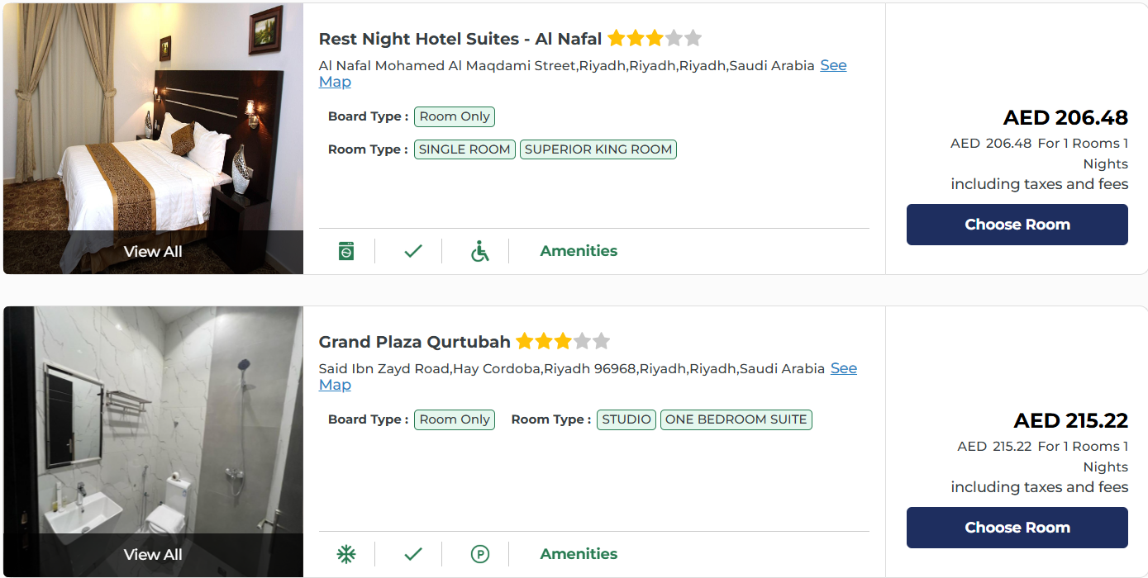
Each hotel listed in the results page is displayed in a structured card format, providing key information and actions to help users quickly evaluate and compare options. Each hotel card typically includes:
1. Hotel Images
- Displays a preview image of the hotel property.
- Users can visually identify the hotel and get a quick idea of its appearance and facilities.

2. Hotel Name, Ratings & Location
- Shows the hotel name along with its star rating.
- The location is displayed to help users understand where the hotel is situated.
- A “See Map” link is provided; clicking it opens a map view showing the hotel’s exact position.

3. Available Board Type & Room Type
- Displays the board type (e.g., Room Only, Breakfast Included) available for that hotel.
- Shows the room type options such as standard, deluxe, or suite based on availability.

4. Amenities
- A quick view of key amenities is shown on the card.
- Clicking “Amenities” opens a popup displaying the complete list of facilities offered by the hotel (e.g., Wi-Fi, pool, parking, gym, etc.).

5. Price Details
- Shows the total amount for the selected number of rooms and nights.
- Includes taxes and fees so users can view the complete cost upfront.
- Helps users compare prices easily across different hotels.

6. Choose Room Button
- A dedicated Choose Room button is available for each hotel.
- Clicking it takes the user to the room selection page where they can view room details, pricing, and proceed with booking.
Review Page :
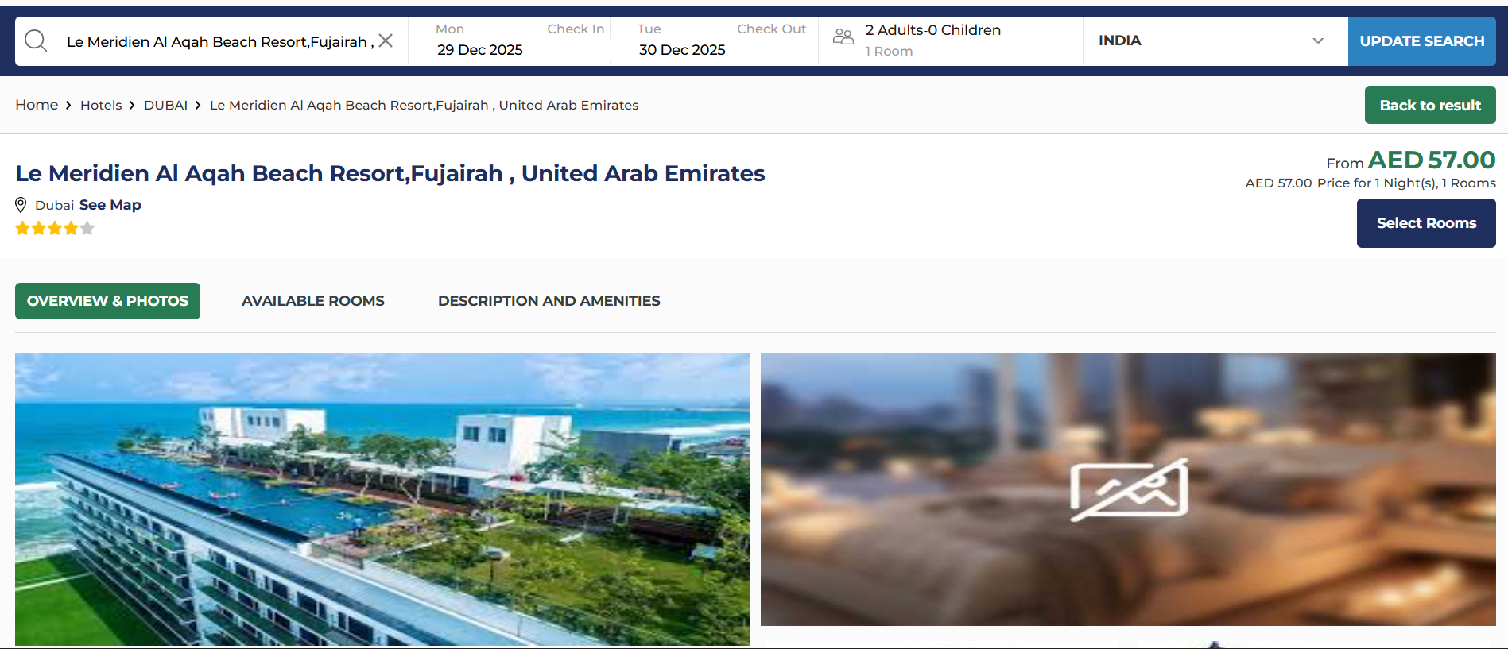
The Review Page allows users to confirm all details of their hotel booking before proceeding to payment. It provides a complete summary of the selected hotel, room type, guest details, stay dates, pricing, and policies. This page ensures that users can carefully review every part of their reservation and make any necessary changes before finalizing the booking.
Modify Search :
- A Modify Search section is available at the top, similar to the previous pages.
- Users can update their search criteria without navigating away from the page.
Back to Result :
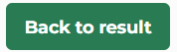
- A Back to Result button allows users to return to the hotel results page to explore other options.
Selected Hotel Details :
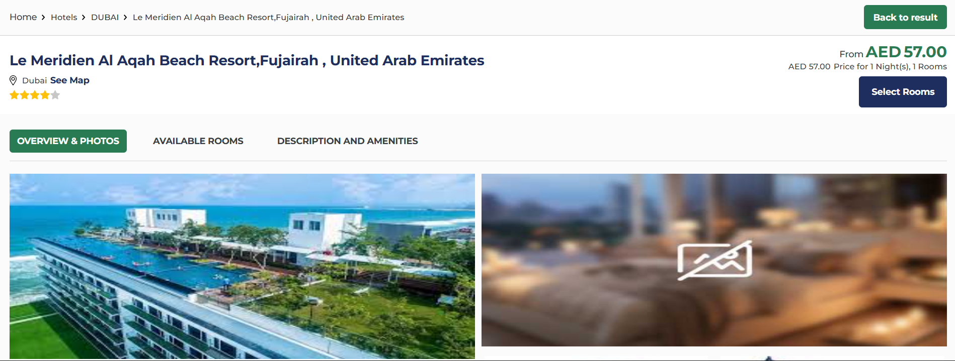
- Displays all key information of the chosen hotel, including:
  - Hotel images
  - Hotel name and star rating
  - Location
  - Price details
- A Select Room button is shown so users can move directly to room selection if needed.
Additionally, the hotel details include three navigation buttons:
Overview & Photos (Selected by default):
- Shows the hotel’s general overview and image gallery.
- Helps users view property photos and key highlights quickly.
Available Rooms :
- Automatically scrolls to the section listing all room options.
- Allows users to access room details and pricing without manual scrolling.
Description and Amenities :
- Takes the user to the detailed description and full amenities list of the hotel.
- Useful for understanding property features, facilities, and services offered.
Room Filters :
The Review Page also provides filters to help users refine the type of room they want to view:
- Breakfast Included
- Free Cancellation
- Non-Smoking
- A Search Room Type field allows users to search specific room names or categories.
- A Clear Filter button resets all applied filters.
Available Rooms :
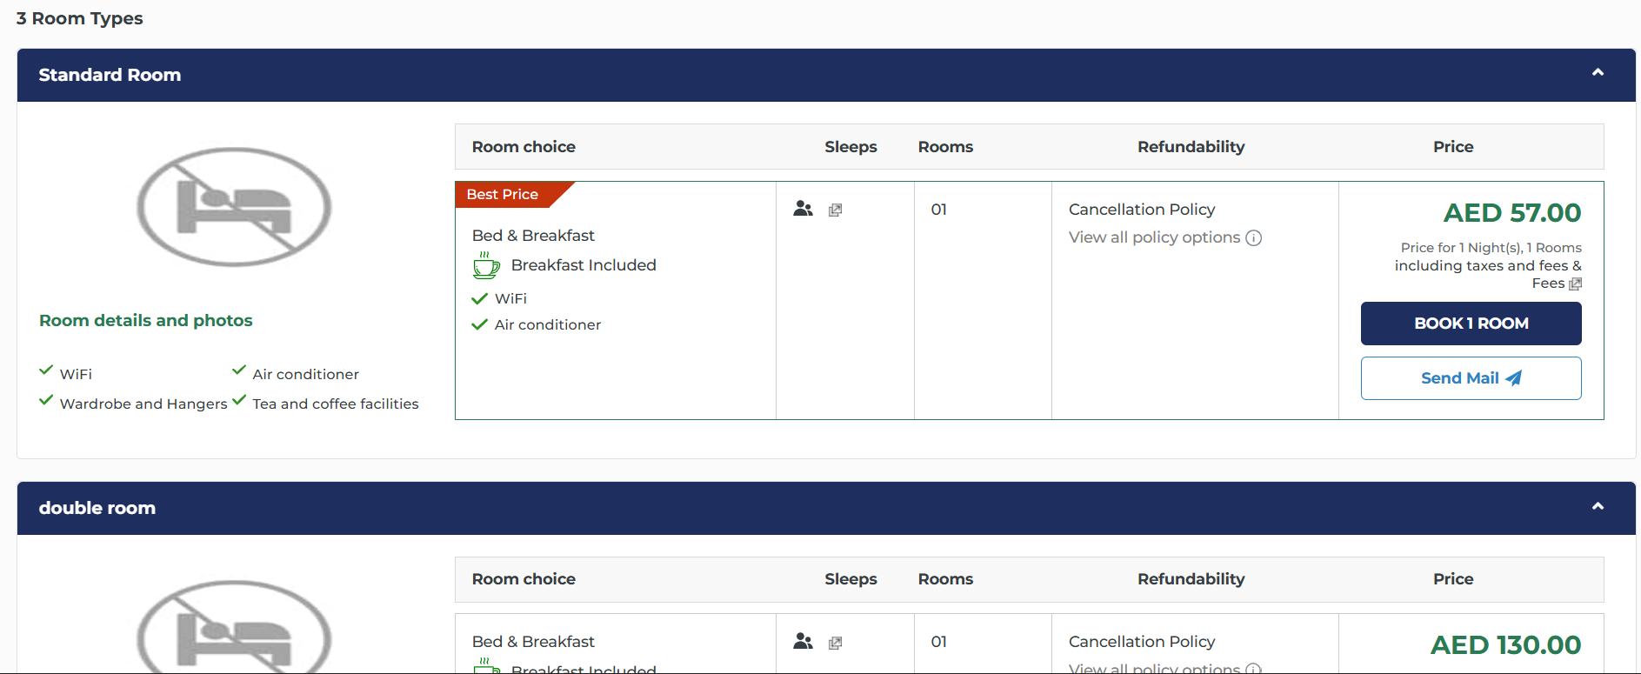
Under the filters, all available room options are listed with complete details:
- Room type and features
- Occupancy information
- Amenities included
- Pricing for selected dates and number of guests
- A Book button to proceed with reservation
- A Send Mail button to share room details via email
Passenger Details Page :
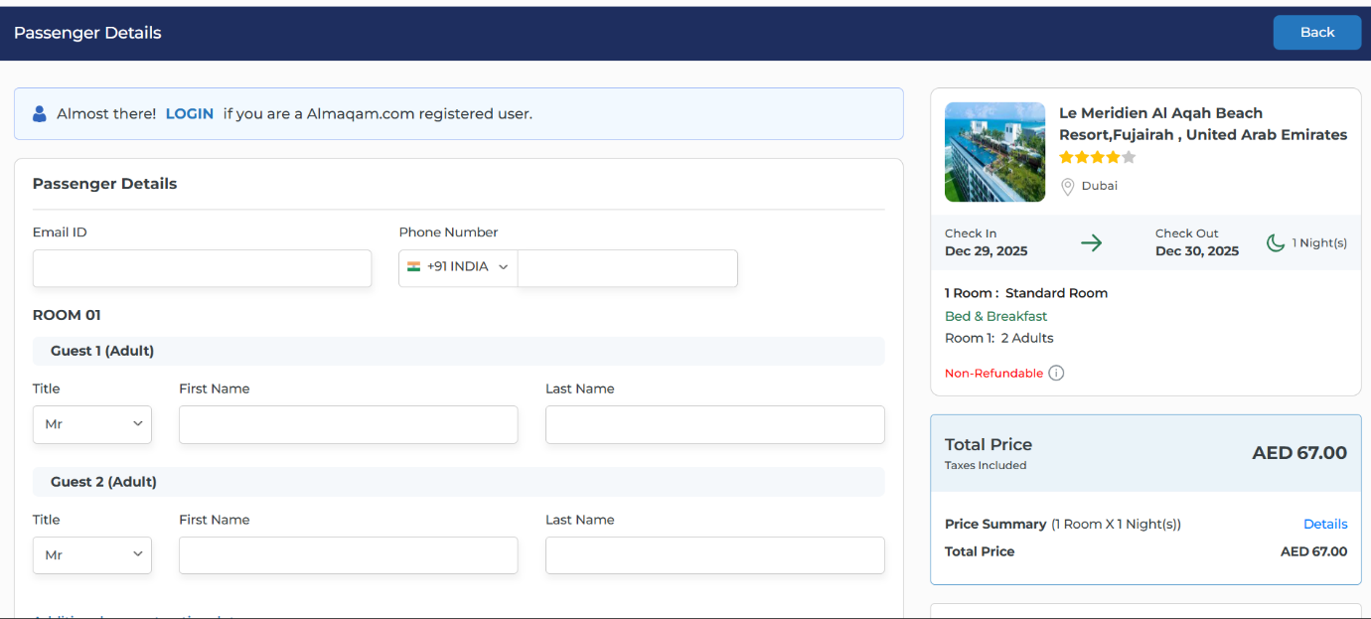
The Passenger Details Page is displayed after the user clicks the Book button. This page collects the necessary traveller information before proceeding to payment and also summarizes the hotel booking details for final verification.
1. Back Button :
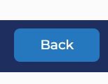
- A Back button is available at the top-right corner, Allows users to return to the previous page if they wish to modify room selection or review details again
2. Hotel Details (Right Side Panel) :
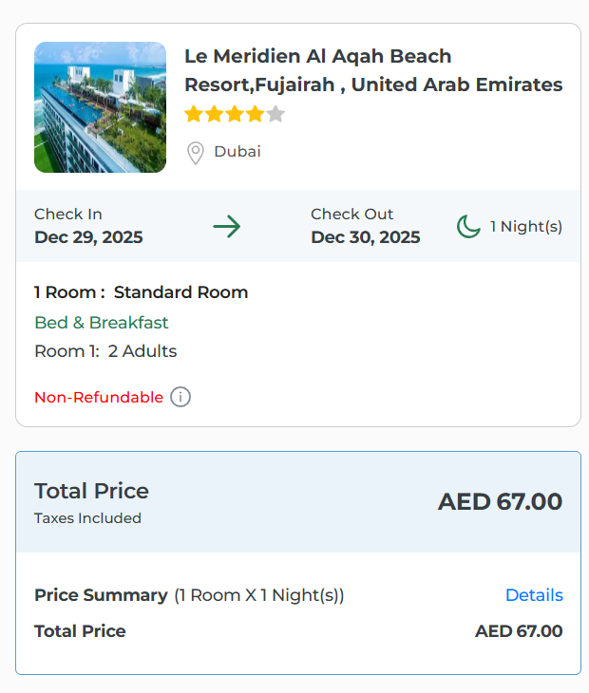
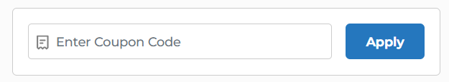
Displayed on the right side for easy reference, this section includes:
- Hotel image, name, and star rating
- Location details
- Check-in and check-out dates, along with the number of nights
- Selected room type and number of guests
- Meal plan (e.g., Bed & Breakfast)
- Refundability status (e.g., Non-Refundable)
- Total price including taxes
- Price summary with a quick “Details”.
- A field to apply a coupon code, allowing users to enter discount codes if available
This panel helps users confirm all booking information before entering passenger details.
3. Passenger Details Form (Left Side) :
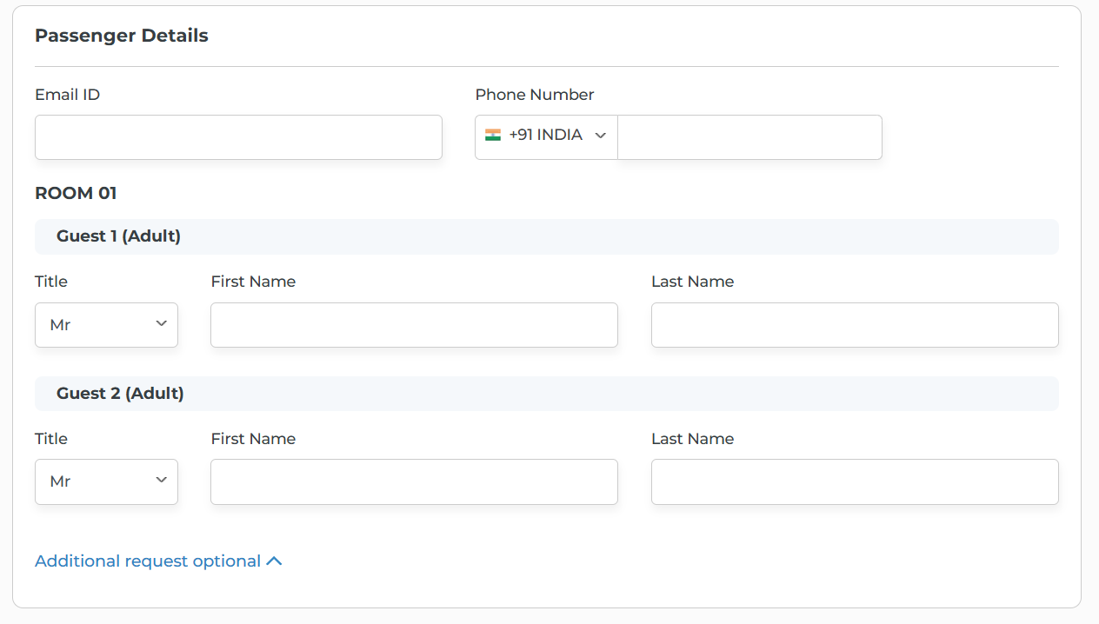
Users must enter required information for all guests staying in the selected room(s). The fields include:
Basic Contact Information
- Email ID
- Phone Number
Guest Information
For each guest in each room, the following details must be filled:
- Title (Mr/Ms/Mrs, etc.)
- First Name
- Last Name
The page displays sections like Room 01, Guest 1 (Adult), Guest 2 (Adult), etc., depending on the number of rooms and guests selected earlier.
4. Payment Section :
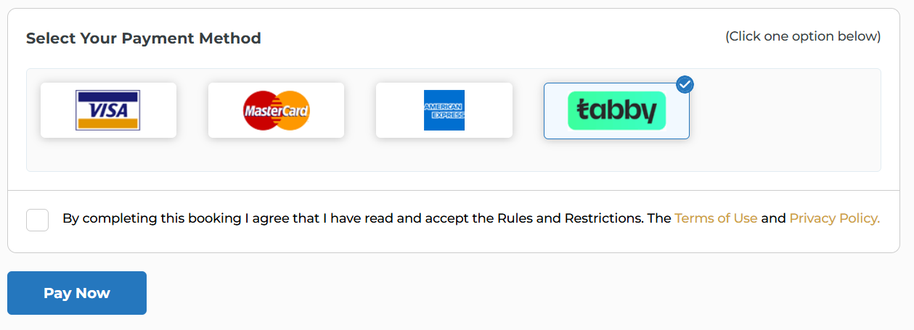
At the bottom of the page, users must choose how they want to complete the booking:
Choose Payment Method :
- Users can select from the available payment options.
Terms & Conditions :
- A mandatory checkbox is provided for users to accept the Terms and Conditions and Privacy Policy.
- Booking cannot proceed unless this box is checked.
Pay Now Button :
- Clicking Pay Now redirects the user to the payment processing page.
- Final step for completing the hotel booking.

Hotel Booking Voucher :
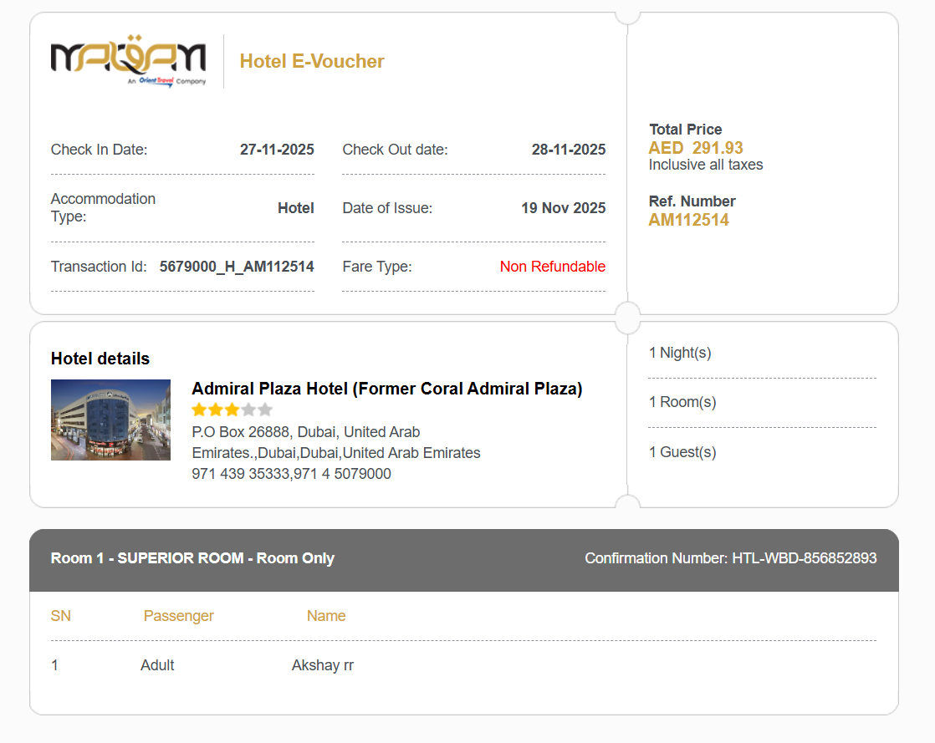
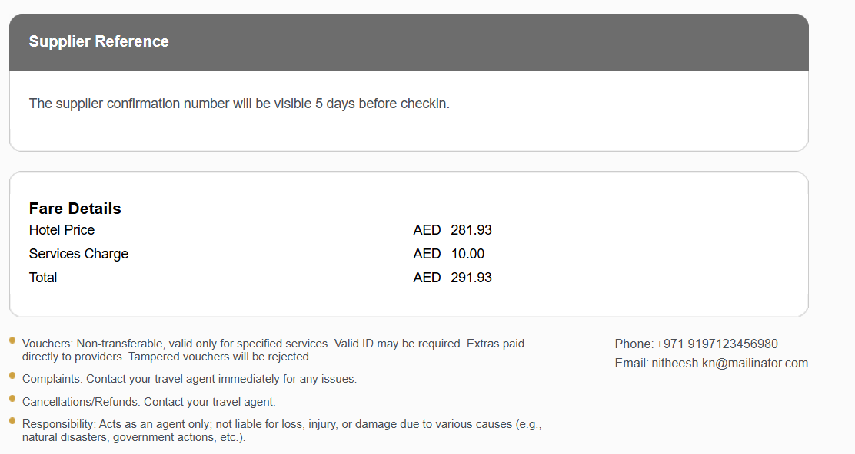
After a successful payment, the system generates a Hotel E-Voucher. This voucher serves as the official confirmation of the hotel booking and contains all necessary details for the guest and the hotel provider. It can be downloaded, printed, or shared as required.
1. Hotel E-Voucher Header
- Shows key booking details such as check-in/out dates, transaction ID, fare type, and total price.
- Includes the voucher title and reference number for tracking.

2. Hotel Details Section
- Shows the hotel’s image, name, rating, and full address.
- Also displays the number of nights, rooms, and guests in the booking.

3. Room Details
- Lists each room’s category and confirmation number.
- Shows the passenger names assigned to that room.
4. Supplier Reference
- Shows a message that the supplier confirmation number will be available 5 days before check-in.
- Used by the hotel/supplier to verify the booking.

5. Fare Details
- Displays the hotel price, service charge, and total amount paid.
- Helps users see a clear price breakdown.
6. Important Notes
- Includes rules about voucher usage, cancellations, and extra charges.
- Provides disclaimers and instructions for contacting the travel agent.
Booking Actions
Booked:
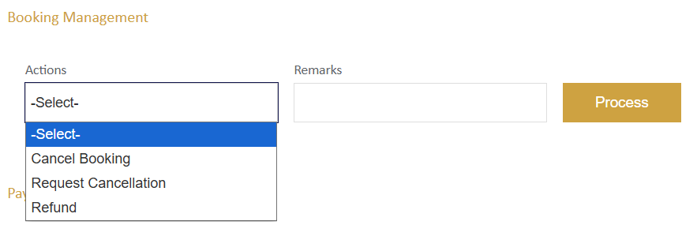
1. Cancel Booking – Instantly cancels the booking when eligible for direct cancellation.
2. Request Cancellation – Sends a cancellation request for bookings that require supplier approval.
3. Refund – Initiates the refund process for a cancelled or refundable booking.

Booking Failed:
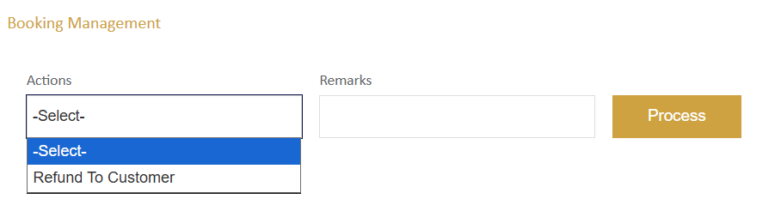
Refund to Customer – Used to return the amount to the customer.
Payment initiated:
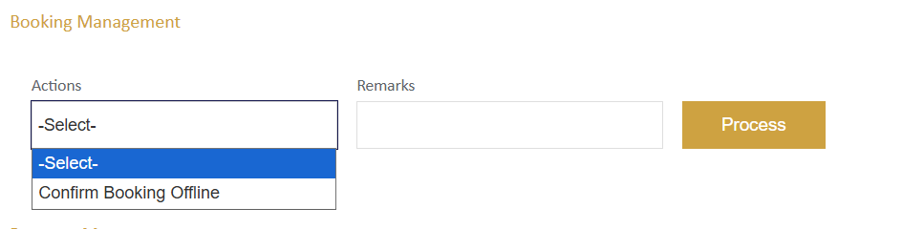
Confirm Booking Offline – Used to manually confirm a booking when payment has been initiated but not completed online.

