Cax Invoice - improvements.

- Each project has an initial project cost, which should be recorded as the project cost. Any additional costs under services, features, etc., should be added to this total cost.
Eg: Refer to the Net Balance column for clarity.
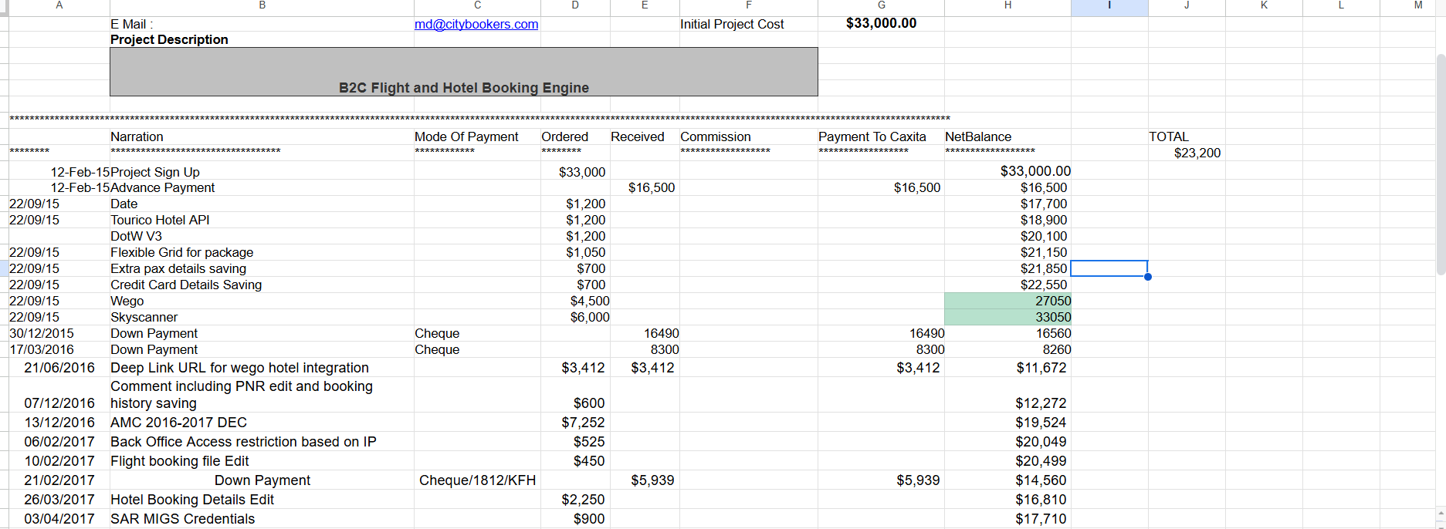
- A field for Down Payment should be added. Any amount invoiced as a down payment should be subtracted from the Net Balance (i.e., the total accumulated amount).
- Any amount deducted under Services or Features should also be subtracted from the Net Balance.
- The final report output should match the format shown in the provided image. Please refer to the image to understand the expected structure.
- Once a cost is set for a service, feature, or project, the invoice amount should not exceed this cost. However, in practice (especially for services), the received amount sometimes exceeds the set cost—this scenario should be handled.
- The system should prevent write-offs or discounts that exceed the received amount. This validation is currently unnecessary and should be removed.
- There should be an option to add any additional services beyond the predefined list.
- An AMC amount of $3,480 was split into two down payments ($1,000 and $1,653), leaving $827 unpaid for 2017–2018.
There’s no data explicitly confirming the $827 was paid.
When renewing the AMC for 2018–2019, the system auto-filled the invoice amount with the unpaid $827 from the previous year, preventing the user from entering a new amount.
As a result, the invoice for the new AMC year couldn’t be created.
This issue isn't limited to AMCs—it can occur with other transaction types too and should be addressed globally.
- The system shows a validation error when the discount exceeds the received amount. This issue needs to be fixed.
