Pending tasks( Green done, blue not done, yellow highlight extra effort), red remarks

Jan task pending points

- Branded fare display – LCC remove cross combination- GDS Branded information and baggage (TBD)- only web side
http://redmine2023.caxita.ca/issues/16425- jan
Need to change grey color. Only once refundable to be seen

- Inventory Transport Management- Branch and sales chanel missing . I can see branch but didn’t find sales chanel. Check with sandeep if this is done.
Inventory transport management (Flight or Bus)- Date ranges stock(Refer to Scope document) - this is done in inventory stock report.
http://redmine2023.caxita.ca/issues/15978

- Package enquiry Management- has bugs and issues.- need to check with Mubashir if its fine now.

- Oman air integration - done. Online void pending, Origin destn only to specific route, req to be sent

- Content Editor upgrade- need to give list of which all sections needed to sandeep
http://redmine2023.caxita.ca/issues/15973

- Flight sales report ticket number wise- pax wise need to do. This is done. Task id will be shared by sandeep. need to verify

- Quotation management for dynamic package pending. In the package enquiry management, url needed and my ideas is missing. Done. Verification pending.

- Hotel module pendings- done. Verification from BA pending
- Transfer design - done. Verification from BA pending

Last Phase pending

- Remarks field in the pax page (B2B and b2c) and the entered remarks should be passed to suppliers (SSR remarks). For flight remarks, need to do like Skysouq
http://redmine2023.caxita.ca/issues/16281 - needed for dynamic package and standalone. For hotel need to check with Arun and Ifthi for each room if we can pass.

2Additional contact number field (destination contact number) in the passenger page (Optional Field) and if entered, this should be saved in the admin and passed to suppliers.- passing to suppliers not done. Have sent mail to flight suppliers- need to check from my side in which field we need to pass request for each suppliers.

3.Pay Later- Separate queue (dashboard) should be there to identify pay later bookings.- On Hold Flight or Hotel bookings & for Fixed departures also.
http://redmine2023.caxita.ca/issues/15957- api and web.

In B2C, there should be an OTP mechanism to hold the booking. That is the customer should receive an OTP through SMS and input in the system to complete the booking process.

When customer is making the payment for Pay Later Booking, system should revalidate the price. If there is a price change that should be notified and only the latest price should be collected from the customer. The transaction should be updated wit the latest price. Effort estimation needed from api and web
http://redmine2023.caxita.ca/issues/15957. not there in sky souq
Need to discuss with ifthi and arun

- Import PNR and Manual Booking creation
- Branch/Sub Agency should be able to retrieve all booking data from GDS and during such retrieval a transaction ID should be created automatically in the system. The system should do the repricing and if the price is different, the system should allow the user to proceed with or without the changes (permission based). Ensure the history of such action is saved in the TQR- check with mubashir. Not there in skysouq

In case of markup and discount rule configured in the system, there should be two options 1: Auto: this will automatically apply the markup and discount configured for a specific agency to the booking. 2: Manual: this will allow the user to edit the markup or discount information manually. Ensure this feature also works based on permission. To discuss with ifthi and arun
http://redmine2023.caxita.ca/issues/15975

- Part payment for tickets and Adding extra charges to the booking
- Extra cost added like Markup, Seat, Meal, Baggage to the booking and TQR does not get updated. It should get added to the total cost of the booking minus what has already been collected. The balance will show as an outstanding in the booking cart/TQR which can be collected through pending payment option.- need to discuss with deepak. Not there in skysouq
http://redmine2023.caxita.ca/issues/16014

- Send quotation is missing (Should be like SKySOUQ) for all products.
http://redmine2023.caxita.ca/issues/16554. sent mail to be done

- Vat System
- The master admin will have an option to configure VAT rule and input VAT for suppliers based on source and output vat to customer based on source.
http://redmine2023.caxita.ca/issues/15963

Admin done as per sandeep. Clarifications from ba side needed. Check with Mubashir.
In sky souq only output vat only we have. Input vat is not there.

Flight- markup and pg only vat to be collected or not. Over seat, meal and baggage markup also vat is added. This is for domestic.
If it is needed for international how we need to apply vat.
How to identify domestic and international.
How vat need to be calculated for hotel and other modules.
In sky souq- over total amt, vat is calculated for hotel
Check these points with mubashir

- Fare Calendar
- Top routes will be configured in the system and will make search on 30 calendar days for the onward and return prices. These prices will be shown in the calendar . Admin should be able to configure the interval (eg 60 Mins, 120 Mins) of the auto search for price update.- extra effort for web and api. Not done in skysouq
http://redmine2023.caxita.ca/issues/15977

- IT combinable fares – Tour Code and dynamic
Need to bring is combinable tick box in deal management in the admin. If it is “is combinable” shouldn’t pass for standalone”. check with Ifthi this task

- Blank booking creation for all standalone types- flight and hotel done. For other standalone modules to be done. Need to check if Ifthi if extra effort is there
http://redmine2023.caxita.ca/issues/16022

- Cancel fixed package – Pax wise cancellation
Need more clarity on this from mubashir. As of now we can cancel only the entire package.
http://redmine2023.caxita.ca/issues/16024

- Haramain integration - provider side done. Remaining under development. Designs to be confirmed from client side.

- PK Fares integration - Is PK fare required. Need to check with client.

- Payment Gateway- If hosted checkout option is available with card saving feature that needs to be implemented. Check if done

- Calendar section needs rework, Year option need to be reworked. Fixing calendar issue & layout

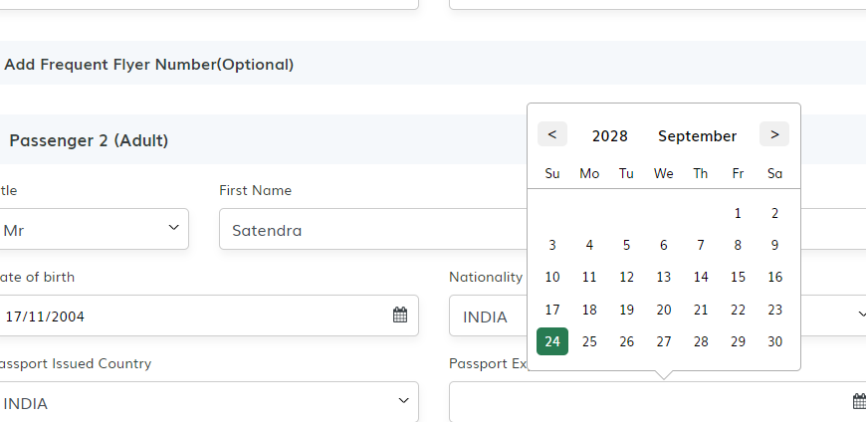

- All product types search engines have limit to 4 or 5 adults and 2 children only- need clarity from Mubashir.
For activity- 39 pax count

- Activity design changes- extra effort. Need to add task. Client have shared sheet.

- LCC Multicities- under qa ( air arabia, flynas), fly dubai - not supporting. Done. Flyadeal need to check if done

- Optimization work ( admin- transfer and activities)- extra effort needed. Need discussion with client
- Inventory Transfer (Backend)
- Inventory Hotel (backend)
- Inventory Visa (Front end and backend)
- Inventory Activities (Front and backend)
- Static Packages (Front and backend)
- Activities result to checkout
- Insurance result to checkout
- Pay later queue for Hotels

- Offer pages

- Detail discount Promotional text need to be shown (B2B and B2C). check if done

- Flight and Hotel Cache
Flight and Hotel Caching result caching on basis of dates, routes and destinations.check if done

- Online Booking Management
- Reissue- All GDS’s pending along with Split PNR

- Airline schedule change : All schedule change information will be queued to a particular GDS queue. System should check the queues and alert the admin (by flagging the transaction ID) on the schedule changes. Once the admin reviews the changes and approves, the changes should be updated in the transaction and updated ticket should be sent to the customer. The history of such notification should be maintained including the approver details (with Remarks)

- Refund and Reissue- Online for all supporting airlines/GDS

- B2C and B2B customers should be able to cancel, void , reissue and refund tickets through their respective interfaces. This was discussed many times and is a priority in Phase 1. This feature is to be made available for all supported suppliers.

- SABRE IUR
These are remarks (Customer code, discount, service fee, credit card charge, booking transaction ID, sales channel, FOP etc) to be passed to sabre system at the time of booking and ticket issuance. Confirmation pending from Mubashir.

- Passive segment
The system will auto create passive segment whenever a ticket is issues for LCC suppliers or an insurance booking is made. The admin will have the option to create a passive segment rule.- Confirmation awaited from Almaqam

- Accounting software integration
Integration will accounting software of Orient travel & tourism agency. Confirmation pending with Almaqam

- Manifest- We have done only dynamic package. If we get confirmation from client, we can start remaining

- SEO settings in packages- Khloud needs to be verified

- Hold fixed departure package OTP function.

- Fixed departure packages- Less seats issue and Hijri/Georgian calendar search

- Mapping areas and destinations in Saudi Arabia- Places API

- Whatsapp and SMS through Webengage

- E-Visa for exempted countries . Fixed package need to remove the Visa requirement from search page. Bring it to pax page. Check with Mubashir

- Credit control module for B2B- Need to check with Mubashir
- OTP hold booking option for GDS (B2C)
- Mail and banner customization – Email
- Social media management- Pixel tracking
- Destination specific alert messages- OD pair or airline. Need to check with Mubashir
- B2C user can request cancellation from profile my bookings
- Cancellation approval email trigger.
- Dynamic package cancellation
- Orient Travel Website
- Mobile APP
- Expedia integration
- Emirates integration
- Insurance is currently searched on basis of country, it should be on the basis of city code
- Fixing airport listing and city listing drop down

- Adding CRM webhooks to the website. Need to check with mubahsir what is this feture.
Fixed Departure Package Management- Share, Download tour program (B2C, B2B and In House). with and without cost. Optimization of package details page (Image Banner section)
Any listing in Mid Office, will have edit, delete, view. Should have filters to sort
- Different SMTP domains- Almaqam & Orient Travels. What to be done. Check with mubashir
- Generative AI – Places API
- Airport and City Listing- Nearby listing
- Activity time- Defining the slots- Inventory side ?? Check with Mubashir
Activity Voucher - is this for standalone?
- Supplier name missing in booking cart
- Edit option missing in booking cart, for Event details like confirmation number, activity code and supplier booking reference.
- Activity date and time is missing
- Only lead pax name is required along with total number of pax.
- Pickup and meeting point missing
- Duration of the tour is missing.
- Private of Shared tour is missing.
- Supplier emergency contact number is missing from vouchers, this information must be picked from Supplier profile.
http://redmine2023.caxita.ca/issues/10886

- Vouchers
Transfer Voucher- done . check from my side. Dynamic package
- From and To Shows Country Code, it must pickup location and drop off location. I:e Jeddah Airport to Pullman Zamzam Makkah
- Pickup time is missing
- Supplier name is missing in booking cart
- Vehicle Type(SUV, Sedan), Transfer type (Private, Shared), Max Passengers (1,2,3) Baggage details missing from Voucher.
- Only Lead pax name is required, and Total Pax. No need for Multiple Names.
- Age is not required, replace with number of guests.
- Arrival and Departure flight number with date and time is missing along with Terminal.
http://redmine2023.caxita.ca/issues/10884

- Dynamic package comments
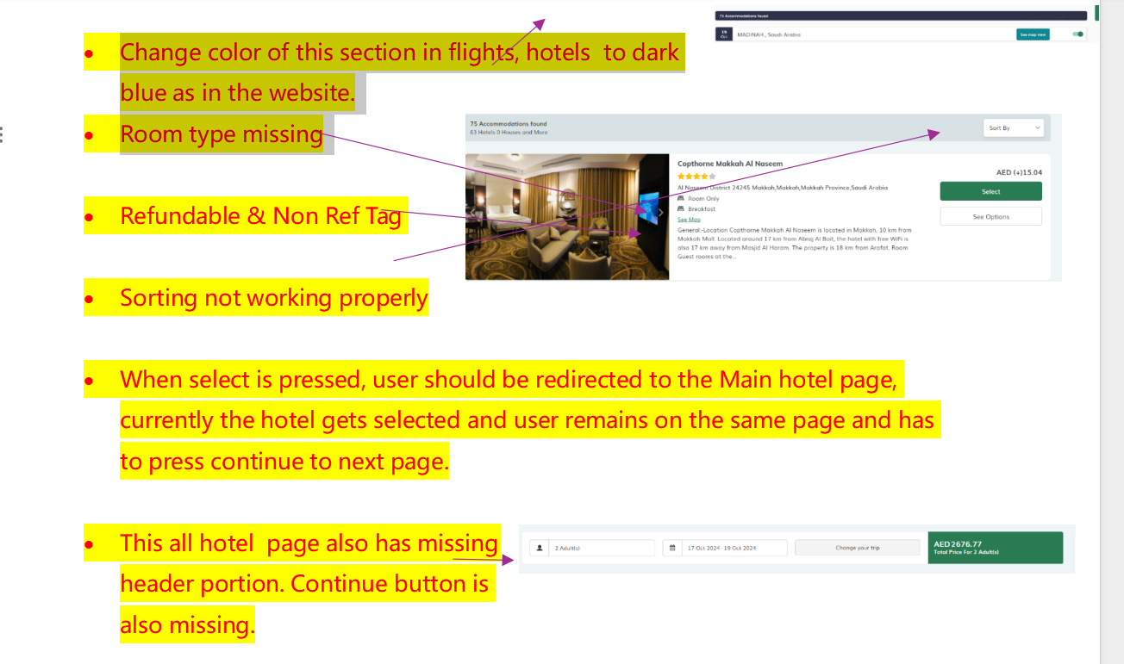

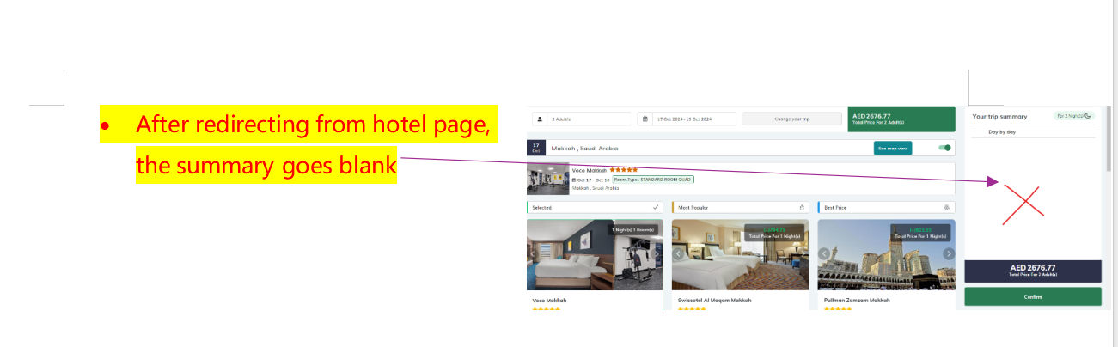
http://redmine2023.caxita.ca/issues/11898
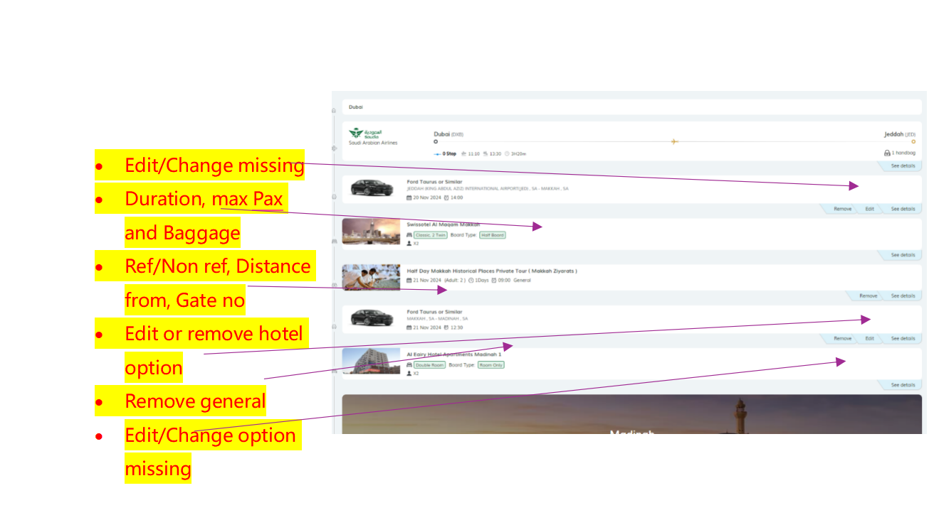
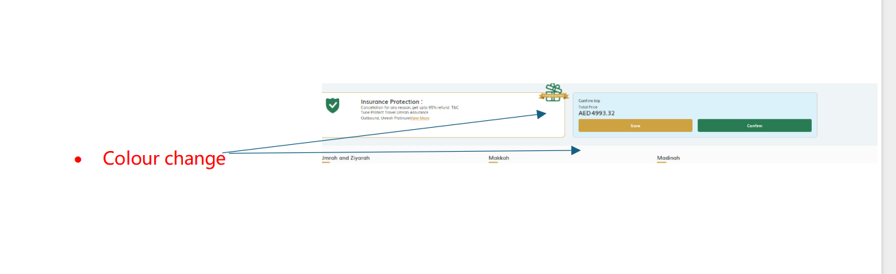

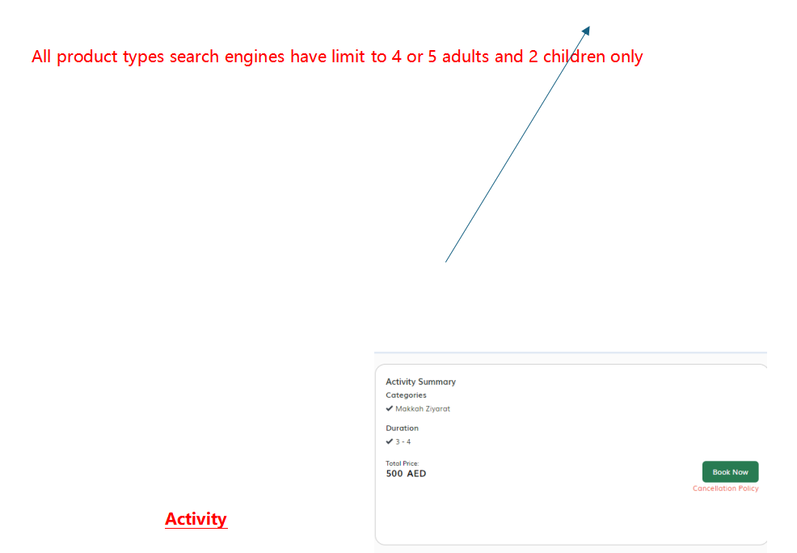
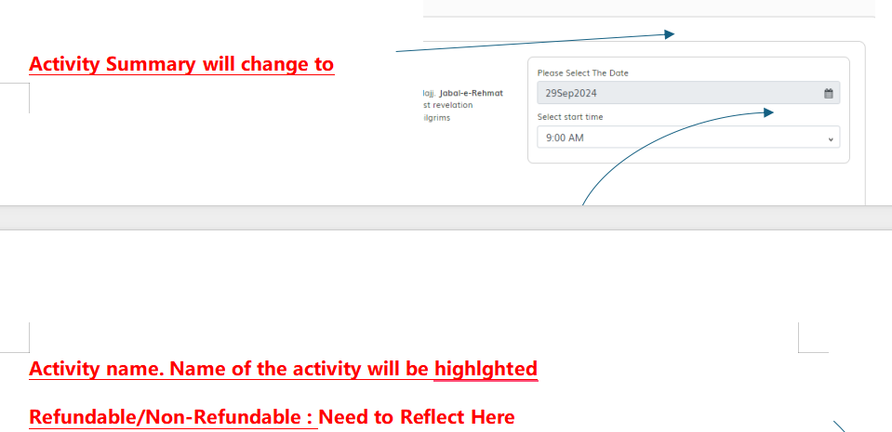

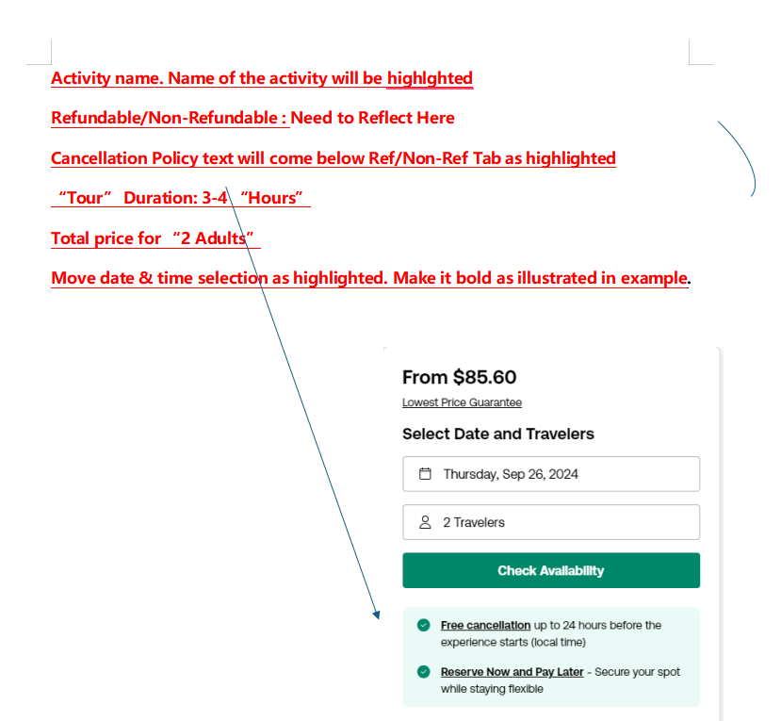

Hotel inventory management- Pickup hotel information from static data

