FLIGHT MODULE

In this section,as a user, the user gets the availability of flight Service.
There are 3 modes of flight journey:Oneway,Roundtrip and multicity.

Once the user opens up the site and start availing the facilities, the user will be provided with the options like

- Source : This field specifies the user can select source by airport name/code
- Destination : This field specifies the users can select destination by airport name/code
- Start date : This field specifies the users start date of travel.
- End date : This field specifies the users end date of travel.
- Travellers : This field specifies the mode of travel whether it is a family or an individual journey. Here there will also be an option to add the number of travellers- adult,child and infant separately.
- Cabin class : This field specifies the user can select cabin class like economy,business class,first class and premium economy
- Preferred airline: This field specifies the user can select preferred airline by airport name/code
- Direct flight : This field specifies the user can select non stop flights/stop flights.
This can be done by selecting the check box near to the direct flight option, once opted the system will output only those results in which the flight travels from the mentioned Source and destination. Thereby, making the customer comfortable in journey and avoiding unnecessary time delays and stoppages.
- Validations to be checked in the flight search panel:
a.If user select different Source and Destination then “system allows to proceed”
b.If user select same Source and Destination then Alert message “Source and destination should be different”.
c.if user select current/future date then “system allows to proceed”
d.if user select date earlier than current date then “system should not showor should not be selectable”
e.Maximum Pax Selection -System allow a maximum of 9 Passengers
f.Child Selection -One adult pax is mandatory for child booking
g.Infant Selection- Infant count should be lesser or equal to Adult count
h.Maximum selectable number of Adult is 9.
i.Maximum selectable number of child is 8
j.Maximum selectable number of infant is 4

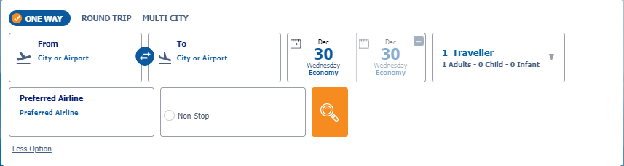

The user/ traveller has to enter the basic details for travel and proceeds with GO/ SEARCH option , the user will be directed to the result page with all available flights within the particular search. Each result contains flight details, fare summary,fare rules and baggage details.
If no results are available for the search criterias, then a message “No results found out” will be shown.
- Flight details:
Source with airport name and code,Destination with airport name and code, Airline Name and Code, Number and Logo ,Airline Equipment Type
Operated by information (incase of codeshare flight),Baggage information of Airline ,Meals information of Airline ,Class information of Airline such as Economy, Business,Premium economy and first class...,Departure Date and Time from source airport,Arrival Date and Time to Source Airport,Total Duration of the flight.
- Fare Summary:
It includes the detailed fare information of each traveller.
- Baggage details:
It includes the baggage information allowed for each passenger
- Fare rules
It includes the rules and conditions.

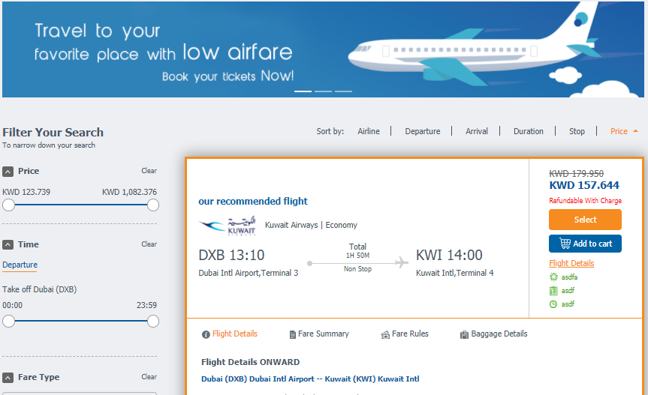

In certain cases, there will be a markup / discount that is to be added along with the total price. In such cases, the markups/ discounts set from the admin panel will be applied to the Airline total and displayed to the user. The split up in the fares will also be available incase if the user wishes to know the split ups of rates that lead to the total amount.

Sort Option : User can able to rearrange flight results in ascending/descending order.Sort options are given below
- Sort by Airline
- Sort by Departure
- Sort by Arrival
- Sort by duration
- Sort by stop
- Sort by Price



Filter Option : User can able to pick up flight results using filter options. Filter options are given below
- Filter by Price
- Filter by Time
- Filter by fare type
- Filter by duration
- Filter by stops
- Filter by Airline

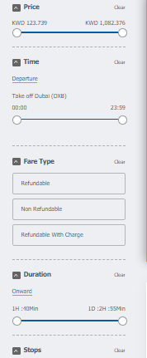

On clicking select option, it will redirect to pax details page from the Details page’s desired flight package and selection.
Summary of selected flight will be shown at the top with change flight option.
Also the price of the airline, the services offered by the airline etc will alos be shown here.
The customer also gets to view the opinions/ ratings of already travelled passengers.

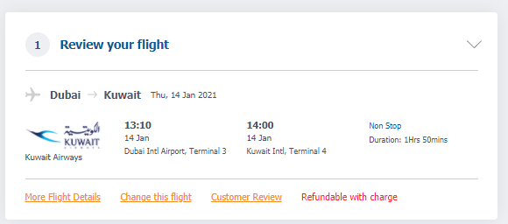
In login and register section, user can login using email and password and then continue with the booking.if the user is not registered user, can register using following details:First Name, Last Name, E mail ID, Phone number with country code and Password. But this option is only an optional case. The user can also continue on to the next section as a guest user itself.

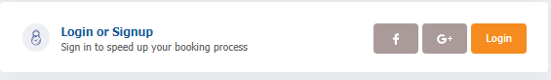

In the pax page the user can enter the details.Passenger have to enter the following details. Title,First Name, Last Name, E mail ID, Phone number with country code,date of birth,passport number. The fields in the Passenger details page? PAX page, unless marked as optional, all the fields are mandatory here, since it is the information that would be coming on the flight ticket.

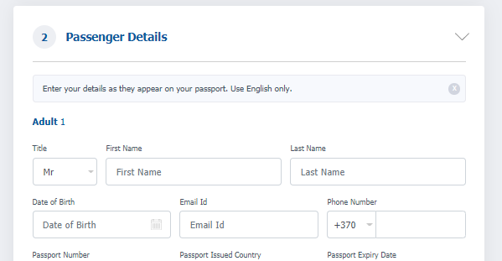

After completing the pax details and clicking on the continue button, it will take the customer to the payment gateway section where the user will be able to choose the desired payment gateway which is integrated on the project. .Upon selection it will redirect to the corresponding payment gateway page.Once the payment get successful ticket page will be displayed on the website. There will be a session expiry time for the payment gateway section of which before the expiry the user must enter the bank name, the card details and the PIN to access the respective bank’s transaction section.
The user can avail the option of price redemption in the payment page by entering the coupon code and applying the same.

On successful redirection to payment gateway, admin will receive 2 email say, Booking success mail and booking success and redirected to payment gateway
If payment got captured,customer receive payment success mail
If payment is not captured, then also customer will receive payment transaction mail.

While explaining the payment status, there are also ceratin other scenarios. At times, there could happen booking failure on which the customer has to go back to the search page or the result page and continue the booking process. Another case to happen is that the payment might get success, but the ticket may not get generated,in this case the customer can contact the admin with the respective reference ID and date of booking or the specific details as instructed by the backend staff and ask for manual ticketing to the admin.

If the payment transaction got success ticket page will be displayed and it contains Logo and Contact Details of the Agency,G PNR and Reference Number,Pax Name, Gender, Category, Ticket Number and Status,Itinerary Details such as Airline name and Logo, Airline number
Airline PNR,From and to destinations,Departure and Arrival and Date and Time,Duration of the flight ,Cabin Type and Booking Class (RBD) ,Baggage Details based on the pax types on ticket (Adult, child and infant ) ,Refundable or Non Refundable ,General Rules,Booked Date
Ticket price excluding payment gateway charge.
On successful ticketing,Admin will receive Ticket successful notification and the Customer will receive e mail with E Ticket.On ticket failure Admin will receive ticket failure notification

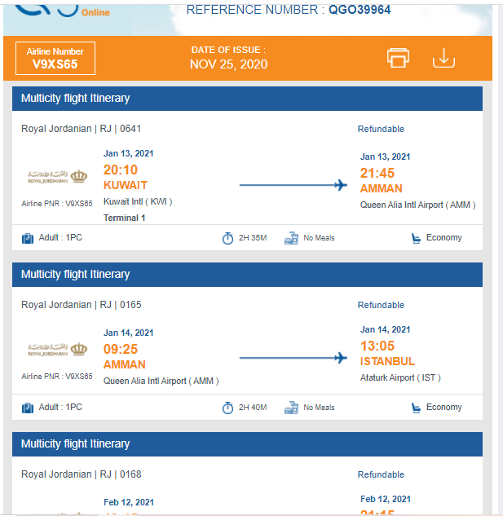

On admin, there is an option called Online booking management, where we can see all the flight bookings saved under different statuses.Also we can view/search transactions based on lead passenger name, reference number, date range, API, transaction status ,User ,Transaction type etc.

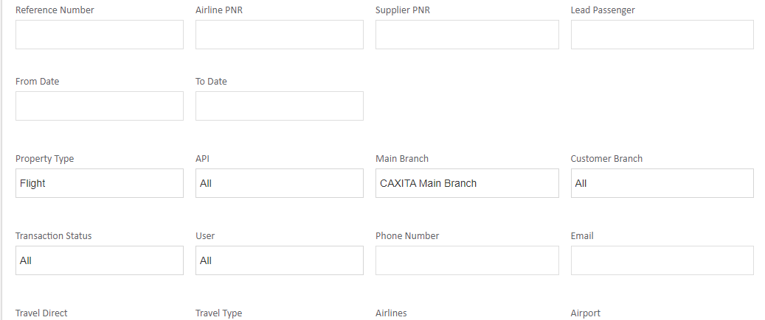

BOOKING ACTIONS IN FLIGHT BOOKINGS

1.Payment initiated - This denotes when user selected the payment gateway to make payment.
2.Payment done - This denotes when user done payment for booking
3.Booked - This denotes the Flight booking received in API, but not confirmed
4.Ticketed - This denotes the booking flight is confirmed and then they will get ticket number.
5.Amend action : When user request for date change we can use amend action from admin section.Admin can change the status to amend requested,After that corresponding charge for that transaction will be calculated and statu can be amend charge calculated.Once the customer approves the charge the admin can change the status to amend approved.Now it will create a new transaction with all data of previous transaction including payment details.In the Amend Charge Details section there will be 3 fields says Amend Charge, Outstanding, Total
Amend Charge: It shows the amount of Amend (Amend Charge) you given
Outstanding: Shows the Amend charge before it is paid
Total: Shows the Final Total + Amend Charge
On the new transaction , the agent can create a Payment Link for the corresponding Amount and send it to the customer.
If you need to add your profit please add it by selecting Extra markup drop down and then create a link for the total amount to be paid. Once the customer made payment, the status will change to Payment Done.
On the payment details section it will update the payment details of New payment as well along with the details of the old transaction
Agent can make the status to ticketed by any of the 3 options.(Ticket manually,Confirm ticketing,Retrieve ticketing)
In the sales report, the new transaction will show like all the amount other than the Amend charge will be ZERO

MY BOOKING FLIGHT SECTION

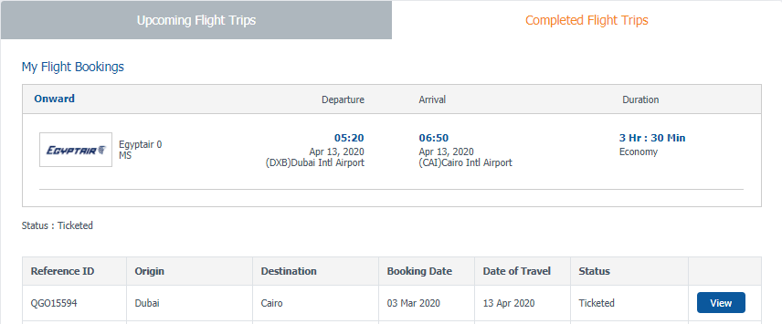

It consists of Upcoming flight trips and completed flight trips.Flight transactions (ticketed/booked/cancelled status) are listed in grid view.
Reference ID,Origin,Destination,Booking Date,Date of Travel,Status are shown in the grid view with View button. On clicking view button it will expand the flight booking with cancel/ok button.When customer proceed with cancel button then the booking cancel request will be sent.
In my profile, customer can save/update his personal information title,firstname, last name, date of birth,nationality,phone number ,passport number,passport expiry and passport issued country,
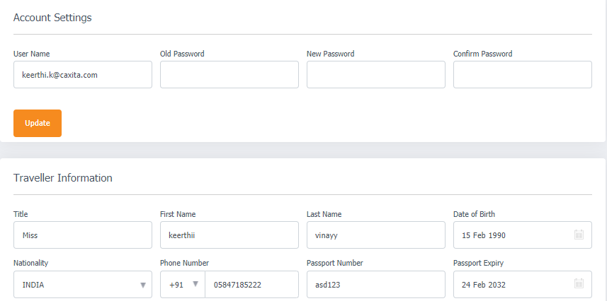

In my reward, it shows the available points and used points
After the travelling date, registered customers are awarded with some reward points.These points are shown in my reward section.

